ROCKETSHIP EDUCATION:

AN EXPLORATORY PUBLIC POLICY CASE STUDY

A Dissertation Presented to

The Faculty of the Educational Doctoral Program in Educational Leadership San José State University

In Partial Fulfillment

of the Requirements for the Degree Doctor of Education

by

Vladimir Gresham Ivanović June 2024

Copyright © 2022–2024 Vladimir Gresham Ivanović.

All Rights Reserved.

*Rocketship Education: An Exploratory Public Policy Case Study*

by Vladimir Gresham Ivanović is licensed under a

Creative Commons Attribution-NonCommercial-ShareAlike 4.0 International License which may be viewed at:

<http://creativecommons.org/licenses/by-nc-sa/4.0/legalcode>

The Designated Dissertation Committee Approves the Dissertation Titled

ROCKETSHIP EDUCATION:

AN EXPLORATORY PUBLIC POLICY CASE STUDY

by

Vladimir Gresham Ivanovic

Approved for the Educational Doctoral Program in Educational Leadership

San José State University

June 2024

Roxana Marachi, Ph.D. (chair) Professor, San José State University Noni Mendoza Reis, Ph.D. Professor Emerita, San José State University Gordon Lafer, Ph.D. Professor, University of Oregon Ferdinand Rivera, Ph.D. Professor, San José State University

# Abstract

ROCKETSHIP EDUCATION: AN EXPLORATORY PUBLIC POLICY CASE STUDY

by

Vladimir Gresham Ivanović

This dissertation is an exploratory case study of the finances of the Rocketship charter school chain, especially those related to real estate. Rocketship is a not-for-profit charter management organization, one of the first in Santa Clara County, California. This study seeks to determine if the financial transactions related to Rocketship charter schools yield profits for investors, despite Rocketship itself being a non-profit entity, and if they do, how and where do they do so. In order to characterize fairly and completely the profits of Rocketship Education itself and Rocketship-related entities, this study uses publicly available documents to track money flowing in and out of Rocketship and related entities, for example, the various Launchpad Development companies. Using data from initial and renewal charter petitions, annual budget documents, filings with county, state and federal government agencies, bond prospectuses, tax credit programs, state and federal grants, plus data from publicly available datasets, this study derives an estimate of Rocketship’s profitability. It has found that, although it is profitable, it is not legally allowed to distribute those profits to individuals or to for-profit entities. Further, it is speculated that Rocketship intends to use its profits to fund the establishment of charter schools in California and in other states. These results, it is hoped, will serve to inform local, state, and federal legislatures when they establish public policy for charter schools, not only in California, but throughout the United States.

*Keywords*: Rocketship Education, charter management organization, privatization, charter finances, education public policy, profit, real estate, bonds, venture funds, philanthrocapitalism

# Acknowledgements

My debts are many.

To Diane Ravitch, whose fierce and intellectually rigorous focus on the inequities of public education, I owe my much weaker commitment to changing public policy so that every child gets the education they need to flourish. To Robin Avelar LaSalle, with whom I lost every (friendly) education argument we had during our first dinner, I owe her sparking my interest righting the inequities in educational policy in California. To Roxana Marachi, my dissertation advisor, to whom, put simply, I owe my doctorate. I truly cannot imagine a better committee chair and I hope to accomplish half of what she has. To Noni Mendoza Reis, Gordon Lafer, and Ferdinand Rivera, members of my committee, thank you for your valuable feedback that improved my writing and thinking. To Arnold Danzig, Bradley Porfilio, and Ferdinand Revera, Ed.D. Program Directors, I owe much gratitude for their support at critical junctures in my journey to a doctorate. To my long suffering wife, Carol, and to our two children, I owe so much for their tolerance of my quirks, not to mention the vast number of books that crept into every corner of our house. To the professors in the Ed.D. program who did their very best to instill in me the requisites of becoming an education leader, I owe much. To Jennifer Carlstrom, who was the first to guide me on my journey through the thicket of educational policy in California, thank you for getting me started. To Jeff Baier, Sandra McGonagle, Randy Kenyon, and Carrie Bosco (herself an Ed.D. graduate), all senior administrators in the Los Altos School District, thank you for listening graciously to my many suggestions for improvement from someone who has never actually run a school district. Lastly, to Cohort 6 (Class of ’22), and especially to Gigi Carunungan and Candice Nance, thank you many times over for your unwavering support (and ceaseless pestering, ”Is it done yet?”).

Nothing in this dissertation was written by an artificial intelligence program. I am

solely responsible for any and all errors in this dissertation.

*Lucius Cassius ille quem populus Romanus verissimum et sapientissimum iudicem putabat identidem in causis quaerere solebat “cui bono” fuisset.*

The famous Lucius Cassius, whom the Roman people used to regard as a very honest and wise judge, was in the habit of asking, time and again, “To whose benefit?”

Pro Roscio Amerino, §§ 84, 86 Marcus Tullius Cicero*a*

*a*<https://en.wikipedia.org/wiki/Cui_bono>

|  |  |
| --- | --- |
| **Contents** |  |
| **Abstract** | **iv** |
| **Acknowledgements** | **v** |
| **List of Tables** | **xi** |
| **List of Figures** | **xiii** |
| **Abbreviations** | **xiv** |
| **Glossary** | **xv** |
| **1 Introduction** | **1** |
| 1.1 Schools and Charter Schools . . . . . . . . . . . . . . . . . . . . . . | 2 |
| 1.2 What is the Purpose of this Study? . . . . . . . . . . . . . . . . . . . . | 5 |
| 1.2.1 Research Question . . . . . . . . . . . . . . . . . . . . . . . | 7 |
| 1.3 Theoretical and Conceptual Frameworks . . . . . . . . . . . . . . . . | 9 |
| 1.3.1 Public Policy as a Theoretical Framework . . . . . . . . . . . . | 9 |
| 1.3.2 A Case Study Approach as a Conceptual Framework . . . . . . . | 11 |
| **2 A Review of the Literature** | **13** |
| 2.1 The Birth of American Public Education . . . . . . . . . . . . . . . . . | 13 |
| 2.2 A History of Charter Schools . . . . . . . . . . . . . . . . . . . . . . | 17 |
| 2.2.1 The Origins of Charter Schools in Segregation . . . . . . . . . . | 18 |
| 2.3 Charter Schools, Free Markets and Privatization . . . . . . . . . . . . . | 20 |
| 2.4 Types of Charter Schools . . . . . . . . . . . . . . . . . . . . . . . . | 24 |
| 2.4.1 Charter School Authorizers and Oversight . . . . . . . . . . . . | 24 |
| 2.4.2 Profit-Making Status . . . . . . . . . . . . . . . . . . . . . . | 25 |
| 2.4.3 Types of Instruction . . . . . . . . . . . . . . . . . . . . . . . | 27 |
| 2.5 Charter Schools in the United States . . . . . . . . . . . . . . . . . . | 28 |
| 2.5.1 Charter Schools in California . . . . . . . . . . . . . . . . . . | 29 |
| 2.6 Surveys of Charter School Research . . . . . . . . . . . . . . . . . . . | 30 |
| 2.6.1 Research on Charter School Finances . . . . . . . . . . . . . . | 34 |
| 2.7 Rocketship . . . . . . . . . . . . . . . . . . . . . . . . . . . . . . . | 35 |
| 2.7.1 Rocketship History . . . . . . . . . . . . . . . . . . . . . . . | 36 |

* 1. Rocketship Finances 38
     1. Rocketship Expansion Funding 40
     2. Rocketship Expansion Difficulties 42
     3. Charter School Accountability 42
  2. Rocketship and Privatization 43
     1. Privatization 43
        1. Philanthrocapitalism 47

1. Research Design and Methodology 48
   1. Process Overview 49
   2. Financing Schools in California 50
      1. Budgets 50
      2. Budgets & Interim Reports 56
      3. Local Control Accountability Plans (LCAPs) 57
      4. Comprehensive Annual Financial Reports 58
   3. Charter School Financing 58
      1. Charter School Financial Documents 59
         1. Petitions & Renewals 61
         2. Authorizer Staff Reports 62
         3. Budgets, Interim Reports, and CAFRs 62
         4. LCAPs 63
         5. Board and Committee Supporting Material 63
   4. Charter Schools and Real Estate 63
      1. Facilities Options 64
         1. Co-Locating 64
         2. Leasing 65
         3. Owning 66
         4. Private Funding: Loans and Foundation Grants 66
         5. Venture Funds 66
         6. Tax Credits 67
         7. Bonds 67
   5. Other Data 68
      1. State and Federal Filings 68
      2. Curated Social Media 69
   6. Gaps and Anomalies 69
      1. Triangulation 69
2. Findings 71
   1. Rocketship’s Corporate Structure 71
   2. Rocketship Locations and Property Information 74
   3. Rocketship’s Finances 75
      1. Rocketship Financial Documents 75
      2. Rocketship’s Financing Alternatives & Models 77
      3. Financing of Charter Schools 78
         1. LCFF 79
         2. Local Property Taxes 80
         3. Local Parcel Taxes 81
         4. Bonds 81
         5. Private Grants 83
         6. Venture Capital Funding 83
         7. Rent Subsidies 85
      4. Debt 85
      5. The New Markets Tax Credit Program 86
         1. The Benefits of the NMTC 86
         2. How NMTC Works 87
      6. Rocketship’s Worth 88
   4. Gaps, Anomalies, and Discrepancies 88
      1. Gaps 89
      2. Anomalies 89
      3. Discrepancies 92
   5. Issues of Equality and Equity 93
3. Discussion 97
   1. Answering the Research Question 98
   2. Public Policy Issues 103
      1. Fraud 104
      2. Real Estate Conversion 105
         1. Disposing of Assets at Closure 106
         2. SB740 Lease Payments 108
   3. Changes to Public Policy 109
      1. Eliminate Sweeps 110
      2. Hold Charter Schools To Their Charter 110
      3. Unaffiliated Board Member 111
      4. Effective Internal Controls 112
   4. Areas for Future Research 112
   5. Conclusion 115

References 116

Appendicies 139

1. A Note on Data Sources 140
2. School Financing in California 142
3. Rocketship’s Santa Clara Properties 151
   1. Mateo Sheedy 152
   2. Sí Se Puede 154
   3. Los Sueños 156
   4. Discovery Prep 158
   5. Mosaic 160
   6. Brilliant Minds 162
   7. Alma Academy 165
   8. Spark Academy 167
   9. Fuerza 169
   10. Rising Stars 171
4. Consolidated Financial Position (2010-2022) 173
5. Consolidated Activities (2010-2022) 178
6. Consolidated Cash Flows (2006-2022) 183
7. Consolidated Functional Expenses (2019-2022) 196

Index 198

Colophon 203

**List of Tables**

1. Attributes of Private, Charter, and Public Schools in California 26
2. Rocketship Schools in Santa Clara County, California 39
3. Budgets as of July 1st 51
4. Charter School Financial Documents 60
5. Charter School Facilities Options 64
6. Charter School Options for Paying for Facilities 67
7. Rocketship Property Information 75
8. Charter School Financing 79
9. Rocketship Bonds 84
10. Venture Capital Funding 85
11. Total Debt, 2012-2022 86
12. Net Assets, 2010–2022 88
13. Types of Conversion 102
14. Mateo Sheedy: Property Information 152
15. Mateo Sheedy: Taxable Amount of Assessed Propery 153
16. Sí Se Puede: Property Information 154
17. Sí Se Puede: Taxable Amount of Assessed Property 155
18. Los Sueños: Property Information 156
19. Los Sueños: Taxable Amount of Assessed Propery 157
20. Discovery Prep: Property Information 158
21. Discovery Prep: Taxable Amount of Assessed Propery 159
22. Mosaic: Property Information 160
23. Mosaic: Taxable Amount of Assessed Propery 161
24. Brilliant Minds: Property Information 162
25. Brilliant Minds: Taxable Amount of Assessed Propery 162
26. Alma Academy: Property Information 165
27. Alma Academy: Taxable Amount of Assessed Propery 166
28. Spark Academy: Property Information 167
29. Spark Academy: Taxable Amount of Assessed Propery 168
30. Fuerza: Property Information 169
31. Fuerza: Taxable Amount of Assessed Propery 170
32. Rising Stars: Property Information 171
33. Rising Stars: Taxable Amount of Assessed Propery 172
34. Consolidated Financial Position, Years Ending 2010–2022 174
35. Consolidated Activities, Years Ending 2010–2022 179
36. Consolidated Cash Flows, Years Ending 2006–2022 184
37. Consolidated Functional Expenses (2019–2022) 197

**List of Figures**

1. California 2019–20 K–12 Funding by Source 52
2. LCFF Components 55
3. Rocketship’s Corporate Structure for Santa Clara County Facilities 72
4. LASD 2019–20 All Funds Summary 144
5. LASD YE 2020 Summary of Net Position 147
6. LASD YE 2020 Change of Net Position 148
7. LASD YE 2020 Net Cost of Services 148
8. LASD YE 2020 Capital Assets 149
9. LASD YE 2020 Long-term Liabilities 149
10. LASD 2019–20 Multi-Year Projection 150
11. Mateo Sheedy Plat Map 152
12. Mateo Sheedy Satellite Photo 153
13. Sí Se Puede Plat Map 154
14. Sí Se Puede Satellite Photo 155
15. Los Sueños Plat Map 156
16. Los Sueños Satellite Photo 157
17. Discovery Prep Plat Map 158
18. Discovery Prep Satellite Photo 159
19. Mosaic Plat Map 160
20. Mosaic Satellite Photo 161
21. Brilliant Minds Plat Map 163
22. Brilliant Minds Satellite Photo 164
23. Alma Academy Plat Map 165
24. Alma Academy Satellite Photo 166
25. Spark Academy Plat Map 167
26. Spark Academy Satellite Photo 168
27. Fuerza Plat Map 169
28. Fuerza Satellite Photo 170
29. Rising Stars Plat Map 171
30. Rising Stars Satellite Photo 172

**Abbreviations**

**ARUSD** Alum Rock Unified School District

**BAN** Bond Anticipation Note

**CAFR** Comprehensive Annual Financial Report

**CAGR** Compound Annual Growth Rate **CDE** California Department Of Education **CINA** Change in Net Assets

**CMO** Charter School Management Organization

**COE** County Office of Education **COVID-19** Corona Virus Disease 2019 **CPRA** California Public Records Act

**CSBA** California School Boards Association **CSFA** California School Finance Authority **DOE** U.S. Department of Education

**EC or Ed Code** Education Code of California

**ECLS-K** Early Childhood Longitudinal Study – Kindergarten class of 1998 or 2011

**EMO** Education Management Organization **FOIA** (federal) Freedom of Information Act **GO bond** General Obligation Bond

**LASD** Los Altos School District

**LCAP** Local Control and Accountability Plan

**LCFF** Local Control Funding Formula

**LEA** Local Education Agency

**SACS** Standardized Account Code Structure

**SARC** School Accountability Report Card

**SARS-CoV-2** Severe Acute Respiratory Syndrome Corona Virus #2

**SCCBOE** Santa Clara County Board of Education **SCCOE** Santa Clara County Office of Education **SCC** Santa Clara County

**SEDA** Stanford Educational Data Archive

**TPS** Traditional Public School

**TRAN** Tax Revenue Anticipation Note

**Glossary**

**ADA** Average Daily Attendance, the method that the state of California uses to determine how many students attend a particular school. An alternative is to use the number of students enrolled, some of whom may attend sporadically but still need to be educated when they do attend. (California Department of Education, 2019)

**arm’s length transaction** A transaction, often financial, where all parties are independent and self-interested. (Wex Definition Team, 2010)

**blended learning** A method of teaching where both in-person instruction and virtual instruction are used. (Graham, 2018)

**bond** A bond is a loan whose terms (maturity date, interest rate) are fixed. Bonds are issued by a borrower (the debtor) to investors (the creditors) who are the source of the funds borrowed. The borrower is liable for repaying the debt, usually on a fixed schedule. In return for getting the funds now, the borrower agrees to compensate the creditor by repaying both the amount loaned (the principal) and interest on the amount outstanding at an agreed upon (ther interest) rate. (Borad, 2015)

**charter school** A publicly funded but privately run school that is independent from the usual public school system. Like public schools, charter schools are tuition-free, must accept all who apply, and are governed by a school board. Unlike public schools, the school board is unelected. (California Department of Education (CDE), 2023b; California School Boards Association, 2016; Eckes, 2024)

**charter school authorizer** A governmental entity that grants charter schools the authority to operate and which provides oversight. In California, a chartering authority could be a public school district, a county office of education, or the California Department of Education. (National Association of Charter School Authorizers (NACSA), 2024)

**charter management organization (CMO)** “A non-profit organization that operates or manages a network of charter schools (either through a contract or as the charter holder) linked by centralized support, operations, and oversight.” (U.S. Department of Education, 2021, p. 2) and (California Department of Education (CDE), 2023a).

**conduit bond** A type of municipal bond where the bond is paid back, not by a public entity’s revenue stream, but by a private entity, the conduit borrower, e.g. a limited liability company or corporation. The public entity, the conduit issuer, is merely a pass through entity between investors and the conduit borrower (Cooper, 2017). (See Government Accounting Standards Board, 2019 for details on what qualifies as a conduit bond.)

**cross-collateralization** A term from bond financing which indicates that an asset has been used as collateral in two different obligations (Lip, 2024).

**debt, convertible** An obligation (a loan or a bond) that can be converted into another form, typically common stock or equity (Chen, 2020), but in Rocketship’s case, from a loan into a grant or donation.

**double bottom line grantors** Grantors (philanthropies) which measure social impact in addition to fiscal performance (Clark et al., 2015).

**education management organization (EMO)** “A for-profit entity that operates or manages a network of charter schools (either through a contract or as the charter holder) linked by centralized support, operations, and oversight.” (U.S. Department of Education, 2021, p. 2) and (California Department of Education (CDE), 2023a).

**general obligation bonds (GO)** General obligation bonds are tax-exempt bonds backed by a public entity’s tax revenues, and not from the revenue of a project. California

state law limits bond debt to 2.5% of total assessed valuation for unified school districts and 1.25% for elementary and high school districts (California Debt and Investment Advisory Commission (CDIAC), 2014).

**municipal bond** A municipal bond is a bond issued by a public entity and bought by investors. The public entity (the debtor) borrows from investors (the creditor). Investors loan money to the public entity, and the public entity pays the investors back over time with interest (Chen, 2022).

**parcel tax** A non-*ad valorem* property tax, i.e. not based on the value of the property, but assessed per parcel (Lu, 2019).

**philanthrocapitalism** Using a market capitalism approach in non-profits (Giridharadas, 2018).

**portfolio school district** A collection of diverse charter schools managed as a single organization (Lake & Hernandez, 2011).

**property tax** A tax based on the assessed value of a property, i.e. an *ad valorem* tax (California Board of Equalization (BOE), 2018).

**Proposition 13** Passed by California voters in 1978 as a constitutional amendment, Prop. 13 devastated funding to local governments, including school districts by limiting the property tax to 1% of assessed value, increases to a maximum of 2% (unless reassessed because of a change in ownership), and requiring a two-thirds majority to increase property taxes, since lowered to 55% by Prop. 39 (Aguinaldo et al., 2022).

**Proposition 39** Passed by California voters in 2000 as a constitutional amendment and state statute, Prop. 39 mandates that public school districts, if requested, must provide reasonably equivalent facilities to charter schools (Aguinaldo et al., 2022).

**Proposition 98** Passed by California voters 1988 as a constitutional amendment and state statute, Prop. 98 defines the minimum funding level of K-14 schools in the state budget (Aguinaldo et al., 2022).

**public school** Public schools are funded by taxpayers and are governed by a publicly elected Board of Trustees. Unlike charter schools, public schools accept, at any time of year, any and all students who wish to enroll. They do not discriminate on the basis of race, national origin, sexual orientation, gender, religion, citizenship, ability, disability, or language proficiency. All are welcome (California Department of Education (CDE), 2023c). (See also Jamie Vollmer’s story about blueberries in Vollmer, 2011.)

**related party transaction** A transaction that is not an “arm’s length transaction” (Kenton, 2022).

**revenue bonds** Tax-exempt bonds guaranteed by a schools revenue instead of by an LEA’s property tax revenue (Chen, 2021).

**unduplicated pupils** The State of California augments school district revenue on a per pupil basis for every pupil that qualifies for free or reduced price lunch, or is an English language learner, or is a foster youth, but only an unduplicated basis.

Notably, children with special needs are not considered *unduplicated pupils*. Neither are homeless children (California Department of Education, 2015).

# Introduction

If, in Harold Lasswell’s words, politics is about who gets what, when, and how (Lasswell, 1936), then education is surely one of the most consequential—and fascinating— of public policy issues. At stake is the well-being of tens of million of students on whose behalf federal, state, and local governments spend upwards of three quarters of a trillion dollars annually.1 The number of stakeholders is huge: every parent and every child is a stakeholder, as are teachers, administrators, legislators, employees of fifty state departments of education, the federal Department of Education, the President of the United States, the U.S. Supreme Court, and state and local courts. Stakeholders exist throughout the United States, in states, counties, cities, towns, villages, and in almost 100 thousand schools in thousands of school districts. The COVID-19 pandemic of the last 2+ years has revealed just how important public education is.

Education is the arena in which parents, legislators, unions, political parties, billionaires, technologists, scholars and educators clash, all vying for recognition, influence and reward. Education is where religion, politics, free market neoliberalism, and social justice intersect. One topic in particular has, in the last fifty years, generated a disproportionate share of discord: the privatization of public education, i.e. school choice.2

Formerly sleepy school board elections have attracted national interest, and with that interest, a flood of money. The 2020 Los Angeles school board election cost over $14M for just four seats and generated articles in the national press. Likewise, a November 2016 statewide proposition in Massachusetts which sought to expand charter schools was covered extensively by national newspapers with one advocacy group spending more

1The 50 states and the federal government spent $734.9B in 2017–18. Using an inflation rate of 2%, spending for 2021–22 would be just shy of $800B. (Author’s estimate using data from “Revenues and Expenditures for Public Elementary and Secondary Education: FY 18”, NCES, 2020)

2“School choice” is an Orwellian name designed to mislead, to dress up the otherwise unpalatable reality that privatization takes something that used to be available freely to all and restricts it exclusively to those who can afford to pay.

than $15M (not including a $425,000 fine for violating campaign law).3 Betsy DeVos, U.S. Secretary of Education under the former President Donald Trump, drew fierce criticism from the start of her tenure with her unwavering support of charter schools, criticism which was endlessly reported on. In short, charter schools became nationally visible.

# Schools and Charter Schools

Most schools in the United States are either traditional public schools, charter schools, or private schools, with one catchall category: alternative schools. Only two states, Nebraska and North Dakota, have resisted all forms of school choice; all states have private schools and an extensive public school system. By definition, school choice encompasses charter, private, magnet, and homeschooling, i.e. every kind of school except traditional public schools. But, because school vouchers in particular are becoming more common, school choice now increasingly refers to school vouchers in addition to charter schools (Enlow, 2022).

Schools, under this definition of school choice, take a number of forms: they can, like traditional public schools be in-person, but unlike traditional public schools, they can also be completely online (virtual), or even a blend of virtual and in-person (blended).

How states finance school choice varies as well. School vouchers, various types of

tax-credits, savings accounts, and tax deductions, have all been used, often augmented by tax dollars. The phrase “school choice” is also associated with 529 savings accounts, student income loans, social impact bonds, and philanthrocapitalism.4

Regardless of how school choice is financed, school choice complicates what used to be a system of mostly public schools plus a few private schools that had been in place for over 150 years. This new kind of financing has raised some fundamental questions: Who benefits from this new financing? Do the children for whom education is the difference

3Details of the financing of the Great Schools Massachusetts 2016 ballot committee are spelled out in Cunningham (2021).

4The use of a market-based approach in philanthropy.

between being poor and flourishing benefit? Is education is being turned into a low-risk, profitable investment for hedge funds, private equity firms, investment banks, and the one percent?

The various forms of school choice have waxed and waned, but charter schools were present at the creation of the privatization movement in education and have continued to enroll more and more students, diverting more and more dollars out of the public school system (Lafer, 2017a; Lafer, 2018; Lafer et al., 2021). School choice has spawned an entire industry devoted to marketing school choice: academic departments and institutions, educational associations, think tanks, astroturf5 advocacy groups, and political action committees, all of which are examples of the marketing of the privatization of public education.

According to the National Center of Education Statistics in the U.S. Department of Education, there were 7,547 elementary and secondary charter schools in the United States enrolling 3,431,230 students in 2019–20 school year (de Brey et al., 2022, Table 216.90, p.144). This represents 7.7% of the total number of elementary and secondary schools and 6.8% of the total number of students in the United States. The state with the greatest charter school presence was California which had 1,321 schools (12.7% of the total) and 674,652 students (11.0%). Within California, in the 2019–20 school year, charter schools in Santa Clara County enrolled 31,584 students (13.6% out of 231,865) (California Department of Education, 2021).

These are notable patterns, and the COVID-19 pandemic has accelerated the growth of charter schools, in contrast to the small decline of recent years. However, this recent growth appears to be almost completely due to the expansion of virtual charter schools (Strauss, 2021). Despite continued growth, charter schools and school choice have remained controversial and have generated heated debate. Reports and studies from

5Astroturf: “The disguising of an orchestrated campaign as a ‘grass-roots’ event.”

opponents of school choice have been answered by reports and studies from advocates of school choice. Both sides claim their methodology to be clearly superior and consider the other side’s fatally flawed.6

What the research indicates—again and again—is that *some* charter schools, under *some* circumstances, for *some* students, seem to do *somewhat* better than traditional public schools. Garcia notes that charter schools start out doing somewhat worse than public schools, but improve over time, with “no discernible difference” (Garcia, 2018, p. 119) after about five years of operation.

On the other hand, the Lubienskis showed after careful and thorough statistical analysis in Lubienski and Lubienski (2014) that public schools out perform charter schools. The Lubienskis used restricted-access 2003 NAEP data from just shy of 300,000 students in 4th and 8th grades in 6041 schools throughout the United States, plus data from the Early Childhood Longitudinal Study, Kindergarten (ECLS-K 98) class of 1998–99.7 Based on the Lubienski’s analyses, there is no evidence that, on the whole, charter schools are superior to traditional public schools in academic performance.

Rather, at best, they perform similarly, and on average, they perform worse.

If charter schools are on average no better than public schools, why are they so fervently touted as the answer to the perceived ills of American public education? Why are eye-popping sums (10× the usual amounts) spent supporting public school board candidates who favor charter schools? Why are charter schools still growing in both enrollment and in number? Is the profit motive is the overriding goal of charter schools, or are they instead driven by a genuine desire to improve the educational outcomes of the

6Jeffery Henig in his book *Spin Cycle: How Research is Used in Policy Debates: The Case of Charter Schools* (J. Henig, 2009), offers a detailed examination of the war of words that resulted from just one report and just one newspaper article.

7The Lubienskis were exceedingly thorough in their statistical analysis and devote over 80 pages in Lubienski and Lubienski (2014) to the details of their two-level hierarchical linear mode (three level for the ECLS-K 98 data). Their data is available from the National Center for Educational Statistics to qualified researchers, so that their analysis can be replicated.

very children who could most benefit from a higher quality education? My goal in this dissertation is to offer some answers to questions like these by examining in detail the finances and financial structure of a single charter school chain, Rocketship Education.

I will use the term *charter school chain* to refer both to for-profit and non-profit organizations that manage more than one charter school since both take both financial and operational control away from schools and centralize it outside of schools, much like public schools are part of a public school district. Charter school chains are essentially franchise operations like McDonald’s or Hertz, but in education instead of hamburgers or rental cars. For-profit charter school chains have traditionally been called *educational management organizations (EMOs)* and non-profit charter school chains *charter management organizations*, but since there is little difference between the two, I will use *charter school chains* when the distinction is unimportant.

The remainder of this chapter provides some context for why I conducted this study. The chapter *A Review of the Literature*discusses the extensive literature on charter schools. The following chapter, *Research Design and Methodology*, details what data will be collected, how it will be collected, and how it will be analyzed. The chapter *Findings*provides the results of analyzing that data in context of this study’s research question. The last chapter, *Discussion*considers the limitations and public policy implications of my study and its conclusions. Finally, it makes some suggestions for how current public policy should be changed to achieve some of the seven goals that the California Legislature set out in *The Charter School Act of 1992*.

# What is the Purpose of this Study?

The goal of this case study is to determine if Rocketship Education is, or could be, profitable, how are these profits are generated, and who benefits. It seeks to analyze as carefully and fully as possible the finances of Rocketship Education and of associated entities, concentrating on their real estate dealings.

Real estate is of special significance for charter schools because they have no facilities when they submit their initial petition. They do have several ways of obtaining the needed facilities, but because they cannot in California raise property or parcel taxes, nor can they pass a bond measure that is paid for by property taxes, charter schools must either obtain facilities from their home public school district or they must lease or buy facilities using funds obtained outside the channels used by public schools. Furthermore, since Rocketship Education is incorporated as not-for-profit corporations, any profits must remain as assets of Rocketship Education with one exception: profits may be transferred to other non-profit, public benefit corporations.

The non-real estate finances of charter schools—at least in California—are similar to public schools. Both use the same state mandated accounting structure because both have very similar needs. Although a charter school may pay more for this or less for that, fundamentally the non-facility-related revenues and expenses of charter schools are similar to those of traditional public schools. But when leasing, buying and potentially constructing facilities enter the picture, a different calculus ensues: Charter school facility needs are immediate and are cannot use financing that is similar to public schools.

This study concentrates on Rocketship Education8 because its popularity has led to core aspects of its model being adopted by other charter school chains such as the Caliber Public Schools or the Navigator Schools, both in California. It is an exemplar of a popular charter school and has had an outsized influence on public education in Santa Clara County.

8A note on names: Rocketship Public Schools is name that Rocketship Education is doing business as starting in June 2020, but since it has been known as Rocketship Education for much longer than it has been as Rocketship Public Schools, this study uses (mostly) the former name. Also, this study uses just Rocketship to refer to Rocketship Education and related entities, such as the various Launchpad Development LLCs that are associated with individual schools.

This study seeks to determine if Rocketship Education or related entities are generators of profit. Furthermore, if the model that Rocketship Education uses does generate profits, can that model be used by other charter school operators within California or perhaps in other states? Many studies have examined the educational outcomes of charter schools and of charter chains, including one specifically on Rocketship’s effect on Milwaukee’s public schools had proposed legislation passed, but Rocketship’s finances, with its real estate transactions as a focus, have not been studied in detail.

It should be noted that this study will not examine the educational outcomes of Rocketship. All charter schools offer themselves as better alternatives to traditional public schools. Rocketship, for example, claims that its pedagogical model of blended learning

* is more efficient than that of traditional public schools,
* offers personalized learning9 through computer-mediated instruction, and
* yet still offers a human connection (at least part of the time) that is similar to traditional public schools.

These claims can and should be tested in other studies by comparing individual Rocketship schools to independent charter schools and to traditional public schools in the same district. The Rocketship chain may be compared to other charter school management organizations, to portfolios of charter schools, as well as to traditional public school districts, but such studies need to be done with care to avoid methodological errors that could reduce the validity of their conclusions.

## Research Question

These questions and themes lead to the following research question: Has Rocketship structured itself to earn a return for its founders and investors, focusing especially on its real estate transactions? In order to answer this research question definitively, this study

9Note that personalized learning is not the same differentiated instruction. All students follow the same path with personalized learning, albeit at different rates, instead of following different paths at different rates, as with properly implemented differentiated instruction.

must be as complete as possible, and that entails understanding the finances of public schools in California, those of charter schools in California, and finally, those of Rocketship Education and related entities.

More broadly, there are additional reasons for studying charter school finances. Are we (the states, the federal government) misallocating the money we spend on charter schools? Could we be spending our tax dollars more wisely? What did taxpayers get for these expenditures? These questions, however interesting and appealing they may be, are beyond the scope of this study and remain for future researchers to explore.

This case study is unique in that it examines in depth the finances of a single charter school chain. There have been studies of the finances of aggregations of charter school chains (e.g.. all known charter school chains in the United States,10 or a selected group of charter school chains). Other studies have explored the effects of charter schools on segregation, academic achievement, or the financial impact of charter schools on their surrounding public school district. But academic studies of the finances of just a single charter school chain seem to be missing.11 Further, studies focusing on real estate of a single chain do not seem to have been performed. It is hoped that the lessons learned from this case study will be used by policy makers to strengthen charter school law in California and elsewhere in order to increase desired outcomes, minimize cost, and reduce unintended consequences.

As tempting and as important as it might be, this dissertation will not examine the academic outcomes of Rocketship or of other charter schools. This dissertation will restrict itself to the finances of those schools. Much excellent work has already been done evaluating charter school outcomes. Section 2.6, *Surveys of Charter School Research*discusses four surveys of charter school research and one overview book.

10See Miron et al. (2021) for a list of currently known charter school chains.

11I distinguish between academic studies and criminal investigations. Clearly, the grand jury indictment of 11 persons associated with A3 Education was a study of a single charter school chain, but it was a criminal investigation, not an academic study.

# Theoretical and Conceptual Frameworks

According to Grant and Osanloo (2014), creating and understanding the theoretical framework for one’s dissertation is “one of the most important aspects in the research process.” (p.12) They liken the theoretical framework of a dissertation to the blueprints that define a house. That framework both defines the organization and the structure of a dissertation, as well as what counts as elements and their relationships. A theoretical framework articulates “the researcher’s understanding of how the research problem will best be explored, the specific direction the research will have to take, and the relationship between the different variables in the study” (Grant & Osanloo, 2014, pp. 16–17).

Further, a “conceptual framework offers a logical structure of connected concepts that help provide a picture or visual display of how ideas in a study relate to one another within the theoretical framework” (Grant & Osanloo, 2014, pp. 16–17). This dissertation uses a case study approach as its conceptual framework within a public policy framework, its theoretical framework.

## Public Policy as a Theoretical Framework

A public policy framework provides a rich set of tools and techniques with which to analyze Rocketship’s finances. Three factors support using a public policy framework to guide understanding and evaluating Rocketship’s finances. First, charter school finance is constrained primarily by public policies set by state legislatures, the creators of charter schools. These laws regulate taxes, grants, borrowing capacity, and reporting requirements of charter schools and charter school chains (Aguinaldo et al., 2020), and by definition, whatever falls within the purview of legislators is public policy. Second, Brighouse et al. (2018), in *Educational Goods: Values, Evidence, and Decision-Making*, provide a succinct definition of what public policy analysis is which matches the purpose of undertaking this case study. They use a values, evidence, and decision-making framework “to make judgments about how well specific policies are likely to realize valued outcomes” (Brighouse et al., 2018, p.1). Last, these three concerns — values,

evidence, decision-making — are considered the key concerns by academics and researchers in the public policy field (Bueno de Mesquita, 2016; Clemons & McBeth, 2021; Fowler, 2013; Gupta, 2011). Using a public policy framework is appropriate when examining charter school finances.

The discipline of public policy sanctions a wide variety of tools and techniques when analyzing issues. (These tools and techniques will be discussed more fully in Chapter 3, *Research Design and Methodology*or in Chapter 4, *Findings*if and when they are used.) Public policy has been studied for years (there are public policy departments in many universities) and it is a mature area of academic research. As in most academic fields, there are fierce debates about the merits and robustness of a particular approach compared to alternatives, but at a high level, what to do is generally agreed upon. Most identify the following five steps (or variants thereof) that are used when creating public policy:

* + - 1. Define the issues and set the agenda.
      2. Formulate one or more policies that address the issues identified.
      3. Evaluate those policies using tools and techniques like cost-benefit analysis, value analysis, political feasibility, game theory, and economic analysis.
      4. Implement those policies by passing legislation, changing practices, or by using the courts.
      5. Evaluate the effectiveness of the policy changes.

Two keys to identifying alternatives during policy formation and later when evaluating consequences are choosing or creating a model, and forecasting. Models identify the essential elements of what is going to be studied and their relationships. Forecasting is a prediction of the future whose consequences are (hopefully) identified in a model. Page (2018) lists 26 major models that have been used in science, business, and medicine.

The methodology of this dissertation draws on two excellent guides to public policy, Clemons and McBeth (2021) and Gupta (2011). The first presents concepts, tools, and techniques used in analyzing public policy; the second a case study approach to public policy analysis. Fowler (2013) treats public policy in the field of education, but with an emphasis on power, politics, policy actors and the messy process of creating and implementing public policy. Clemons and McBeth concentrate on explicating different theoretical approaches to public policy, whereas Gupta is the most practically oriented.

Since much of the evidence that will be presented will include financial data, the tools and techniques which manipulate and display data play an important role. First and foremost is finacial analysis. But, as Epple et al. (2016) show in Chapter 2, being clear on what exactly is being analyzed and what are the inherent limitations of that data is fundamental. It makes no sense to analyze brilliantly the wrong data or to stretch the right data beyond reasonable bounds.12

## A Case Study Approach as a Conceptual Framework

Broadly, social science research falls into one of two categories. The research may make many observations with a narrow focus, or may instead adopt a broader focus, but with a correspondingly smaller number of observations. Gerring calls these “large-C” or “small-C” studies, respectively (Gerring, 2017, p. xvii). Of course, the boundary between large C and small C studies is not sharply defined.

Gerring calls small C studies *case studies*. In this dissertation I study only one entity, Rocketship Education, and only one aspect of that entity, namely Rocketship’s finances. But I consider the topic of Rocketship’s finances broadly, examining as many different kinds of financial transactions as are publicly available for the subset of Rocketship schools that are in Santa Clara County.

12Examples of the former are data which are not representative of the underlying population. Examples of later are studies which fail to recognize confounding variables.

McCombes (2019) says that case studies are a “detailed study of a specific subject, such as a person, group, place, event, organization, or phenomenon”. They are “‘good for describing, comparing, evaluating and understanding different aspects of a research problem” and are “an appropriate research design when it allows you to explore the key characteristics, meanings, and implications of the case.” Two papers go into detail about using the case study approach: Crowe et al. (2011) and Rashid et al. (2019). Yin (2018) provides a detailed methodology for doing case study research well.

A case study framework for public policy research is ideal because the theory and practice of case studies is well-known and has been used both for public policy research and in public policy analysis for years. A case study framework formalizes an in-depth examination of a single topic, in this case, the finances of Rocketship Education and related entities.

This introduction has made the case that public education is important to many stakeholders, but that there is also discord around larger issues like values, ideology, and implementation. Charter schools have been offered as way of disrupting American public education from its hide-bound, archaic, and sclerotic present, driving it, despite opposition, into a dynamic future where education is tailored to each child’s real needs. Establishing whether financial gain plays a key or even a primary role in American educational reform by carefully examining Rocketship’s finances is both timely and important: Rocketship Education is growing, and with it, Launchpad Development. They have served as a model for other charter school chains in the United States.

# A Review of the Literature

Rocketship exists in a social and educational context that has a long history. This chapter reviews that context; what other researchers and scholars have said about the origins of charter schools, their history, and their ostensible goals before characterizing the finances of public schools in California and then the unique aspects of charter school finance.

American public education has—allegedly—been a failure, at least “[a]ccording to highly publicized NAEP results in the mid 1980s”, in desperate need of reform. It turns out, this urge for reform has a long history: America’s schools have been judged as needing reform ever since the idea of free public education took hold in the early 1800s.13 Since then, a succession of educators and reports have documented the abysmal [sic] state of American education (Gove & Meier, 2000). Yet, not everyone agrees with this negative evaluation of American public schools. Berliner and Glass (2014) in *50 Myths and Lies That Threaten America’s Public Schools: The Real Crisis in Education* refute those myths which have been advanced to show that American’s schools are in a crisis. This chapter examines these and other points of view.

# The Birth of American Public Education

Prior to the Civil War, Horace Mann introduced widely copied reforms (Pulliam & Van Patten, 2007) into the existing system of education which was then not free, not open to all, and not compulsory. Those schools had hardly changed since the founding of the Boston Latin School on April 23, 1635. In the early 1900s, John Dewey, an educational leader of the Progressive Era (1896–1916) preached reform, but it was not until the publication of *Nation at Risk* in 1983 that the modern zeal for education reform took form. *Nation at Risk* was the most influential of roughly 30 major education reform reports starting in 1982 and continuing up until 2005 Pulliam and Van Patten (2007, p. 252).

13Wikipedia has an excellent summary article on *Education in the United States* available at

<https://en.wikipedia.org/wiki/Education_in_the_United_States>.

That American public education needed reform was repeated constantly, mainly by conservatives, despite underwhelming evidence of its veracity and substantial evidence to the contrary. Through constant repetition, the need for reform has become accepted wisdom. The answer to this need was to take the government’s “monopoly in education” (Milton Friedman’s characterization) out of the hands of faceless bureaucrats and subject it to the rigors of free markets which would, it was asserted with scant evidence and with the complete absence of a theory of action, increase efficiency, choice, and quality. Thus vouchers and charter schools were legitimized.

No amount of research, it seems, can dispel the *idée fixe* that American education is in dire straits, and further, piecemeal changes were simply not enough to make substantive changes. No matter what J. R. Henig (1994) or Berliner and Biddle (1997) or Nichols et al. (2007) or Glass (2008) or Berliner and Glass (2014) wrote, the idea that American education needed fundamental, pervasive reform persisted; education reform was an evidence-free endeavor.

Garcia writes in *School Choice*

The four primary arguments put forth in support of school choice are the elimination of government bureaucracies, the interjection of competition into education through market forces, the promotion of parental choice as the most granular form of local control, and school choice as the “new” civil rights issue of our time14. (Garcia, 2018, p. 55)

What is noteworthy is that none of the four arguments are about student achievement or attainment. A poorly staffed, badly run, charter school located in a dangerous neighborhood is as capable of satisfying the four requirements as is a high quality charter school. Whatever school choice is about, it is not about students and how well they are doing.

14Lest Garcia be tarred as anti-school choice, he is merely following Anatol Rapoport’s Rules for Constructive Criticism, the first of which is to restate the argument of the person you are criticizing better than they themselves have done.

To be clear, it is not the case that every American school is a model for the rest of the world: systematic, persistent, pervasive inequities and injustices abound and have been powerfully written about in Kozol (1992), Valenzuela (1999), Kozol (2005), Heitzeg (2009), and Roithmayr (2021). The Coleman Report (Coleman, 1966) concluded that ten years after *Brown v. Board of Education*, American schools were still segregated and were still unequal. Surprisingly and contrary to the expectations of many, the report laid most of the blame for unequal educational outcomes on systematic, persistent, pervasive inequalities and injustices outside of schools. The report said,

Taking all these results together, one implication stands out above all: That *schools bring little influence to bear on a child’s achievement that is independent of his background and general social context*; and that this very lack of an independent effect means that the inequalities imposed on children by their home, neighborhood, and peer environment are carried along to become the inequalities with which they confront adult life at the end of school (Coleman, 1966, p. 325).

The report concluded that family background, the socioeconomic background of a school, and a student’s sense that they were in control of their lives were more important than race-based disparities in explaining the black-white achievement gap (Pearce, 2016).

Downey (2020), using two ECLS-K studies, 1998 and 2011, supports this conclusion but in a slightly different way. He finds that academic inequality is reduced when children are in school, and increases when children are not in school, i.e. during the summer, which runs counter to the notion that schools exacerbate the achievement gap.

None of this should be a surprise because it is also clear that public schools in the U.S. have been systematically underfunded for decades; their dismal performance is more likely the result of the poverty of their neighborhoods and their lack of funding than it is the other way around. For example, the California School Boards Association’s (CSBA) Education Legal Alliance Adequacy Committee found that there exists a “substantial gap in funding between what K-12 education [in California] receives and what K-12 education needs even to meet the standards prescribed by the state (Bray, 2015, *iii*). Baker et al.

(2018) in their aptly titled report *The Real Shame of the Nation: The Causes and Consequences of Interstate Inequity in Public School Investments*, develop a *National Education Cost Model* (Baker et al., 2018) which accounts for regional cost differences as well different funding levels to show that inadequate funding is present throughout the United States. Garcia (2018) says in *School Choice* that the “existence and importance of the issues that reformers believe plague public education are based as much on tradition and reputation as they are on tangible research evidence” (Garcia, 2018, p. 54). Finally, and tellingly, grossly inadequate funding is a characteristic of communities that are racially segregated and which are not white (Darling-Hammond, 2012; Rothstein, 2017).

J. R. Henig (1994)’s book, *Rethinking School Choice*, which came out a mere three years after the passage of the nation’s first state charter school law in Minnesota15 and two years after the second in California16 lays out a key argument against charter schools. Henig says,

The real danger in the market-based choice proposals is not that they might allow some students to attend privately run schools at public expense, but that *they will erode the public forums in which decisions with societal consequences can democratically be resolved* [emphasis added] (J. R. Henig, 1994, *xiii*).

Translated, this means that the decisions about public education’s form and content are not going to be made by parents and teachers, but by people who do not have a stake in the outcome. It is now a matter of badly misaligned incentives.

But even before that, in 1982, Education Alternatives Committee, Citizens League attached a minority report to *Rebuilding Education to Make It Work*. The majority report advocated for vouchers, but he was unsure. Education Alternatives Committee, Citizens League says in a paragraph that is as accurate today, forty years later, as it was in 1982:

In conclusion, this report is part of a national movement toward privatization of public services and responsibilities. I believe this movement will have the eventual result of a complete retreat by this society from a

15Laws of Minnesota 1991, chapter 265, article 9, section 3

16Education Code, Title 2, Division 4 Part 26.8, §47600 *et. seq*

societal responsibility for the powerless who are difficult or expensive to educate, house, protect, etc. I believe the committee and board majority when they say that they are committed to equal access and equity. They say, trust that we will do the right thing. I do trust them, I do not trust the societal momentum of which vouchers is a part. It is a very destructive wave that has caught up many good people. It scares me to death (Education Alternatives Committee, Citizens League, 1982, p. 48).

The belief that that American schools were in crisis due to poor academic outcomes, sclerotic teacher unions resistant to change, ineffective and bureaucratic administrators more concerned with job safety than educating children is simply not supported by the evidence. But the idea that American schools are in crisis has been continuously promoted, and sheer repetition has turned fiction turned into fact, and this “manufactured crisis”, to use David Berliner and Bruce Biddle’s turn of phrase (Berliner & Biddle, 1997), has been used to justify school choice in the form of vouchers and charter schools. But charter schools did not actually take off until “education reformers across party lines realized that charter school laws could be crafted in ways that made it possible to open nonunion public schools, or even allow public schools to be managed by for-profit companies” (Goldstein, 2015, p. 172)

This literature review will first examine charter schools, their origins and the early research. It then examines the various models of charter schools such as virtual charter schools, charters which use blended learning, and charter management organizations before taking a closer look charter schools in Santa Clara County and in Rocketship in particular. It ends with a consideration of the finances and financing of charter schools.

# A History of Charter Schools

Charter schools (privately run, but publicly financed schools) have an ugly racist origin in the post-*Brown v Board of Education* era as a method of evading the U.S. Supreme Court’s mandate to educate both black and white Americans equally and not separately. Fifty years later, charter schools turned segregation academies into the preferred vehicle for privatizing public schools for profit while maintaining segregation.

## The Origins of Charter Schools in Segregation

The first charter schools were not founded for educational or economic reasons.

Charter schools had their origin in the aftermath of the U.S. Supreme Court’s decision in *Brown v. Board of Education* (1954). “[*Brown*] was the genesis of school choice as a public policy mechanism” (Garcia, 2018, p. 8). In the Deep South, academies sprung up as part of the massive resistance to the U.S. Supreme Court’s unanimous 1954 ruling which answered the question, “ Does segregation of children in public schools solely on the basis of race, even though the physical facilities and other ‘tangible’ factors may be equal, deprive children of the minority group of equal educational opportunities” (*Brown v.*

*Board of Education*, 1954, p. 9)? with “We believe that it does.”

In order to circumvent *Brown*, white parents in eleven states formed thousands of private schools, and until the early 1970’s, these segregation academies received public funds (Rooks, 2017, p. 81). These origins of charter schools have been amply documented, in Frankenberg et al. (2010), Frankenberg et al. (2011), and especially in Suitts (2019) and Suitts (2020). Alexander in *The New Jim Crow* quotes Rosenberg (1991, p. 52) “The statistics from the Southern states are truly amazing. For ten years, 1954–1964, virtually *nothing happened.*” She goes on to say,

Not a single black child attended an integrated public grade school in South Carolina, Alabama, or Mississippi as of the 1962–1963 school year. Across the South as a whole, a mere 1 percent of black school children were attending school with whites in 1964—a full decade after *Brown* was decided (Alexander, 2011, p. 235).

In the years after *Brown*, some localities went further than merely forming segregation academies. Prince Edward County in Virginia closed all of its schools for five years rather than integrate. Other jurisdictions closed pools, parks, zoos, and recreational facilities instead of integrating. This deliberate evasion of racial equality continued until a 1968 U.S. Supreme Court ruling put a stop to the practice of closing public facilities to avoid integrating them (Brennan, 1968).

The irony is that while charter schools started life as 100% white, they now serve intensely segregated students of color. Frankenberg et al. (2019, p. 47) noted that,

Nearly three out of four students in the typical black student’s charter school are also black. This indicates extremely high levels of isolation, particularly given the fact that black students comprise less than one-third of charter students. Latino isolation is also high, but not as severe as for blacks or whites across all charter schools.

Unfortunately, these segregation academies still exist, but instead of excluding children of color the way segregation academies did, they disproportionately target and enroll children of color. While these schools are no longer referred to as segregation academies, they make up a sizable subset of charter schools and often include the word “Academy” in their name. In Santa Clara County, for example, 11 out of 21 charter schools authorized by the county currently include “Academy” in their name (Santa Clara County Office of Education, 2023).

Nikole Hannah-Jones, in her keynote speech at the Network for Public Education’s Fourth Annual Conference, said that it has never been the case that a majority of

African-Americans have attended majority white schools (*Nikole Hannah-Jones’s Keynote at the Network for Public Education’s 4th Annual Conference*, 2017). She then added ruefully, that this was quite a feat considering that African-Americans make up roughly one seventh of the population of the United States. Orfield and Frankenberg note that the percent of African-Americans in majority white schools rose from 0% in 1954 to a peak of 43.5% in 1988 before steadily declining to 23.2% in 2011 (Table 3: Percent of Black Students in Majority White Schools, 1954–2011, Orfield & Frankenberg, 2014, p. 10). Hannah-Jones also commented that American public education does not even live up to the Separate but Equal doctrine espoused in *Plessy v Ferguson* and overturned by *Brown v Board of Education*. More recently, Heilig et al. made the same point using 2015–16 Common Core of Data.

They say, “Nationally, we find that higher percentages of charter students of every race attend intensely segregated schools” (Heilig et al., 2019, p. 205). This segregation has an

effect on the achievement of the students thus segregated: it makes the “achievement gap” worse. “Racial segregation is strongly associated with racial achievement gaps, and the racial difference in the proportion of students’ schoolmates who are poor is the key dimension of segregation driving this association” (Reardon, 2016, p. 47).

# Charter Schools, Free Markets and Privatization

Just a year after *Brown*, Friedman (1955) published his article “The Role of Government in Education” in *Economics and the Public Interest* (Friedman, 1955) that reframed charter schools as an economic problem in education instead as a way of evading court-ordered integration. That paper ensured that charter schools would no longer be morally tainted by their association with virulent racism, but rather would take on the honorable task of breaking up what was called a monopoly. Charters, operating in a free market,17 would allow parents to choose the best alternative from an array of competing choices. Tellingly left unspecified was exactly how the free market would ensure that the array of competing choices actually offered valuable educational alternatives rather than mere alternatives.

In 1981, Ronald Reagan ran and became President of the United States based on a platform of less government is better government. This platform included eliminating the U.S. Department of Education (The Republican Party, 1980). True, eliminating the Department of Education is not the same as shutting down an entire school district the way white parents did in 1964, but the thought is there. Haney-López (2014) expertly dissects how it is possible to voice racist thoughts without actually using racial words, a practice perfected by President Ronald Reagan (Haney-López, 2014).

Now, only liberty and freedom matter, in education, as in other fields. It is school choice or bust; school choice is proffered not only as *the* panacea for all that ails America’s public schools, but it is even touted as the morally right thing to do. Without a trace of

17No one really wants a free market because a market completely free of regulation would have unenforceable contracts, rampant monopolies, and constant and ruinous market failures. What people really want when they use the phrase “free market” is a heavily regulated market which allows them to profit, unfettered, while restraining or excluding others.

irony, the former President Donald Trump framed school choice as the civil rights issue of our time in a garbled statement at the signing of an executive order on Safe Policing for Safe Communities: “School choice is the civil rights statement [sic] of the year, the decade and probably beyond. Because all children have to have access to quality education. A child’s zip code in America should never determine their future” (as quoted in Lennox, 2020).

Education reformers have latched on to the notion that schools need to be privatized and freed from bureaucratic control for reasons of efficiency, increased flexibility, and accountability (Garcia, 2018). This claim is made despite educational management organizations (EMOs) themselves being high overhead, opaque bureaucracies with scant accountability.

Baker and Miron identified four major policy concerns with the privatization of public education:

1. A substantial share of public expenditure intended for the delivery of direct educational services to children is being extracted inadvertently or intentionally for personal or business financial gain, creating substantial inefficiencies;
2. Public assets are being unnecessarily transferred to private hands, at public expense, risking the future provision of “public” education;
3. Charter school operators are growing highly endogenous, self-serving private entities built on funds derived from lucrative management fees and rent extraction which further compromise the future provision of “public” education; and
4. Current disclosure requirements make it unlikely that any related legal violations, ethical concerns, or merely bad policies and practices are not realized until clever investigative reporting, whistleblowers or litigation brings them to light.

(Baker & Miron, 2015, p. 3).

In California at least, these policy concerns have not been addressed since Baker and Miron wrote about them.18

Charter schools are now just one of the many forms of *privatization*, when public functions are performed by private parties for profit. Privatization is a manifestation of the corporate takeover of the world, first documented more than fifty years ago by Domhoff in and elaborated on in seven subsequent editions of his book *Who Rules America?* Domhoff argues that corporations and the corporate elite really run the United States, and by extension, the world. Kahn and Minnich (2005) make much the same point in their book *The Fox in the Henhouse: How Privatization Threatens Democracy* (Kahn & Minnich, 2005). They list “[s]chools, prisons, welfare, Social Security, water and sewer systems, buses, trains, subways, highways, waterways, sanitation systems” (p. 30) as examples of formerly government run functions that are in whole or in part privatized.

They could have also listed postal mail, space travel, and now every facet of education. Cohen and Mikaelian in *The Privatization of Everything: How the Plunder of Public Goods Transformed America and How We Can Fight Back* lay out in detail how privatization has infiltrated American life and the consequences of this takeover of public goods by private firms run for profit (Cohen & Mikaelian, 2021). Black in *Schoolhouse Burning* (Black, 2020) focuses on the less tangible but arguably more important consequences of privatization of public schools, the loss of democratic control.

Privatizers make money by turning goods or services that used to be publicly available into private goods and services that must be paid for before they can be used. The canonical example of privatization is the enclosure of the commons in Britain in the 16th and 17th centuries whereby land that previously had been owned collectively by a village was now owned by an individual who charged villagers for the privilege of using that land

18Changes in policy to address some of these concerns have been strenuously opposed by charter school advocates. For example, the California Charter Schools Association opposed an accountability bill, *AB1316 School accountability: financial and performance audits: charter schools: contracts. (2021–2022)*, which merely sought to make charter school finances more transparent.

(Simon Fairlie, 2009). But modern privatizers have many more ways of turning a profit. They can obtain tax benefits, invest in other firms with public monies, invest in financial instruments with public monies, obtain a monopoly, engage in fraud, corruption, or outright theft, engage in self-dealing, obtain grants or loans on favorable terms, sell what does not belong to them, avoid paying for externalities, pay below market rates for goods or services, skew public-private partnerships to create unearned profits, engage in

pay-for-success contracts, or offer social impact bonds.

Charter school operators have even more options. They can inflate enrollment, charge excessive management fees, mis-characterize expenses, omit or inaccurately report financial data, fail to open a school or close one soon after receiving a grant, or sell their facilities to investors and lease them back, all at potentially inflated prices. Many charter schools have a long history of duplicitous or fraudulent actions (Baker & Miron, 2015; In the Public Interest, 2018; Burris & Bryant, 2020; Lafer et al., 2021).

School choice has been actively marketed and promoted by billionaires who do not send their children to public schools.19 The Walton family, Eli Broad, Bill Gates, the Koch brothers, the Zuckerbergs, and Laurene Jobs, are all on the list of the 500 richest people in the world. Their collective wealth exceeds half a trillion dollars, and they are busily engaged using that wealth to fix the very problems that their accumulation of wealth caused. Giridharadas (2018) whose book, *Winners Take All*: *The Elite Charade of Changing the World*, says that it is a “Trying-to-Solve-the-Problem-with-the-Tools-That-Caused-It” issue (Giridharadas, 2018, p. 142).

The effects of billionaire spending on education cannot be over emphasized. Bill Gates made $2B in grants aimed at creating smaller schools (Gates, 2009, p. 11), despite a lack of evidence that they were educationally valuable. These grants were eventually discontinued when the initiative did not produce the intended results. Gates was also

19Ravitch lumps these billionaires together, calling them the “Billionaires Boys Club”, an epithet first used in *The Death and Life of the Great American School System* (Ravitch, 2016).

instrumental in funding and promoting the Common Core State Standards and associated assessments whose premise was that if we only had high enough academic standards, student outcomes would magically improve, again without evidence that the reforms were educationally valuable and without evidence of a mechanism of improvement.

# Types of Charter Schools

Charter schools in California can be broadly classified along three axes. The authorizer/oversight axis has to do with what entity approved their charter and who will exercise oversight. The profit/non-profit axis classifies schools by their intent to generate a profit, or not. Lastly, the in-person/blended/virtual axis characterizes the pedagogical approach: Are their classes in-person, virtual, or a blend of the two?

## Charter School Authorizers and Oversight

Charter schools in California are potentially subject to a three step process to gain authorization to operate. The first step is to submit a petition to the school district in which the charter wishes to locate. This petition must contain a number of required elements, all of which are specified in Education Code §47605(c)(5)(A–O), the commonly called “15 Required Elements (A-O elements)” (Aguinaldo et al., 2021, p. 89). Besides some technical details, the petition must contain a description of the charter’s annual goals which must align with state priorities, for all pupils and for various subgroups; how these outcomes are to be measured; how the charter is to achieve a racial and ethnic balance similar to its district, its governance structure, and its finances. All of these elements are captured in *“Charter Petition Evaluation Matrix”* by the Fiscal Crisis and Management Team (FCMAT), a document intended to provide a legally sound checklist for authorizers (Fiscal Crisis and Management Team, 2022).

If a petition contains all the required elements, then the public school district may approve the petition, possibly with additional stipulations. If the public school district denies the charter school’s petition, it must state why. The charter school may appeal that

denial to that County’s Board of Education (CBOE), and if the CBOE denies the charter school’s appeal, under certain circumstances, the charter school may appeal to the State Board of Education (SBE). A denial by the SBE terminates the process, and the charter school is not permitted to open. Currently, appeals to the SBE are only successful if there has been an abuse of discretion by the public school board or the CBOE.

Public school districts (called LEAs, local education agencies, in the parlance of the California Department of Education (CDE)) may authorize one several kinds of charter schools. Table 1, *Attributes of Private, Charter, and Public Schools in California*is a summary of the attributes of the types of schools in California. A public school district may sponsor a charter school directly, in which case the district exercises oversight. These dependent charter schools are authorized by the local public school board and are subject to the board’s jurisdiction. It also is possible for all the schools in a district to convert to charter schools, and then the public school board becomes the charter school board. Lastly, charter schools may be authorized by a public school district or a county office of education with a governing board that is distinct and independent from the authorizer’s governing board.

## Profit-Making Status

Until the 2019–20 school year, charter schools in California could be run directly or indirectly by a profit-making organization. California now prohibits profit-making organizations, either a single school or a charter management organization, from submitting an initial charter school petition or a renewal.

Even though profit-making charters are banned, there are many ways of getting around this restriction. Charter operators can contract with outside firms to provide some or all services, and those firms may be profit-making firms. Charter operators are able to lease, buy, or sell their facilities, and those transactions might generate a profit. Charter operators can sell their facilities and lease them back from the buyer. This kind of financial transaction converts an illiquid asset (buildings) into a liquid asset (cash) and

**Table 1**

*Attributes of Private, Charter, and Public Schools in California*

|  |  |  |  |
| --- | --- | --- | --- |
| **Attribute** | **Private** | **Charter** | **Public** |
| Funding | parent tuition | tax dollars | tax dollars |
| Governing Board | self-appointed | self-appointed | elected |
| Accountable | no | authorizer | elected |
| Duration | unlimited | time-limited | unlimited |
| Follows Ed. Code | no | no | yes |
| Taxation Powers | none | none | yes |
| Voter Facilities Bonds | no | no | yes |
| Facilities Grants | no | yes | yes |
| Enrollment | unlimited | capped | unlimired |
| Unionized | rarely | rarely | yes |
| Curriculum | completely flexible | very flexible | flexible |
| Standardized Testing | no | yes | yes |
| Teacher Certification | no requirement | required | required |
| Teacher Pension | perhaps | perhaps | yes |

also generates a revenue stream from the rental income, all of which is ultimately paid for by taxpayers. Charter operators may also charge schools a management fee or an expansion fee. For-profit charter operators are not restricted in the salaries they can pay administrators.

However, charter school board members in California have recently become subject to the conflict-of-interest laws specified in Government Code §§1090–1099 and

§§87100–87314 (Becerra & Medeiros, 2018). Generally, government officials are prohibited from benefiting financially from their positions as public servants, but it remains to be seen if these conflict-of-interest laws will prevent profiteering by school board members, administrators, or relatives of either.20

20The law is necessarily complex. Two useful guides (total: 300 pages) are Chaney et al. (2010) and Ennis et al. (2016). A more general guide to local government ethics is “Understanding the Basics of Public Service Ethics” from California’s Institute for Local Government (Institute for Local Government, 2016).

## Types of Instruction

Charter schools, unlike almost all public schools, vary in their instructional format. In-person instruction is similar to that in traditional public schools, with one exception: the so-called “no excuses” charter schools (J. Horn, 2016; Torres & Golann, 2018; Golann, 2021). These schools emphasize a highly scripted, rigid code of conduct that relies on fear, intimidation, and Skinnerian behavior modification as foundational elements of their pedagogy. Unlike schools which offer in-person instruction, virtual charter schools have no face-to-face instruction; everything is mediated by some sort of technology, typically, computers running specialized software, paid for by taxpayers. In between in-person instruction and virtual instruction is blended learning. It is simply a mixture of

in-person and virtual instruction (M. B. Horn & Staker, 2015).

Since 2013, virtual charter schools have been studied extensively by Alex Molnar, Gary Miron and others and at the National Education Policy Center, University of Colorado, Boulder (*Virtual Schools in the U.S. 2013*, 2013; *Virtual Schools in the U.S. 2014*, 2014; *Virtual Schools in the U.S. 2015*, 2015; Miron & Gulosino, 2016; *Virtual Schools in the U.S. 2017*, 2017; Miron et al., 2018; *Virtual Schools in the U.S. 2019*, 2019; *Virtual Schools in the U.S. 2021*, 2021; *Virtual Schools in the U.S. 2023*, 2023). Their annual reports are depressingly consistent: virtual schools not run by a public school district significantly underperform public schools. Their conclusions are echoed by Woodworth et al. (2015) and Garcia (2018). Yet, despite being clearly academically inferior to public schools, the number of students attending virtual schools has risen year after year. Their pre-pandemic growth seems to be slowing, but their performance, compared to public schools, has not measurably improved.21 (*Virtual Schools in the U.S. 2019*, 2019, p. 11).

21Although *Charter Schools in Perspective: A Guide to Research* is otherwise an excellent summary of the research on charter schools, they incorrectly state (p. 117) that there is little research of online or virtual charter schools. The authors must not be aware of the NEPC series on virtual charter schools. However, according to *Virtual Schools in the U.S. 2019* (2019, p. 117),there is only one study on blended charter schools.

Pre-pandemic, charter schools in California were legally deemed classroom-based (e.g. not virtual) if students spent no more than 20% of their time in front of a computer.22 Blended charter schools, on the other hand, offer some sort of face-to-face interaction with a teacher along with online activity without face-to-face interaction. But they too offer only marginally better educational outcomes than fully virtual charter schools (*Virtual Schools in the U.S. 2019*, 2019). Rocketship schools use a blended instructional model.

# Charter Schools in the United States

Charter schools are one of several different kinds of school choice that are or have been available in the United States. Vouchers, private schools, home schooling, educational savings accounts, freedom-of-choice plans, magnet schools, and open enrollment are all forms of school choice. Home schooling accounts for less than 5% of all the students in United States. Private schools enroll about 12% of the total. Magnet school account for a few percent. Roughly, the various form of school choice, including charter schools, account for just under a quarter of all American students.

The characteristic that home schooling and private schools share is that they are agnostic about public schools. Not so for charter schools, voucher, and

freedom-of-choice plans. Charter schools, voucher programs, parent trigger programs, and freedom-of-choice plans explicitly want to supplant or replace public schools (Garcia, 2018, pp. 5, 15, 35).

The first charter schools, other than segregation academies, were founded in Milwaukee, Wisconsin in 1991, followed by California starting in 1992. Conceptually, charter schools were based on an amalgam of ideas from Milton Friedman, Albert Shanker, and Ray Budde. Milton Friedman came at it from an ideological point of view,

22The California Education Code §47612.5(e)(1) does not mention computers, but bases its definition of classroom-based on students being physically at the schoolsite with a certificated teacher in charge. Under that definition, a roomful of students behind computers with a teacher in attendance would qualify as classroom-based and not virtual. California’s Education Code does not recognize the blended category.

but couched in economic terms. Albert Shanker, in 1988, in a speech at the National Press Club, proposed that *teachers* in conjunction with *parents* be allowed to form a school *within* a school district. Shanker made no mention of competition, or free markets, or even of charter schools. Shanker’s speech emphasized curriculum and learning, not governance or finance. Ray Budde first thought of charter schools in the early 1970s, but his proposal generated no interest and it was not until 1988 that he published his ideas (Budde, 1988).

## Charter Schools in California

Charter schools, in California as elsewhere in the United States, enter into a contract (the charter) with a chartering authority that specifes what they are to do and how, and in return, are exempt from the entirety of California’s Education Code (with the exception of five technical provisions). The California Legislature, when it enacted the *The Charter School Act of 1992*23 (Ed. Code §47600), spelled out its intent in passing that legislation. The Act has been amended a number of times in its nearly 30 years of existence, but its intent has remained the same. It specifies that charter schools should

1. Improve pupil learning.
2. Increase learning opportunities for all pupils, with special emphasis on expanded learning experiences for pupils who are identified as academically low achieving.
3. Create new professional opportunities for teachers, including the opportunity to be responsible for the learning program at the school site.
4. Provide parents and pupils with expanded choices in the types of educational opportunities that are available within the public school system.
5. Hold the schools established under this part accountable for meeting measurable pupil outcomes, and provide the schools with a method to change from rule-based to performance-based accountability systems.
6. Provide vigorous competition within the public school system to stimulate continual improvements in all public schools.24

23Current California law can be accessed at <https://leginfo.legislature.ca.gov/faces/home.xhtml>. California Regulations are at [https://ccr.oal.ca.gov](https://ccr.oal.ca.gov/). California’s Education Code (Ed.Code) is at [https://leginfo.legislature.](https://leginfo.legislature.ca.gov/faces/codesTOCSelected.xhtml?tocCode=EDC&tocTitle=%2BEducation%2BCode%2B-%2BEDC) [ca.gov/faces/codesTOCSelected.xhtml?tocCode=EDC&tocTitle=+Education+Code+-+EDC](https://leginfo.legislature.ca.gov/faces/codesTOCSelected.xhtml?tocCode=EDC&tocTitle=%2BEducation%2BCode%2B-%2BEDC)

24This goal was added in 1998.

It is important to keep these goals in mind because charter schools have contractually agreed to meet these goals in return for funding, independently of whatever other goals they explicitly specified in their initial petition. Note, in particular, that the Legislature said nothing about profitability, and in fact, California enacted in 2018 a prohibition against for-profit charter schools (Ed. Code §47604 et seq.).

# Surveys of Charter School Research

It has been about 30 years since the first charter school law was passed. In the last decade, researchers have published several surveys of the research on charter schools. The first two decades ( 1990–2010) were somewhat experimental and different enough that the research that came out of that period is less relevant than more recent research. The first survey of the last decade, is “Beyond Ideological Warfare: The Maturation of Research on Charter Schools.” In it, J. Smith et al. (2011) systematically reviewed charter school research as it existed in 2011. The authors were interested, not so much in the conclusions of the studies they looked at, but how the research was performed, how it was structured, what facets of charter schools were examined, and what was the subject of the research in order to “separate empirical evidence from politicized conjecture”

(p. 460). They reviewed a total of 323 peer-reviewed articles and research center reports and found that student and school outcomes were the most commonly studied topics. They noted many studies were unable to generalize their findings because of variations in policy between states and localities. The authors also noted that there was a lack of longitudinal studies which is not surprising due to policy variations. Furthermore, they found that “acceptance into a peer reviewed journal does not always ensure that qualitative research adheres to the standards of providing substantiation that findings are credible and trustworthy or that quantitative research provides evidence of the studies’ validity, reliability and generalizability” (p. 466) Finally, the authors noted that many studies could not draw causal connections.

Four years later, Berends (2015) chose as his focus the various theories that researchers used when looking at the social organization of charter schools. In “Sociology and School Choice,” Berends (2015), found, like J. Smith et al., that most studies concentrated on student achievement and neglected educational attainment such as high school graduation, college admission, and the granting of a degree. He notes that “the effects of charter schools on student achievement are mixed (some positive, some negative and some neutral)” (p. 170) Berends thinks the context in which charter schools operate is important in order to understand the magnitude of any effects and to understand what we can expect from school reform. He identifies longer school days, a focus on achievement, behavioral policies, teacher coaching and feedback, and

data-based decision-making as characteristics most often associated with effective charter schools. Lastly he looks at innovation and distinguishes between curriculum and class-room based changes, and organizational changes, and he found hat charter schools mostly innovate on the structural side rather than the academic side.

Next, Epple et al. (2016), in *Charter Schools*, did much the same as Berends, but concentrated on the technical aspects of study design (Epple et al., 2016). The authors observed that which the research question being answered by a particular study was often much narrower or significantly different than the research question the authors set out to answer or thought they were answering. The heart of their review is an analysis

of “the methodological challenges in evaluating charter effectiveness” (p. 141), and the strength and weaknesses of the various approaches that have been used. They find that researchers used one of five statistical methods: lottery-based design, fixed-effect approaches, matching procedures, ordinary least squares (OLS) regression, and instrumental variable approaches (p. 165), and they evaluated each approach. Epple et al. also discuss the much scrutinized virtual control record method of matching charter school students to public school students that came out of Stanford’s Center for Research

on Education Outcomes (CREDO) which was criticized on purely statistical grounds in Gabor (2015).

In 2015 and then updated in 2018, Public Agenda released a guide to charter school research for non-academics, a review of current charter school research that was written in a way that is accessible to the public. The chapter on finance focused on four questions: how charter schools are funded, how charter schools and traditional schools compare in per pupil funding, what financial effects do charter schools impose on traditional public schools, and what are, if any, differential spending patterns between traditional public and charter schools (Public Agenda, 2018, pp. 78–89).

The finance chapter revealed that the 48 states with school choice programs had 48 different methods of funding public schools and charter schools. This variation in funding models made comparisons difficult. In addition, each state has likely gone through several iterations of models of charter school funding, and this lack of commonality prevents researchers from conducting valid longitudinal studies. The authors answered their first question on funding by referring to a compilation of state funding amounts.

Their answer to the second question was yes, different levels of funding do exist, and in a few cases, by as much as 40% to nearly 60% less. Their take on whether it matters was hedged because studies differ in their conclusions for a variety of reasons. Likely not published in time to be reviewed by Public Agenda, was Baker (2018) which emphatically says that money does matter. They answered their third question with an unambiguous yes, charter schools affect the finances of public schools. More recent research, Lafer (2018), Baker (2019), and Miron et al. (2021) validates that conclusion. Lastly, they conclude that charter schools do spend their revenues differently, in part because charters spend more on administration than public schools do and sometimes more on facilities.

The last of the four academic surveys, Zimmer et al. (2019), considers who was served, racial segregation effects, both academic and non-academic outcomes, management structure, and the financial effects of charter schools. Since Zimmer is a co-author of both this survey and of the previously cited Epple et al. (2016), the kinds of study designs analyzed are similar. Zimmer et al. intend to synthesize “the best research to inform the debate [about the value of charter schools]” (p. 2). They go beyond the 2016 study and survey studies on racial segregation, selective enrollment, and student pushout. Zimmer et al. conclude that charter schools lead to greater segregation for African Americans, but not necessarily for whites or Latino students. They find that charter schools do engage in sometimes subtle forms of selective enrollment and student pushout. Independently, and two years later, Mommandi and Welner document thirteen major ways that charter schools effectively choose who they enroll (Mommandi & Welner, 2021). After summarizing three different kinds of research (fixed effects, lottery-based, and match and other regression), they turn their attention to research on non-cognitive outcomes. Their penultimate chapter looks at research on indirect effects.

Although Garcia (2018) is not explicitly a survey of the existing literature, it contains

in Chapter 3 much material on the research evidence which guides (or should guide) school choice policies. His goal is to present general trends that “reflect the weight of the evidence” (p. 93). The weight of the evidence, Garcia finds, points to the conclusions that “school choice policies are more likely to separate, rather than integrate, students from different racial/ethnic and socioeconomic backgrounds” (pp. 159–60), “how countries and states structure school choice policies can have a profound impact on how school choice functions at a practical level” (p. 160), “low-income students face obstacles to participating in school choice plans” (p. 161), lastly, “one should expect student achievement gains under school choice plans to be modest at best and inconsistent across subjects and years” (p. 161), and “a major reason for the inability of school choice to have an impact on the academic core of schools—teaching and learning—is that school

choice came of age at the same time as high-stakes accountability policies that encourage standardization” (p. 162)

Garcia makes a point that had not been made before: Since both public schools and charter schools are measured the same way (standardized tests), “the incentives to implement innovative pedagogical strategies are curtailed because the methods by which students are able to demonstrate their learning are uniform across all schools and restricted to the format of the tests” (p. 163) He predicts that school choice in its many forms will continue to expand.

## Research on Charter School Finances

Charter schools have been much studied, and the last decade has produced a number of reports examining charter school finances based on carefully collected evidence. For example, Lafer (2014), published an analysis of a proposed law in Milwaukee, WI (Lafer, 2014) that was specifically tailored to benefit a to-be-opened Rocketship school. Lafer went on to author two other studies on charter schools, public policy, and finance: *Spending Blind: The Failure of Policy Planning in California Charter School Funding* (Lafer, 2017b) and *Breaking Point: The Cost of Charter Schools for Public School Districts* (Lafer, 2018).

Carol Burris, Executive Director of the Network for Public Education, and several co-authors have produced three reports on money and charter schools: Burris and

Pfleger (2020), Burris and Bryant (2020), and Burris and Cimarusti (2021). The National Education Policy Center, a research center based at the University of Colorado, Boulder, with over 150 scholars and academics from institutions across the U.S. whose goal is “to produce and disseminate high-quality, peer-reviewed research to inform education policy discussions” (“National Education Policy Center,” 2021), has produced hundreds of reviews of research, policy and legislative briefs, some of which are annual surveys of charter schools. The series on profiles of EMOs have been produced annually for fifteen years; the series on virtual charter schools, for ten years.

Baker’s contributions to the NEPC are especially noteworthy. He is an author or

co-author of 28 reviews of reports, studies, or articles on school finance, in addition to six policy, legislative, or research briefs. Baker co-wrote with Gary Miron *The Business of Charter Schooling: Understanding the Policies That Charter Operators Use for Financial Benefit* (Baker & Miron, 2015) which introduces many of the tools and techniques for evaluating how charter schools operate for profit.

Lafer’s report, *Spending Blind: The Failure of Policy Planning in California Charter School Funding*, is particularly revealing. He writes, “Any time there is a low bar of entry for firms seeking to access government funds, one can expect to find corruption, and the charter industry is no exception” (p. 18) But even absent corruption, there is ample opportunity to make lots of money. Lafer documents $2.5B of Californian taxpayer money spent over fifteen years on charter school facilities, in many cases where there is no documented educational need and where the charter school is of lower quality that nearby public schools. Lafer says, “It’s as if legislators turned on a faucet of money and then just walked away” (p. 12) Since Lafer’s report came out four years ago, only half-hearted changes have been made to turn the faucet off.25

# Rocketship

Rocketship is well-known in the charter school world. It even has been the subject of a “biography”, *On the Rocketship* (Whitmire, 2014).26 Rocketship’s leaders and supporters routinely describe it as “high performing”, “deserving of huge credit”, “dynamic”, and “nationally lauded”. Rocketship schools, it is claimed, outperform some of the best public

25In California, new for-profit charter schools have been outlawed, and it has been established that charter schools must abide by conflict of interest laws. Existing, for-profit charter schools may renew their charters, and using a for-profit charter management organization to “sweep” all of a charter’s revenue allows charters to bypass any conflict of interest law. Consideration of the financial impact of a charter school on its host district is now allowed, but only for initial petitions. Finally, the ability of the State Board of Education to ignore a district’s or a county’s denial of a petition has, in most cases, been eliminated.

26Just three other charter schools share this distinction: Geoffrey Canada’s Harlem Children’s Zone (Tough, 2009), Jacobs’s *Our School*, and the KIPP schools (Mathews, 2009; J. Horn, 2016)

schools in the country. Rocketship “believe[s] that every student deserves the right to dream, to discover, and to develop their own unique talent”.27

Rocketship is one of the largest non-profit charter school chains in the United States.

They operate 21 schools in the United States; thirteen in California, three in each in Nashville, TN and Washington, D.C., and two in Milwaukee, WI. In Santa Clara County, CA, they have eight TK-5 elementary schools authorized by the county that served 4,254 students in the 2019–20 school year plus 1,240 students in two district authorized schools, for a total of 5,494 students.

## Rocketship History

On February 16, 2006 John Danner, a tech entrepreneur turned educator, filed with the California Secretary of State incorporation papers for Rocketship Education. Danner, Don Shalvey, Jennifer Andaluz, and Eric Resnick are listed as the initial members of Rocketship Education’s board of directors. Danner had significant teaching experience (Nashville, TN public schools) prior to Rocketship, as did Shalvey (Aspire Public Schools, a CMO) and Andaluz (founder and Executive Director of Downtown College Prep, a charter school in San José). Resnick, the fourth member in the founding group, was a hedge fund manager who had a “a deep understanding of financial management and real estate transactions” (Danner, 2006, p. 13). The inclusion of Resnick, an expert in real estate transactions, at the very beginning of Rocketship, is interesting because one of the preferred ways for charter school investors and founders to generate profits is via real estate deals. John Danner eventually left Rocketship in 2013 to found Zeal Learning, an online math tutoring tool, and was replaced by Preston Smith who became CEO. Smith was the first principal of the Rocketship’s first school, Mateo Sheedy, and was

27Rocketship, like many charter school advocates and privatizers, excel at choosing memorable, compelling names and tag lines that are impossible to argue against but which nonetheless misrepresent

— deliberately so — their goals.

subsequently listed as a Rocketship co-founder in the charter petition for Rocketship’s second school.

Matt Hammer, Executive Director of PACT (People Acting in Community Together), brought Danner and Smith together, and has promoted charter schools through his advocacy non-profit, Innovate Public Schools.28 Reed Hastings was an early supporter of Rocketship and he proselytized Rocketship to the larger charter school community. When he promised Rocketship $250K for each of the first eight Rocketship schools opened, his donation caught the attention of philanthropic venture funds (Whitmire, 2014, p. 50).

Danner chose to open his first school in the San José Unified School District. Danner prepared a 300 page petition that he submitted to the San José Unified School District on 04 May 2006, which held a public hearing on the matter on 20 June 2006. On 13 July 2006, the SJUSD Board of Education denied his petition at another public meeting. He then appealed this denial to the Santa Clara County Board of Education and presented a modified petition that—as far as the SCCBOE was concerned—overcame the objections raised by the SJUSD. They conditionally approved Danner’s first charter school at their 18 October 2006 meeting. The school opened in August 2007 for the 2007-08 school year.

As of 2023, Rocketship had expanded to 21 schools in California, Tennessee, Wisconsin, Washington, D.C. and Texas, ten of which are in Santa Clara County. Table 2, *Rocketship Schools in Santa Clara County, California*on page 39 lists those ten, when they opened, and when they submitted initial petitions and renewal petitions.

Opening schools did not go smoothly for Danner and Rocketship. Various community organizations opposed opening one or more Rocketship charter schools. The most consequential opposition was a 2014 lawsuit brought by the Alum Rock, Evergreen, Franklin-McKinley and Mount Pleasant school districts which contended that the SCCOE had exceeded its authority in approving in advance 20 county-wide Rocketship charters,

28<https://innovateschools.org/>

bypassing local school districts as authorizers. At the time of the lawsuit, three Rocketship charters had opened under this county-wide authorization, and in a settlement, Rocketship agreed not to seek to open 13 of the 20 charters. In the end, only five county-wide charters opened.29

Over a period of nine years, Rocketship opened ten schools in Santa Clara County. Eight schools were either countywide charters or charter schools whose petitions were denied by the local public school district, but subsequently approved by the Santa Clara County Board of Education. Table 2, *Rocketship Schools in Santa Clara County, California*lists the eleven Rocketship schools that were approved and the ten that opened. Note that only two schools were approved by the school district in which there were expected to locate. This lopsided result suggests that current charter school laws are tilted in favor of charter schools.

# Rocketship Finances

Charter schools have a number of unique financial needs. They need startup funds, operating funds, and often funds to expand, funds that public schools do without.

Rocketship is no exception. The *operation* of charter schools are funded by federal, state, and local governments, but funding *expansion* may or may not be funded with tax dollars, depending on the laws of a particular state. The difference between what is funded at taxpayer expense and what’s not must somehow be funded with outside money. Startup money is needed for facilities, desks and chairs, teacher and administrator salaries, legal fees, curriculum materials, etc., all of this before even one student registers. Startup facilities cost vary widely. In California, if the charter school chooses to use public school district facilities under Proposition 3930, their need for funds will be lower than if they

29Sharon Noguchi reported that nearly $500K was spent on this lawsuit and not on educating children (Noguchi, 2015).

30Proposition 39, passed by California voters in November 2000, contains a provision that requires public school districts to provide charter schools facilities “sufficient to accommodate the charter school’s students” (Secretary of State, California, 2000, pp. 38—41) (Smaller Classes, Safer Schools and Financial

**Table 2**

*Rocketship Schools in Santa Clara County, California*

|  |  |  |  |  |
| --- | --- | --- | --- | --- |
| **School** | **Type** | **Opened** | **Renewed** | **Notes** |
| Mateo Sheedy | District appeal | 2007 | 2009, 2015, 2019 | Denied by SJUSD, approved by SCCBOE |
| Sí Se Puede | District appeal | 2009 | 2011, 2017 | Denied by ARUSD, approved by SCCBOE |
| Los Sueños | Countywide | 2010 | 2015, 2020 | SCCBOE charter |
| Discovery Prep | Countywide | 2011 | 2016 | SCCBOE charter |
| Mosaic | District | 2011 | 2016, 2020 | Approved by ARUSD |
| Brilliant Minds | Countywide | 2012 | 2017 | SCCBOE charter |
| Alma Academy | Countywide | 2012 | 2017 | SCCBOE charter |
| Spark Academy | District | 2013 | 2018 | Approved by FMSD |
| Alum Rock | District appeal | — |  | Denied by ARUSD, approved by SCCBOE, but withdrawn 2015 |
| Fuerza | Countywide | 2014 | 2018 | SCCBOE charter |
| Rising Stars | District appeal | 2016 | 2021 | Denied by FMSD, approved by SCCBOE |

Note: Charter schools whose term expired after 01 Jan 2022 but before 30 Jun 2025 had their terms extended by two years.

choose to lease or build their own facilities. In the latter case, startup facilities costs might involve the purchase of land and the construction of school buildings, or might just involve lease payments. But since state funding is tied to attendance, some startup funding is necessary. Thus the federal government provides grants, administered by the states, for this purpose.

Early on, Rocketship indicated its intent to expand. In 2009, Rocketship announced plans to open six new schools (Cook, 2009). It submitted a petition to Santa Clara County to open countywide charters and within three years had actually opened four schools.

Accountability Act, 2000). Regulations governing Prop. 39 facilities are in California Code of Regulations, Title 5, §11969.

Like many other CMOs and EMOs, Rocketship needs to expand to increase revenue enough to be worth the while of investors. A single school’s profit is not enough, but by using economies of scale, a “portfolio” of charter schools might suffice. A portfolio of charter schools is a collection of schools—almost always charter schools—managed as a whole.

The idea of a portfolio of schools comes from finance where a carefully chosen portfolio of investments can have lower risk collectively for a given level of return than a mere assembly of individual investments (See Wikipedia contributors, 2024, for an overview of the mathematics of modern portfolio theory). Hill et al. claim to have invented the term *portfolio school district* (Hill et al., 2009, p. 1) and with it a strategy to implement a portfolio district. Just a year later, J. R. Henig et al. defined portfolio strategy for charter as

A loosely coupled conglomeration of ideas held together by the metaphor of a well-managed stock portfolio and its proponents’ *unshakable belief* [emphasis added] that the first step for successful reform must be to dismantle the bureaucratic and political institutions that have built up around the status quo (J. R. Henig et al., 2010).

Hill et al. acknowledge, in dry, understated language, that overcoming the objections and criticisms of educators and scholars to their unshakable belief will be difficult: “It is hard to imagine that a portfolio strategy could be introduced into a major city without significant conflict” (p. 2). Portfolio strategy is most often associated with Paul Hill and The Center for Reinventing Public Education, which is now located at the Mary Lou Fulton Teachers College at Arizona State University.

## Rocketship Expansion Funding

California, startup charter school funding has waxed and waned, in part because federal funding has varied. Currently, the U.S. Department of Education provides startup funds to states under the Charter Schools Program State Educational Agency

(SEA) grant program31. The federal charter school funding programs are listed in National Charter School Resource Center (2020). *The Federal Charter Schools Program: 2020 Annual Report* notes that

At the core of the Charter Schools Program are the Grants to State Entities (SE Grants). The State Entity program offers competitive grants to states, which then make subgrants within their states to *open new charter schools and replicate or expand existing charter schools* [emphasis added] (National Alliance for Public Charter Schools, 2020).

Funds like the NewSchools Venture Fund32 and the Charter School Growth Fund I & II33 exist to fund the development and expansion of charter schools and charter management organizations. In 2007, when Rocketship Mateo Sheedy was started, Rocketship used lines of credit and loans to fund its beginning (Danner, 2006, p. 260).

Now, charter schools have many more options for funding startup or operations.

Charters have at least three other sources of facilities funding: bonds, tax credits and foundation or individual contributions. Betsy DeVos, who served as Secretary of Education for Donald Trump, has personally donated $12.6M to Rocketship. Reed Hasting, a founder and now CEO Netflix has donated more than $2M. In addition, investors in charter schools can avail themselves of the New Market Tax Credit if certain investment criteria are met, and if so, the investors can get back 39% of their investment over a period of seven years in the form of tax credits. If their investment returns, say, 20%, then combined, they are looking at nearly a 60% return on their investment, a fantastic return. Charter schools and charter school operators can also issue revenue bonds. Revenue bonds are guaranteed by a revenue stream instead of by property tax revenues the way general obligation bonds are. Note that both are tax-exempt. As of 2015, charter schools issued over $11B in revenue bonds according to Clark-Herrera et al. (2019).

31<https://www2.ed.gov/about/offices/list/oii/csp/funding.html> 32<https://www.newschools.org/>

33<https://chartergrowthfund.org/>

## Rocketship Expansion Difficulties

In 2014, the Santa Clara County Office of Education and Rocketship were sued by four Santa Clara County public school districts: Alum Rock, Mount Pleasant,

Franklin-McKinley and Evergreen. At issue was the SCCBOE’s bulk authorization of twenty countywide Rocketship charter schools. Sixteen months, 17,500 pages of evidence, and an estimated $435,000 later, Rocketship, the public school districts, and Santa Clara County settled (Noguchi, 2015). As part of the settlement, Rocketship agreed to withdraw 13 of the 20 countywide charters thus far authorized. Since one of the remaining countywide charter had already been withdrawn, that left six potential charters still authorized but as of yet, unopened. So far, it appears that Rocketship has instead attempted to expand in locations beyond Santa Clara County: San Pablo34 and Concord in California, Nashville in Tennessee, Milwaukee in Wisconsin, Washington,

D.C. and Fort Worth in Texas.

## Charter School Accountability

In California, all K–12 schools, including privately managed charter schools like Rocketship, must submit annual budgets, Comprehensive Annual Financial Reports (CAFRs), and since 2014, Local Control and Accountability Plans (LCAPs). LCAPs are three year plans, possibly updated in years two and three, which detail how a school will use its funds to address state priorities, and to improve educational outcomes for foster youth, English learners, and low-income students, along with the metrics which will be used to show progress (Aguinaldo et al., 2021, pp. 66–84). Given that the content of LCAPs are discretionary, and given that Rocketship specifically targets areas where the state is especially interested in improving educational outcomes, further analysis of LCAPs and budgeting may be warranted.

34unsuccessfully

# Rocketship and Privatization

Some contend that the central purpose of charter schools is to disguise a money-making operation (Saltman, 2018). Whitmire, who now sits on the board of

Rocketship Education and who in 2014 published *On the Rocketship*, makes note of the role that private venture funds played in Rocketship financing (Whitmire, 2014, pp. 25, 65). It is instructive to remember that private, for-profit venture funds exist to make money.

True, they often are “double bottom line” grantors (Clark et al., 2004), but as Tewksbury says

Particularly with the added case of Rocketship, a blended learning chain of charter schools, is that the [NewSchools Venture Fund] is using its clout to further blur the lines between for-profit and non-profit educational projects and organizations, thus smoothing the groves (sic) for marketizing educational policy and practices. (Tewksbury, 2016, p. 75)

who then goes on to cite Ball who makes the connections and rationalities clear:

Symbolically, philanthropy provides an ‘acceptable’ alternative to the state in terms of its moral legitimacy. It has also provided a kind of rehabilitation for the forms of capital that were subject of ‘ill repute’ in the public imagination. Strategically, philanthropy has provided a “Trojan horse” for the modernizing move that opened the ‘policy door’ to new actor and new ideas and sensibilities (Ball, 2012, p. 32).

Privatizers use investment banks, hedge funds, and private equity firms as vehicles for investing (Stowell, 2018). These investment vehicles are called *alternative investments*, in contrast to *traditional investments* like stocks and bonds. Investment banks provide the financial expertise that hedge funds and private equity firms need.

## Privatization

Charter CMOs and EMOs appear to be following the lead of prison and health care privatizers. They lobby legislators intensively. They position themselves as being more efficient than the “wasteful” public sector, and they claim to to be able to do better that public schools, prisons or hospitals at a lower cost. Since charter schools have positioned themselves as being in competition with traditional public schools, they need to do at

least as well as traditional public schools, or failing that, appear to do so. This calls for creative marketing, and so, to that end, pro-charter advocacy organizations, some university-affiliated institutions, and some think tanks have been harnessed to churn out pro-charter puff pieces that are regularly debunked.35 Evidently even creative marketing is not enough to prod the free market to supply the educational choice that charter school advocates feel is necessary, so pro-choice advocacy organizations also lobby state representatives and fund pro-charter public school board candidates.

Charter school marketing is extensive and wide-reaching (Finalsite, 2024; Charter School Capital, Inc., 2019; Cohen & Lizotte, 2015). Organizations like The 74 Million, a reference to the 74 million children in America (The 74 Million, 2024) or Innovate Public Schools (Innovate Public Schools, 2014) an advocacy organization, produce reports, news items, briefs and what claims to be research that is slanted toward charter schools and away from public schools.

One example of this so-called research is an article that was not peer-reviewd, “Emergency-Licensed Mass. Teachers’ Performance on Par with Other New Educators, Report Finds” by Piper-Vallillo that references unpublished paper Bacher-Hicks et al. (2023b) (11 citations), also not peer-reviewed, that references on a unpublished paper Bacher-Hicks et al. (2023a) (8 citations) again not peer reviewed study whose conclusions were based on self-reported data from “168 responses to the survey (9% of the potential pool), 84% indicated hiring at least one ELH. This group of administrators was split on why they hired ELHs; half indicated that [ELHs] emergency license holders were the strongest applicants in the hiring pool, while the other half indicated that ELHs were the only applicants for the position” (Bacher-Hicks et al., 2023b, p. 3). So we have an article

35The National Educational Policy Center ([https://nepc.colorado.edu](https://nepc.colorado.edu/)) in the School of Education at the University of Colorado (Boulder) currently has over 150 NEPC Fellows who aim “to produce and disseminate high-quality, peer-reviewed research to inform education policy discussion” on a wide variety of topics. They often review pro-charter school publications which have been presented as academic research even though those publications have not been peer-reviewed and often have serious methodological problems which weaken or negate their conclusions.

based on an unpublished paper that was a follow up to a study that reported that less than 10% of the pool of self-reporting respondents. No attempt was made to adjust for potential bias (which the study actually refers to), and then based on that 10%, a conclusion is drawn about the entire pool and presented as research: “On the survey, school administrators (n=120) who had hired [emergency license holders] were most likely to say that they were just as effective or more effective relative to other newly hired teachers across all four Massachusetts Educator Evaluation performance standards” (Bacher-Hicks et al., 2023b, p. 3).

These influence techniques are reminiscent of how OxyContin was marketed by the Sackler family, which is not surprising since Jonathan Sackler, now deceased, founded or funded charter advocacy groups like 50CAN, ConnCAN, Families for Excellent Schools, the Northeast Charter School Network, Education Reform Now, Partnership for Educational Justice, and The 74 Million. Dubb (2017) describes the similarities in marketing strategies used to sell oxycontin and those used to promote charter schools, where the focus of all communications was to highlight benefits while ignoring or erasing harms. While this is the standard playbook of corporate marketing, we now have public education dollars being spent on such tactics. When a national exposé published by National Public Radio (NPR) documented serious concerns about Rocketship’s practices (Kamenetz, 2016), The 74 Million immediately published an *ad hominem* attack on NPR, accusing the report to have been a “hit piece” on the charter network (P. Smith, 2016). The response of The 74 Million addressed a few of the issues raised by NPR while leaving unanswered dsome of the most serious concerns.

Unlike many other forms of privatization, charter schools have competition. When a local government turns over the task of supplying water to a town, for example, there is not another public water company serving the same customers to serve as a comparison. Privatization is often an all-or-nothing proposition. Charter schools, on the other hand, can be and are often compared to the public schools in the same school district.

The presence of very visible competition has an interesting consequence: charter schools view public schools as an existential threat, precisely the opposite of the cooperative, synergistic relationship that state legislators envisioned. In fact, reports on the successful sharing of innovations appear so infrequently that sharing might as well be completely absent.

Given that charter schools in California get the same per pupil funding as do public schools, there are a limited number of ways that charter schools can generate “excess” funds. They can lower operating costs by putting students in front of computers for 25% of the day which allows them to hire fewer teachers. According to the Christensen Institute, this is worth $500K per year per school in 201136 (Christensen Institute, 2011). They can tap into state or federal facilities grants unavailable to public schools like the Paycheck Protection Program (Rocketship Education, 2020, p. 18). Baker and Miron (2015) catalog the creative ways that charter schools across the United States operate to make money.

Charter schools employ fewer and less experienced teachers than public schools do. A teacher with 10 or 20 years of experience can easily command a salary that is twice that of a newly minted teacher. Rocketship schools have a student-to-teacher ratio that is officially as high as 35:1 (Santa Clara County Office of Education, 2023, p. 44), and if aides are counted as teachers, it is an estimate which understates the number of students per teacher. The combination of fewer and less expensive teachers can reduce the cost of teacher salaries to one-third of what public schools pay for teachers. This reduction is significant because teacher salaries typically account for from one-third to three-quarters of the total expense of running a school. Charter schools that employ a blended pedagogy can further reduce the cost of salaries, with virtual schools dispensing entirely with teachers, effectively reducing the single largest component of running a school to zero.

36Assuming 3.5% inflation per year for 13 years means $500K in 2011 is the equivalent of $782K in 2024.

# Philanthrocapitalism

Philanthrocapitalism is the term used to describe the approach to philanthropy that prioritizes operating non-profits as businesses, i.e. making money while “doing good”. The epigraph to Giridharadas’s book *Winners Take All* is a quote taken from Leo Tolstoy’s *Writings on Civil Disobedience and Nonviolence* which captures the absurdity of making money while “doing good”:

I sit on a man’s back choking him and making him carry me, and yet assure myself and others that I am sorry for him and wish to lighten is load by all means possible … except by getting off his back.

For philanthrocapitalists, the techniques and vehicles used to extract a profit from public education are extensive and often hidden from view. Saltman (2018) lists the following in *The Swindle of Innovative Educational Finance* (pp. *xii*–*xiii*): social impact bonds, higher education lending and student income loans, charter school real estate, tax credit, and municipal schemes, and philanthrocapitalist educational technology schemes.

Marachi and Carpenter (2020), Burris and Cimarusti (2021), Scott (2009), Baker and Miron (2015) make similar claims along the lines that education has been captured by big business, and where substantial, possibly hidden profits are to be made.

# Research Design and Methodology

This dissertation is an exploratory, case study using a public policy lens that examines the finances of Rocketship Education. Exploratory means that the precise data that will be collected and the precise methods used to analyze those data are not fully known in advance and will depend on this study’s findings as the inquiry evolves. Case studies are in-depth examinations of a single topic that are limited in space or time.

Public policy is the set of laws, regulations, rules, and guidelines that affect the actions of an element of society. It is “the decisions, measures, programs, strategies and courses of action adopted by the government or the legislative body” (Knill & Tosun, 2020, p. 3).

Public policy mandates, constrains, and abets Rocketship Education’s actions and how it structures its finances to meet its goals.

Finance, as it pertains to Rocketship Education, encompasses all transactions of monetary value which involve the legal entities called Rocketship Education (DBA Rocketship Public Schools) and Lauchpad Development, plus other entities with which it has significant financial relationships. An expansive view of Rocketship’s finances might also include those of its founders who, perhaps went on to found companies that sold software to Rocketship, and entities focused on real property from whom Rocketship might have bought, leased, or sold real property, or entities that bought student data for resale. The expansive view is beyond the scope of this dissertation.

This chapter contains six sections. The first, Section 3.1, *Process Overview*, describes at a very high level the three steps of inquiry this dissertation will follow. Since understanding how schools are financed is essential to understanding Rocketship’s finances, a pair of sections, Section 3.2, *Financing Schools in California*and Section 3.3, *Charter School Financing*, will give an overview of school financing in California by describing the normal, common financial disclosures and reports made by all districts and schools, followed by the essentials of charter school finance.

The fourth section, Section 3.4, *Charter Schools and Real Estate*, covers the varieties of real estate transactions that charter schools might be involved in. The fifth section, Section 3.6, *Gaps and Anomalies*, discusses how potential gaps or anomalies in the financial data might be discovered.

In order to make what’s being analyzed more concrete, Appendix B, *School Financing**in California*on p. 142, contains some example tables drawn from the budget document of the Los Altos School District (LASD) for the 2019–20 school year. LASD’s budget documents use the Standardized Account Code Structure (SACS) data that are submitted to the state, but the data are presented in a way that is both visually appealing and informative.37 The high level view is given in Figure 4, *LASD 2019–20 All Funds Summary*on

p. 144. That view is further broken down in five more tables. The sixth and final table is a projection of LASD’s finances for the current year (2018–19), the year whose budget is being presented (2019–20), and five years into the future. The first half of the table contains the assumptions used when generating the second half. The budget document becomes LASD’s official budget for the following year when it is approved by the Board of Trustees at an open board meeting.

# Process Overview

Explaining the real estate-related finances of Rocketship Education is a key focus of this dissertation. Where do Rocketship’s revenues come from? Where are they spending that revenue? Are there investors who make money off of Rocketship? And, critically, if Rocketship takes in more money than it spends on education, where does that money go?

To respond to these questions, the basic process steps for this dissertation will be to gather financial data for the Rocketship schools being studied, identify any gaps or

37LASD’s annual budgets have won the Meritorious Budget Award for Excellence from the Association of School Business Officials International for the quality and comprehensiveness of its financial statements sixteen times. They are a good model for what information an annal budget should contain. That information and data, although available elsewhere, is truly informative and serves as a record, a history if you will, of LASD’s past, its actions, and the data which guided those actions.

anomalies in the data, and then draw some conclusions based on that data. The initial data being analyzed are discussed in Section 3.2, *Financing Schools in California*and Section 3.3, *Charter School Financing*in pp. 50–58 later in this chapter. Triangulation of data will be used to identify gaps and anomalies (See Section 3.6.1, *Triangulation*.)

Analyzing the finances of Rocketship Education means, for example, determining the attributes of a particular bond. Are these bonds general obligation or revenue bonds? Are they obligations of Rocketship Education or Launchpad Development and funded by their revenues, or are they conduit bonds issued by a government agency and are obligations of Rocketship and not guaranteed by the issuer, to be funded by Rocketship’s revenues?

# Financing Schools in California

## Budgets

In California, primary and secondary schools (grades TK–12), community colleges (grades 13-14), and charter schools (TK-12) are financed with a combination of federal, state, and local funds as seen in Figure 1, *California 2019–20 K–12 Funding by Source*(p. 52).38 From the point of view of the current fiscal year, there are three budgets: The prior year’s budget, the current year’s budget (the enacted and approved budget), and next year’s budget (the budget yet to be enacted). The prior year’s budget is often amended for technical reasons, e.g. to account for errors, changes in allocations, or changes due to data that was missing at the end of the fiscal year. For example, the State of California often shifts funding from one year to another in order to make the state budget balance.

In June of every year, the California Legislature passes a budget for the next fiscal year which runs from July 1st of the current year to June 30th of next year. The Governor signs this budget into law and it is then called the enacted budget. This version of the budget describes the *intent* of the Governor and the Legislature, but might not provide any actual

38Since federal funds account for only 8% of total funding for California’s elementary school children (Legislative Analyst’s Office, 2021), the federal contribution will not be considered further. Note that federal facilities grants to charter schools are not part of this 8%.

money for a particular program. Often funds for programs authorized by the enacted budget are appropriated in *trailer bills* that are passed piecemeal in the months following the adoption of the budget. Starting July 1st, the enacted state budget becomes the current budget. During the course of the fiscal year, revisions are made to the current budget, either because circumstances or priorities have changed. At the end of the fiscal year, this current and possibly modified budget becomes the prior year’s budget, and during the following year, technical adjustments can be made. Exactly how much money was spent, or what was misclassified and improperly allocated will change the prior year’s budget. This modified and corrected budget becomes the final independently audited budget. The upshot of this is that there are actually multiple versions of California’s budget and one should know which budget is being referred to when one uses the phrase “the budget”. Most often, one means the current budget, except during “budget season” which starts when the Governor releases a budget proposal in January, continues through May when the Governor revises that proposal, and ends in June when it is enacted into law. Table 3, *Budgets as of July 1st*lists the different budgets as of July 1st. Once the Governor and the Legislature have negotiated their differences, and a budget has been passed by the Legislature and signed by the Governor, it becomes the enacted budget. Starting July 1st the enacted budget becomes the current budget.

**Table 3**

*Budgets as of July 1st*

|  |  |  |
| --- | --- | --- |
| **Budget Name** | **Fiscal Year** | **Notes** |
| revised/prior | previous | may be modifed for technical reasons after the end of the fiscal year |
| enacted | current | can be modified if circumstances or priorities change |
| proposed | next | is under discussion by governor & legislature |

Figure 1, *California 2019–20 K–12 Funding by Source*shows what money California uses to fund its primary and secondary educational system, i.e. grades K–12.39 The amount of

**Figure 1**

*California 2019–20 K–12 Funding by Source*

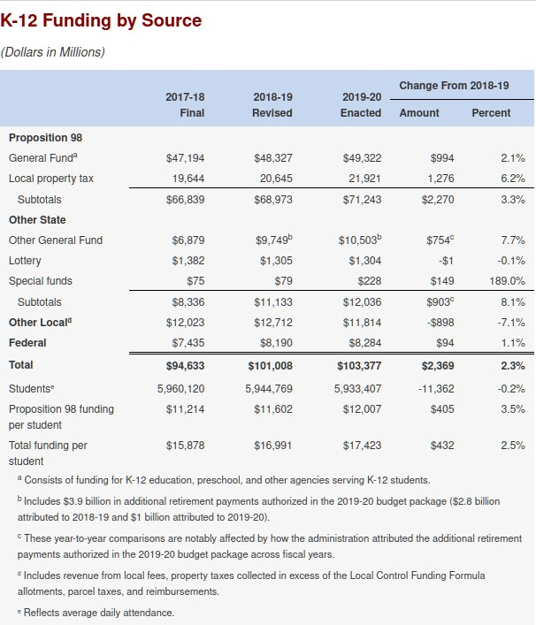

Legislative Analyst’s Office (2021).

the state budget that is allocated to K-12 is governed by Proposition 98. How Proposition

39Transitional Kindergarten (TK) did not exist in 2019, so Figure 1, *California 2019–20 K–12 Funding by**Source*only shows funding for Kindergarten through high school, i.e. K-12.

98 money is allocated to local educational agencies (LEAs) is calculated using a formula known as the Local Control Funding Formula (LCFF).40 LEAs include individual charter schools, county offices of education, and local public school districts. The total amount of funding for TK–14 is calculated using a formula enacted by voters in 1988, since modified, called Proposition 98. That proposition passed as a response to the notorious Proposition 13, which was enacted a decade earlier, and which decimated school funding. Prop. 98 was originally meant to be a minimum guaranteed funding level, but has evolved into a target to be met, i.e. both a floor and a ceiling. The Legislative Analyst’s Office (LAO), which serves as an independent, non-partisan research arm of the California Legislature in much the same way that the Congressional Research Service serves the U.S. Congress, calls Prop. 98 “A Tale of Complexity” and says that “A Plethora Tests and Rules Govern the Minimum Guarantee”, and that “‘[The] State Has Made Myriad Adjustments to the Proposition 98 Calculations” (Kapphahn & Kuhn, 2017, p. 5). Undoubtedly LCFF is complex, but LCFF is more transparent, has fewer rules, is more equitable, and is more responsive to the needs of public school districts that have a high proportion of under-served students than its predecessor, the Revenue Limit System. The Revenue Limit System was also complex, but in a completely difference way because it had many separately funded programs, called categorical programs, each with their own set of requirements, rules, durations, and funding levels. Each passing year saw more programs being added to the set of categorical programs until the entire collection became so unwieldy and so inequitable that the need to replace it was felt by everyone.

The most succinct summary of how LCFF amounts are calculated is provided by the

California Department of Education (CDE) (2023a): Funding entitlements under the LCFF consist of:

40Currently, the LCFF funds transitional kindergarten and community colleges as well as public primary and secondary schools, so it ought to be known as funding grades TK-14. Appoximately 89% of LCFF funding goes to grades TK-12.

1. Grade span-specific base grants based on ADA, that reflect adjustments for grades K–3 class sizes and grades 9–12 (school districts with qualifying schools may receive a necessary small school (NSS) allowance in lieu of the base grants);
2. Supplemental grants equal to 20 percent of the adjusted base grants multiplied by the LEA’s unduplicated percentage of English learners, income eligible for free or reduced-price meals, and foster youth pupils;
3. Concentration grants equal to 65 percent of the adjusted base grants multiplied by an LEA’s percentage of unduplicated pupils above 55 percent;
4. Two add-ons equal to the amounts school districts received in 2012–13 for the Targeted Instructional Improvement Block Grant and

Home-to-School Transportation programs;

1. An Economic Recovery Target add-on; and
2. Beginning in 2022–23, an add-on for current year Transitional Kindergarten ADA.
3. Base, supplemental, and concentration grants, as well as necessary small school allowances, receive cost-of-living adjustments as provided through the annual budget. Beginning in 2023–24, transportation related add-ons and the Transitional Kindergarten add-on will also receive cost-of-living adjustments.”

For the 2022-23 school year, a school41 with 543 pupils total (181 TK–5 pupils per strand and 3 strands), of which 70% are unduplicate pupils, and assuming the maximum size for a classroom with one teacher, the core LCFF calculation (adjusted grade-span base + supplemental + concentration) is as follows:

**Adjusted base grant** (one-time adjustment + COLA + grade-span) x unduplicated count

TK–3: $10,119 × (127 pupils × 3 strands) = $3,855,339 4–5: $ 9,304 × (54 pupils × 3 strands) = $1,507,248

**Supplemental grant** (20% of adjusted base grant) x unduplicated count

TK–3: 20% × $10,119 × (70% × 127 × 3) = $ 538,330

4–5: 20% × $ 9,304 × (70% × 54 × 3) = $ 210,270

**Concentration grant** ((% over 55%) x 65% of adjusted base grant) x unduplicated count

41Loosely based on Discovery Prep which has only 428 students.

|  |  |  |
| --- | --- | --- |
| TK–3: (70% - 55%) × (65% × $10,119) × 127 × 3 | = | $ 375,895 |
| 4–5: (70% - 55%) × (65% × $ 9,304) × 54 × 3 | = | $ 159,829 |
|  |  | ========== |
| total |  | $6,271,016 |

Figure 2, *LCFF Components*diagrams just the major components of the LCFF. It takes the Fiscal Crisis and Management Team’s (FCMAT’s) spreadsheet of 45 individual sheets to specify completely how the LCFF for a particular school or district is calculated (Fiscal Crisis and Management Team, 2024). The intricacies of LCFF funding are also covered in Chapter 3 of Aguinaldo et al. (2022, pp. 35–58).

**Figure 2**

*LCFF Components*

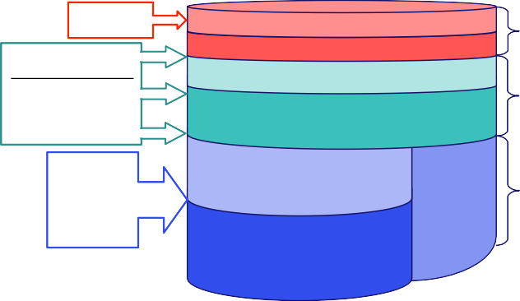12-13 Award Level

Unduplicated Pupil Count English Learners

Low Income Foster Youth

*Targeted Instructional Improvement Block Grant Transitional Kindergarten (TK) Add-on*

Concentration Grant Supplemental Grant

Add-ons

Supplemental & Concentration

Average Daily Attendance

Grade Span Adjustment

Necessary Small School

Adjusted Base Grant

Base Grant

Adapted from “Local Control Funding Formula Resources for School Districts and Charter Schools” at <https://www.fcmat.org/PublicationsReports/LCFF-Calculator.xlsx>

As seen in Figure 1, *California 2019–20 K–12 Funding by Source*on 52, Proposition 98 funding accounts for nearly 70% of California’s K–12 funding, with the remainder coming from local property taxes and fees, and from various federal and state sources. This money is distributed to local educationa agencies (LEAs) which then distribute it to public school districts. Public school districts then distribute LCFF funds to charter

schools located within their district. For community-funded districts (see below), charter schools represent a significan drain on their revenues.42

Some districts are funded outside the LCFF system. These used to be called “basic aid” districts, but since the term is confusing, they are now called “community funded” districts. These are districts where their share of their county’s annual property tax revenue is greater than their annual LCFF entitlement. They get only “basic aid”, i.e. the constitutionally required minimum funding (the greater of $120 per pupil or $2,400 per district) from the state. For districts which are not community funded, the state contribution is the difference between a district’s LCFF entitlement and its share of district property taxes. In other words, the state ensures that each district gets at least its LCFF entitlement, the total amount which is determined by Prop. 98.43.

## Budgets & Interim Reports

For a given fiscal year, the annual budget is the first of four important financial documents produced. Since budgets must be approved before the start of a fiscal year, budgets are actually produced and approved in the prior fiscal year.44 The next two financial documents are two (unaudited) interim reports, one in December, and another in March, which track how well the school or district is adhering to its approved annual budget, adjustments being allowed, and finally, after a certified public accountant has audited the school or district, a comprehensive annual financial report (CAFR) is produced in the fiscal year following the period it covers. State law requires that an independent auditor certify this retrospective account of the school or district’s financial

42For example, LASD sends $10M to the Bullis Charter School (BCS) annually, equivalent to roughly 11% of revenue.

43An invaluable and comprehensive description of K-12 funding in California, for both public school districts and charter schools, can be found in an annual publication from School Services of California, Inc., e.g. *School Funding and Accountability in California: A Guide to K-12 Public School Finance in California*

44Since a school’s budget must be approved before the state’s budget is finalized, it is a certainty that a school district’s budget will need to be modified after it has been approved.

activity as being an accurate representation of the school’s finances for the previous fiscal year.

## Local Control Accountability Plans (LCAPs)

An important, recurring, non-financial report of a school district or a charter school is the Local Control Accountability Plan (LCAP). Although the LCAP is a three-year plan, it is updated annually. The focus of an LCAP is on the programs that a school district or charter school is going to implement, finance, and monitor that will allow the district or school to meet state goals. These goals are set periodically by the California Department of Education to ensure that students with the greatest needs are in fact served, and are in addition to the seven goals that the Legislature has set for charter schools in general.

Typically, LCAP goals remain the same over their three year lifespan, but their financing may change if the metrics used to measure progress toward achieving those goals are not showing progress. In unusual circumstances, how the goals are to be achieved might change. LCAPs are California’s way of ensuring that all public schools, including charter schools, meet the same set of priorities or goals. Apparently, some LCAPs have been on the order of 500 pages long, although the norm is much less.

For each activity or group of activities, schools must indicate what goal is being met, if the goal includes increased services for disadvantaged student, how well the school or district has met that goal, and how much money has been allocated to achieving and reporting those goals. (The reality of what the Department of Education wants is an order of magnitude more complicated than this description, but it is accurate as far as it goes.)

Unlike budgets and CAFRs, LCAPs do not have to “add up”, nor do they have to offer a complete financial picture, but they do have to be consistent with other financial data.

Expenditures have to be budgeted, and the amounts in a school’s budget must agree with what’s in the LCAP. The charter or public school’s board must approve an LCAP at the same time as it approves its annual budget. According to Aguinaldo et al. (2022, p. 81),

while no explicit approval of a charter school’s LCAP is required, chartering authorities may revoke the charter for a school which repeatedly fails to improve student outcomes.

## Comprehensive Annual Financial Reports

The final major source of financial data from charter schools is an annual, independently audited, financial statement called the Comprehensive Annual Financial Report (CAFR). These are sent to the California Department of Education (CDE) and to a charter’s County Office of Education (COE) annually. They cover the previous fiscal year and are similar to annual budgets because they report the same information, but in a format suitable for computer processing. CAFRs are retrospective whereas budgets are prospective. The major difference between budgets and CAFRs is that CAFRs are independently audited and budgets are not.

Similarly to bond underwriters, financial auditors are liable for “omitting, misstating, or obscuring [items which] could reasonably be expected to influence decisions that the primary users make on the basis of those financial statements” (Cayamanda, 2020), and this requirement tends to increase the diligence of the auditors. However, potential liability does not always result in truly comprehensive financial statements; sometimes the lure of accounting fees overwhelms any misgivings, as was the case with Enron and Arthur Andersen in 2001. Errors and sloppiness may exist, but in general, fraud is thankfully rare, in part because fraud on the part of auditors would likely result in the loss of the auditor’s license, effectively ending their business.

# Charter School Financing

In California, charter schools are financed the same way as public schools are, from the same pot of money, using the same set of rules, except for one significant difference: how they finance facilities. Unlike public schools, charter schools have no taxing authority, so they cannot pass bond measures or parcel taxes. This lack of a taxing authority means that charter schools must either occupy existing public school facilities (possibly even displacing existing public school students) or seek grants and donations to

fund non-district facilities, either leased or purchased. The federal government provides significant amounts of money for facilities through the Charter School Program (National Charter School Resource Center, 2020, pp. 0–10). Likewise, the state of California provides support for charter school facilities (Aguinaldo et al., 2023, p. 114).

An in-depth analysis of charter school finances requires a broader lens than one used for public schools because, in addition to all of the financial dealings of traditional public schools, almost all of which also apply to charter schools, every charter school also has a large and immediate need for facilities that traditional public schools do not have. These needs potentially involve bonds, loans, grants, construction, and the purchase, lease, or sale of real estate. Traditional public schools do issue several kinds of bonds, levy parcel taxes, and buy real estate on which they build schools, but they do so infrequently.

Usually public schools have done this years ago, but new charter schools have an immediately and reoccurring need for facilities. They face these needs once when they start up, and whenever they outgrow their facilities because of increased enrollment. The needs of charter schools for facilities and the financing associated with obtaining those facilities is more pressing, more immediate, and more common than the corresponding needs of traditional public schools whose enrollment does not fluctuate as much.45

## Charter School Financial Documents

The challenge for this inquiry will be to organize the financial documents and data collected so that gaps and anomalies can be identified, interesting and valid comparisons can be made with public schools and other charter schools, and the flows of money in and out of Rocketship can be identified. One way of organizing charter school data is chronologically from when they appear.

45Usually a public school district sees a change in enrollment because of significant demographic changes like immigration or emigration, birth rate increases or declines. Charter schools can see large enrollment changes absent any demographic change, even if the total number of students residing in a district stays the same. In some instances, increased enrollment in charter schools comes from public school students switching from the public school system to charter schools. This is what is happening to Oakland, CA and it produces simultaneous but opposite changes in enrollment.

Table 4, *Charter School Financial Documents*, summarizes the official, publicly available, and required financial reports about charter school finances, in chronological order. Note that budgets, interim reports, LCAPs, and CAFRs are also required of public schools.

**Table 4**

*Charter School Financial Documents*

|  |  |  |  |
| --- | --- | --- | --- |
| **Name** | **Description** | **Frequency** | **When** |
| Initial Petition | Comprehensive description | Once | Before opening |
| Renewal Petitions | Similar to initial petition | Every 5 years | Years 5, 10, 15, … |
| Budget | Complete financial plan | Annually | Before June 15th |
| LCAP | How to meet state priorities | Every 3 years | With budget |
| Interim Reports | Current spending | Twice yearly | December, March |
| CAFR | Audited financials | Annually | In the following year |

The first financial statement from a charter school is contained in their initial petition. The purpose of the initial petition is to provide an authorizer with data on the charter school’s educational program, pupil outcomes, methods to measure these outcomes, the charter school’s governance structure, methods of racial and ethnic balancing, teacher and student health and safety, and among other measures.46 Subsequent charter school data makes their apprearance during the school year, and then finally when a certified audit is completed.

All of Rocketship’s schools have both initial and renewal petitions. These are voluminous, but fortunately the financial part is only a small portion of the total number of pages. In addition, a petition may have a corresponding staff report prepared by authorizers which evaluates the petition. These documents, and the others mentioned above are reviewed in the sections which follow.

46Ed. Code §47605 (c)(5)(A–O)

# Petitions & Renewals

Before a charter school may legally begin operations, they must present to a chartering authority a petition which must contain certain required elements, and that petition must be accepted (with or without stipulations.) The absence of one of these elements is grounds for denying the charter’s petition to operate. For example, what is the intent of the charter school? How is the charter school going to measure its success or failure? What population is it targeting? And, what are its financial projections?

One of the required elements of any petition is a financial projection. Although no one expects a charter school (or any public school district for that matter) to prepare and adhere to a budget that exactly matches what’s been projected, budgets are expected to be a reasonable approximation of future revenues and expenses.

Petitions run anywhere from a hundred or so pages to over a thousand and they contain a wealth of financial data. Fortunately, these documents are all publicly available and could, if needed, be the subject of a California Public Records Act (CPRA) request.

The CPRA is the California equivalent of the federal Freedom of Information Act (FOIA). Many of the documents mentioned in this dissertation are available from the California Departments of Education and Finance, or from the Santa Clara County Office of Education.47

Since Rocketship schools are all operated by a single entity, (currently) Rocketship Education, DBA Rocketship Public Schools, a 501(c)(3) non-profit, their financial statements and those of their affiliates are rolled up into a single document, for example, “Rocketship Education, Inc. and Its Affiliates, Consolidated Financial Statements and Supplementary Information, Year Ended June 30, 2022 (with Summarized Financial Information for the Year Ended June 30, 2021)”. Every school is included in this single

47Since these documents are required to be publicly available and may be freely copied, no copyright is applicable.

document, as are separate Launchpad Development LLC’s that actually own the facilities leased to individual schools, plus two divisions provide specialized services.

# Authorizer Staff Reports

Another set of documents that are related to initial and renewal petitions are the staff reports which usually accompany the agenda item which evaluates the charter school’s petition in view of approval. In these reports, the authorizer’s staff presents the findings and rationale for their recommendation to approve or not the petition of the charter school.

# Budgets, Interim Reports, and CAFRs

Once a charter has been granted the right to operate, it must file annually with the California Department of Education, just like public school districts, certain forms that detail its revenues and expenses. State law also mandates an annual audit by an independent accounting firm which charter schools must file with their County Office of Education. All together, these forms should provide a complete picture of a charter school’s finances, and crucially, everything should be in agreement. Charters must approve and publish at a public meeting their annual budget, and they, just like traditional public schools, cannot spend unbudgeted money unless the governing board approves changes at a public meeting.

Interim reports detail the differences between a school’s budgeted revenue and expenses and actual revenue and expenses. Interim reports are filed twice each year in January (covering July - December) and April (covering January - March). As with the annual budget, deviations must be approved at a public meeting.

An independent public accounting firm audits the previous year’s revenues and expenses and this becomes the definitive record of actual revenues and expenses. The textual version of their report is a consolitdated financial statement; the database on which it is based is a SACS (Standardized Account Code Structure) form and, when printed, is called the Comprehensive Annual Financial Report (CAFR) CAFRs are

submitted to the school’s County Office of Education (COE) to be forwarded to the California Department of Education.

# LCAPs

Like public schools in California, charter schools must submit an Local Control Accountability Plan (LCAP) that details how the charter school will meet the eight current state LCFF priorities regarding basic services and school conditions, state academic standards, parent engagement, student achievement, student engagement, school climate, access to a broad program of study, outcomes of a broad program of study (Aguinaldo et al., 2023, pp. 67–68).

The intent of the LCAP is for schools to identify what they need to improve, paying particular attention to underserved groups, and how they plan to improve, and how they will measure improvement.

# Board and Committee Supporting Material

Other sources of financial data are background material, presentations, and other documents that serve as input to board and committee meetings of both public schools and charter schools. Rocketship publishes on their website, as required by California’s Brown Act, agendas and supporting material for its board meetings and for certain committee meetings.48 Currently, Rocketship only provides on its web site meeting agendas and supporting material going back to February 2017. However, they had previously made material available going back to their founding in 2006, and that data was captured before it was deleted and will be part of this study.

# Charter Schools and Real Estate

The last major financial topic of interest has to do with real estate. Since charter schools in California must obtain the facilities they plan to occupy before they receive any

48The Brown Act requires board-appointed committee meetings to be open to the public if they are standing meetings whose subject matter is within the jurisdiction of Rocketship’s board, or if a majority of Rocketship’s board are members of the committee.

per-pupil state funding, real estate looms large in charter school finances. Charter schools have some leeway to choose whether to own or lease, and how to finance the acquisition of facilities, but in the end they must have or access to classrooms, play areas, administrative offices, and athletic fields for their students.

## Facilities Options

As shown in Table 5, *Charter School Facilities Options*, charter schools have three options: co-locate, lease, or purchase (with or without construction of bespoke facilities).

**Table 5**

*Charter School Facilities Options*

Option Description

Co-locate The charter school occupies “reasonably equivalent” facilities provided by the public school district in which the charter school is located.

Lease The charter school occupies facilities that it leases.

Own The charter school buys existing facilities or buys land and builds their own.

Real estate transactions entail numerous, detailed legal documents, many of which are publicly available. If a charter school co-locates, then the terms have to be approved at a open meeting of the public school district in which the charter is located, and those are public documents. If the school’s facilities are leased, and SB740 funds are used to pay part of the rent, then appraisals and the amount of rent should be available from the administator of the SB740 program. Ownership, with or without construction, has even more documents associated with the facility.

# Co-Locating

The least costly option for charter schools is to co-locate in an existing school.

Proposition 39 and enabling regulations49 require that school districts furnish facilities for all in-district charter school students that are reasonably equivalent to those of students in the district in which the charter school resides. Facilities include regular and specialized classrooms, administrative offices, playgrounds, and athletic fields. It does

49Ed. Code §47614 et seq. and 5 CCR § 11969.1

not matter if the school district has unused space or not. It does not matter if the charter school grows in enrollment year over year. The requirement is rigid; school districts are required to furnish reasonably equivalent facilities under Proposition 39. However, districts and charter schools may enter into agreements outside of Proposition 39 concerning what facilities districts will provide to the charter school. Many charter schools choose the co-locating path, with or without a district’s cooperation.

In theory co-locating is the least costly and most timely option for charter schools to obtain facilities, but often there is litigation over the extent or appropriateness of the facilities that the district provides. Sometimes these lawsuits drag on for years, often at a considerable expense for both the charter school and the public school district.

# Leasing

Charter schools may lease their facilities from either a related party such as a 509(a)(3) supporting charity, or at arms length, from an unrelated party. The terms and length of leases vary. If the lessor is an unrelated party, the charter schools may take advantage of grants offered by the Charter School Finance Authority50 which are authorized by Ed.

Code §47614.5 et seq. and CCR §1017051 “to offset annual on-going facility costs for charter schools that service a high-percentage of students eligible for free or

reduced-price meals (FRPM) or located in a public elementary school boundary serving a similar demographic” (California State Treasurer, 2023). The amount of the grant is the lesser of the school’s ADA × $1,420 or the annual rent × 75%.52 To be eligible, 55% of a charter school’s students must be eligible for free or reduced-price meals (FRPM) or be located in a public elementary school boundary serving a similar demographic (California State Treasurer, 2023, §1).

50Originally administered by the Department of Education; now administered by the California State Treasurer.

51aka SB740

52This is the basic calculation. As expected, there are variations and permutations, and these are enumerated in §6, Grant Award Calculations of the program’s FAQ.

If the charter school is leasing from a related party, usually SB740 grants are not available. However, the definition of *related party* in this case does not include non-profit entities whose only business is supporting charter schools. For example, a non-profit charter school may lease a property from a related non-profit entity whose only business is owning and maintaining that property. This is the relationship that Rocketship Education has with the owners of the facilities they lease. The structure of Rocketship Education is diagrammed in Figure 3, *Rocketship’s Corporate Structure for Santa Clara County**Facilities* on p. 72.

# Owning

The third way of obtaining facilities is to own the needed facilities, or to have a related party own the facilities. These might be purchased, or the land purchased and facilities constructed. Most public school districts own their own facilities, but since these were likely bought and built using bond money derived from taxes, charter schools, lacking taxing authority, are unable to pay for their facilities this way. If a charter school’s leadership decides they should own their own facilities, there are a number of ways they can go about this, as shown in Table 6, *Charter School Options for Paying for Facilities*.

# Private Funding: Loans and Foundation Grants

Individuals or non-public entities often loan or give money to charter schools, including Rocketship. Some are outright grants; others are expected to be paid back; still others may be partially paid back and then forgiven. Each grant has its own set of terms and interest rate.

# Venture Funds

The NewSchools Venture Funds53 and the Charter School Growth Fund54 are two examples of venture funds that specialize in charter schools. Since it is unlikely that

* + - * 1. <https://www.newschools.org/>

* + - * 1. <https://chartergrowthfund.org/>

**Table 6**

*Charter School Options for Paying for Facilities*

# Option Source of Funds

Private grants or loans

Private entities (individuals or foundations) may make a grant or a loan to a charter school.

Venture funds Venture Funds which ostensibly intend to make money often loan money to charter schools.

Federal or state grants

Both the federal government and states have programs which offer funds that may be used to pay for existing facilities or for new construction.

Tax credits The federal government offers tax credits for investors whose investments meet certain criteria.

Bonds Charter schools may use the commercial or municipal bond markets to obtain funds, but property or parcel taxes may not be used to pay them off.

investors will invest in a fund that does not return a profit, a future investigation should establish exactly how these funds turn a profit.55

# Tax Credits

Tax credits are often used as a source of funds to buy or construct facilities. For example, the New Markets Tax Credit (NMTC) is a 39% tax credit, usable over seven years, available to those who make an investment in specified economically depressed neighborhoods. This 39% tax credit is can be used to offset federal taxes on other investments. Note that the investment which generates the tax credit may itself also have a return. The NMTC is discussed in more detail in Section 4.3.5, *The New Markets Tax**Credit Program* on p. 86.

# Bonds

All bonds are to some extent risky, some more than others, and purchasers of those bonds are compensated for taking on that risk by being paid interest on the amount

55It is interesting that none of the web sites of these funds mentions that fund’s return on investment (ROI). The absence of any indication of a return on investment is either an innocent mistake or much more likely, an attempt at obfuscation.

borrowed. So, when a bond is issued, the terms (e.g. interest rate, repayment schedule, collateral, etc.) are described in great detail in a prospectus. These prospectuses, in addition to the terms, contain financial information relevant to assessing the risk associated with purchasing that bond. Bonds, after all, are loans, and when millions of dollars are being loaned, those making the loans want to be assured of getting paid back and paid back on time, particularly since charter schools are known to close abruptly.

Bond prospectuses can be mined for data that might not appear in petitions or financial statements because bond underwriters might be liable for representations or omissions in a prospectus which are material. This liability, of course, is not unlimited. If bond underwriters exercise due diligence or the misrepresentation is not material, the underwriters are probably not liable. Crucially, the definitions of *material misrepresentation* and *due diligence* depended on both statute and case law, so a bond underwriter can only make a reasoned guess at their exposure to liability. The result is that bond underwriters are likely to be more diligent than is absolutely necessary.

# Other Data

## State and Federal Filings

Two filings are of particular interest, one with the state, and one with the federal government: FPPC Form 700, Statement of Economic Interests, and IRS Form 990, Return of Organization Exempt from Income Tax. Both forms force the disclosure of personal financial information (Form 700) or personal financial information and business financial information (Form 990).

Some officers of Rocketship may be required to submit annually to the California Fair Political Practices Commission (FPPC) Form 700, Statement of Economic Interests. This particular requirement of charter school officers is not settled law,56 but if Form 700 is

56Rocketship’s initial petition for Mateo Sheedy states that Form 700, Statement of Economic Interest, shall be filed by all board members, candidates for board membership, corporate officers, principals and assistant principals, among others.

filed, it will list the submitter’s assets and income that are related to the position they hold in Rocketship Education or Launchpad Development. The intent is to prevent related-party transactions by enumerating an officer’s economic interests so that a school can avoid doing business with entities that might indirectly benefit an officer. (Of course, direct benefit is absolutely not permitted, and if it occurs, is graft.)

The federal Internal Revenue Service grants income tax exemptions to organizations that meet the requirements of §501(c)(3) of the Internal Revenue Code.57 These organizations must file Form 990 annually that provides some minimal financial data.58

## Curated Social Media

Some web sites maintain data related to Rocketship. For example, the *Scoop.It!* topic, ‘Charter Schools & “Choice”: A closer look’59 is devoted to charter schools in general, but also has material specifically on Rocketship. The now extinct web site, “Stop Rocketship Education Now!”60 was created and maintained by community volunteers. Web scrapes of both of these sites were obtained in case they were deleted (which in fact was the case with “Stop Rocketship Education Now!”).

# Gaps and Anomalies

No financial statement is perfect, and not all are in agreement. But there is a difference between an innocent mistake or omission, and one designed to deceive and mislead. Triangulation can be used to capture gaps and anomalies.

## Triangulation

5726 USC 501, i.e. Title 26, Subtitle A, Chapter 1, Subchapter F Part I § 501(c)(3)

58Tax returns of for-profit organizations are not public documents and their contents do not have to be disclosed; however, in order to sell stock to the public, i.e. to be listed on a stock exchange, firms are required to publish various financial documents, which like bond prospectuses, are required to be informative and complete.

59<https://www.scoop.it/topic/charter-choice-closer-look> 60[http://www.stoprocketship.com](http://www.stoprocketship.com/)

Triangulation is the process of comparing different documents from different sources that contain overlapping topics. The greater the number of sources, the greater the chance of catching gaps and anomalies.

One might ask questions such as:

* Does everything add up?
* Are there important, missing documents?
* How much do these gaps or anomalies matter?
* Are the oddities long-standing or fleeting?

Examples of triangulation might be comparing Rocketship’s LCAPs to their budget, or comparing IRS Form 990 data to their audited financial statements.

# Findings

This chapter presents the results of investigating Rocketship’s finances using the approach outlined in Chapter 3, *Research Design and Methodology*whose goal was to answer this dissertation’s research question: “Has Rocketship structured itself and its finances, to earn a return to investors, focusing especially on real estate, and if so, how?”

The first section presents Rocketship’s corporate structure, a structure that separates Rocketship schools from Rocketship facilities. The next section, Section 4.2, *Rocketship**Locations and Property Information*, details what facilities Rocketship has in Santa Clara County, where those facilities are located, when they were acquired, and what real estate rights Rocketship has in those properties. Then, given Rocketship’s real estate holdings, the third section characterizes the finances of Rocketship that were used to fund the purchase of those properties. The penultimate section reviews what gaps, anomalies and discrepancies were found in Rocketship’s financial data. The final section, Section 4.5, *Issues of Equality and Equity*, looks briefly at issues of fairness.

Note that Rocketship financial data, starting in 2014, are for all of Rocketship Education and Launchpad Development, i.e. for schools and facilities in California, plus those in Tennessee, Wisconsin, Washington, D.C., and Texas.

# Rocketship’s Corporate Structure

One of the original four members of Rocketship’s board of directors was Eric Resnick, a specialist in real estate finance (MarketScreener, 2024). He was expected to “provid[e] a deep understanding of financial management and real estate transactions” (Danner, 2006, p. 13), so it appears that Rocketship’s corporate structure was designed with real estate transactions in mind. From the start, Rocketship has kept schools and their facilities separate. This structure is diagrammed in Figure 3, *Rocketship’s Corporate**Structure for Santa Clara County Facilities*for Rocketship facilities in Santa Clara County.

The parent corporation, Rocketship Education, Inc. (RSED) was formed in California on February 16, 2006 as a 501(c)(3) public benefit corporation under California’s Nonprofit

**Figure 3**

*Rocketship’s Corporate Structure for Santa Clara County Facilities*

**Rocketship Education (RSEA)**

Launchpad Development Company (LDC)

*Launchpad (LP)*

*Launchpad Development One LLC (LLC1) RMS facilities*

*Launchpad Development Two LLC (LLC2) RSSP facilities*

*Launchpad Development Threee LLC (LLC3) RLS facilities*

*Launchpad Development Four LLC (LLC4) ROMO facilities*

*Launchpad Development Five LLC (LLC5) RDP facilities*

*Launchpad Development Eight LLC (LLC8) RSA facilities*

*Launchpad Development Ten LLC (LLC10) RSK facilities development*

*Launchpad Development Eleven LLC (LLC11) RBM facilities*

*Launchpad Development Twelve LLC (LLC12) RFZ facilities*

*Launchpad Development Sixteen LLC (LLC16) RRS facilities*

Rocketship Support Network (RSN)

Rocketship Mateo Sheedy Elementary (RSM)

Rocketship Sí-Se-Puede Academy (RSSP)

Rocketship Los Sueños (RLS)

Rocketship Mosaic Elementary (ROMO)

Rocketship Discovery Prep (RDP)

Rocketship Alma Academy (RSA)

Rocketship Brilliant Minds (RBM)

Rocketship Spark Academy (RSK)

Rocketship Fuerza (RFZ)

Rocketship Rising Stars (RRS)

Public Benefit Corporation Law (California Corporation Code §§5000–10841). RSED owns all the Rocketship schools and Launchpad Development Company, a 509(a)(3)

non-profit public benefit corporation.61. RSED plus the schools plus Launchpad Development Company are known collectively as Rocketship Education and Its Affiliates (RSEA). RSEA is not a recognized corporate entity; it is just a convenient way of referring to all things Rocketship.

Launchpad Development Company owns one non-profit public benefit corporation LLC for each school, generally named “Launchpad Development <number> LLC”, and that entity owns the actual school facilities. In addition, Rocketship has two functional divisions:

* Rocketship Support Network (RSN) which provides management resources, back-office support, and organizational strategy to Rocketship schools
* Launchpad (LP) which provides investment and asset management, and administrative services to Launchpad LLCs

This separation between the operation of schools from the funding of their facilities raises the question of why Rocketship has chosen this structure. Reuting, in Reuting (2023), describes Limited Liability Corporations (LLCs) as “the best entit[y] for holding real estate, no doubt about it. They offer the most liability protection of any entity type out there, and when you’re looking to protect valuable assets, this peace of mind is priceless.”

According to RSEA board documents from 2009 (Rocketship Education, 2009c,

pp. 12–13), four reasons were given for this corporate organization. Without Launchpad and its LLC’s, Rocketship would be taking on liabilities associated with financing or with lawsuits related to the California Environment Quality Act (CEQA), as well as risks associated with financing. Launchpad would also protect Rocketship from cash flow

61A 509(a)(3) corporation is a “charity that carries out its exempt purposes by supporting other exempt organizations, usually other public charities” and “has a relationship with its supported organization sufficient to ensure that the supported organization is effectively supervising or paying particular attention to the operations of the supporting organization” (Internal Reveue Service, 2023, accessed 29 Sep 2023)

fluctuations which might lead to large and unnecessary speculation.62 The third reason specified was that this separation would allow Rocketship to focus on “Great Schools” and Launchpad focus on building “Great Sites”. Finally, a need to increase the market for developers of charter facilities was recognized. At a Board offsite on 23 Jun 2009, these reasons were expanded on significantly in an 18 page presentation, Rocketship Education (2009b).

The vision of Rocketship’s founders was expansive. In an article on Rocketship’s use of New Market Tax Credits (NMTC) to fund Rocketship’s fourth school, Disovery Prep, the authors note, “The organization’s long-term goal is to expand from its seven existing schools to 2,000 schools in 50 cities, serving 1 million students.” (Carlisle & Kovalkoski, 2012, p. 3). Here, one can make two observations. First, recognizing a market need for charter facilities matches this dissertation’s conclusion, and second, this recognition came early in Rocketship’s existence.

# Rocketship Locations and Property Information

According to Rocketship Education (2009c, p. 7), before Launchpad was formed, the Rocketship board itself chose sites for its schools using two principal criteria: Was the proposed location within 1 mile of a PI63 or otherwise low performing school, and did the location qualify under the New Market Tax Credit Criteria (NMTC) that 75% of the student body would receive free and reduced lunch (FRL)? In September 2009, they added two additional criteria. First, would building a school be possible for less than $8M at 5% interest, and second, for a school with a planned enrollment of 450 K-5 students, were there at least 3× that number of potential students within 1 mile or was there compensating interest from families outside the 1 mile radius? These selection criteria appeared very early on in September 2009 and they demonstrate that Rocketship was

62What that speculation might be was not specified.

63A PI is a school under Program Improvement, a designation under Title I, that indicates that the school has failed to show adequate yearly progress for two consecutive years and is therefore subject to improvement or corrective action measures

aware of the NMTC criteria and chose locations for their schools which would meet NMTC criteria.

A list of Rocketship schools in Santa Clara County is listed in Table 7, *Rocketship**Property Information*with details of each property given in Appendix C, *Rocketship’s Santa**Clara Properties*starting on p.151.

**Table 7**

*Rocketship Property Information*

|  |  |  |
| --- | --- | --- |
| **School** | **Address** | **Property Information** |
| Mateo Sheedy | 788 Locust St., San José, CA 95110 | Section C.1, *Mateo Sheedy* |
| Sí Se Puede | 2249 Dobern Ave, San José, CA 95116 | Section C.2, *Sí Se Puede* |
| Los Sueños | 331 S. 34th St, San José, CA 95116 | Section C.3, *Los Sueños* |
| Discovery Prep | 370 Wooster Ave, San José, CA 95116 | Section C.4, *Discovery Prep* |
| Mosaic | 950 Owsley Ave, San José, CA 95122 | Section C.5, *Mosaic* |
| Brilliant Minds | 2960 Story Rd, San José, CA 95127 | Section C.6, *Brilliant Minds* |
| Alma Academy | 198 West Alma Ave, San José, CA 95110 | Section C.7, *Alma Academy* |
| Spark Academy | 683 Sylvandale Ave San José, CA 95111 | Section C.8, *Spark Academy* |
| Fuerza | 70 S. Jackson Ave, San José, CA 95116 | Section C.9, *Fuerza* |
| Rising Stars | 3173 Senter Road, San José, CA 95111 | Section C.10, *Rising Stars* |

# Rocketship’s Finances

## Rocketship Financial Documents

Every year, as required by law, Rocketship issues an independently audited financial statement for the preceding school year. Rocketship, rather than issuing a separate financial statement for each of its affiliates, consolidates them into a single document, typically called *Rocketship Education, Inc. and Its Affiliates Consolidated Financial Statements and Supplementary Information Year Ended June 30, <year>*. Four annual financial statements are reported:

* Financial Position, which corresponds to a business’s balance sheet
* Activities, which corresponds to a business’s income statement
* Cash Flows, which corresponds to a business’s cash flow statement
* Functional Expenses, which is usually only used by non-profits

The four different financial statements for the years 2010–202264 were collected and the data summarized in Table 34, *Consolidated Financial Position, Years Ending 2010–2022*, Table 35, *Consolidated Activities, Years Ending 2010–2022*, Table 36, *Consolidated Cash Flows,**Years Ending 2006–2022*, and Table 37, *Consolidated Functional Expenses (2019–2022)*, in Appendices D – G starting on pp. 174, and online in this dissertation’s *Data Dashboard*, a Google spreadsheet which is incorporated into this dissertation by reference.65

These four annual financial statements allow a detailed view of how Rocketship finances its facilities. Financing charter schools in California is more complicated than the financing of traditional public schools because charters need to obtain facilities often independent from the public school district in which they are located. Table 8, *Charter**School Financing*on p.79 describes what facility financing options a charter school has compared to a traditional public school. Note that ending up with facilities that satisfy a school’s needs may require the purchase of land, the construction of new facilities, or the modification of existing facilities, in addition to operating those facilities. Each of these alternatives may require different financing methods.

In addition to the annual consolidated financial statements, Rocketship Education and Launchpad Development must file an IRS Form 990, a form that all tax-exempt entities must file annually. This form is public information and provides a different point of view than the annual financial statements. Form 990s for non-profits are available on the IRS web site for the tax years 2016 to the present.66

Form 990, according to Fishman is intended to “provide a complete picture of your non-profit—including its activities, finances, governance, compensation, and tax

64The years ending 2006–2008 were rolled up in a single audit statement and was not reported on until 2009, and was restated in 2022 making the year ending 2010 the first “normal” year. Functional expenses for the years 2008–2018 were collected but are not summarized.

1. [https:](https://docs.google.com/spreadsheets/d/1c4akEKFj9bmVfLFQwi7ewMifSjRbrw5xpjh_UjO4oYY/view)

[//docs.google.com/spreadsheets/d/1c4akEKFj9bmVfLFQwi7ewMifSjRbrw5xpjh_UjO4oYY/view](https://docs.google.com/spreadsheets/d/1c4akEKFj9bmVfLFQwi7ewMifSjRbrw5xpjh_UjO4oYY/view)

1. <https://apps.irs.gov/app/eos/>

compliance.” (Fishman, 2022, p. 84) In addition to Form 990 itself (12 pages) there are potentially 16 additional schedules for a total of 80 pages; the instructions for the full 990 run to 300 pages. Rocketship Education and Launchpad Development Company Form 990s are available at <https://apps.irs.gov/app/eos/>and on the GuideStar web site. An analysis of Rocketship’s Form 990 for the years 2005 through 2020 does not reveal any significant anomalies or omissions. However, this might be due to the different form and purpose of a 990 compared to an annual audit. Further investigation to match the data of Form 990 with that of an annual statement is warranted.

## Rocketship’s Financing Alternatives & Models

To illustrate the variety of financing options that could be used, many of Rocketship’s petitions state that they used three different financing options for nine schools as of 2015: “Launchpad successfully financed four of the nine Bay Area Rocketship projects with New Market Tax Credits, four projects by issuing long term tax exempt bonds, and one project through short term private financing.”

Rocketship also prepared a detailed spreadsheet of their financial model, *Current RSED Financial Model 061909* (Rocketship Education, 2009a), that projects earnings and expenses out to the year 2045. This spreadsheet contains a huge amount of data.

Although the number of documents asked for by a Fiscal Crisis and Management Team (FCMAT) audit is much larger, the number of years analysed by Rocketship is significantly longer. The entire spreadsheet is available at [https://docs.google.com/](https://docs.google.com/spreadsheets/d/1e5j8nn2Ofg6l5BlOaPi_qcByGH_OAt232RrvTkoJy2Q/edit?usp=view)

[spreadsheets/d/1e5j8nn2Ofg6l5BlOaPi_qcByGH_OAt232RrvTkoJy2Q/edit?usp=view](https://docs.google.com/spreadsheets/d/1e5j8nn2Ofg6l5BlOaPi_qcByGH_OAt232RrvTkoJy2Q/edit?usp=view)

and is incorporated by reference. Rocketship maintains an archive of its board agends, materials, and minutes at [https://www.rocketshipschools.org/about/](https://www.rocketshipschools.org/about/board-of-directors/board-agendas-archive/)

[board-of-directors/board-agendas-archive/](https://www.rocketshipschools.org/about/board-of-directors/board-agendas-archive/), but it has removed agendas, meeting materials, and minutes prior to 2017. Any meeting material used here prior to that date was collected before Rocketship removed those files.

Also revealing of Rocketship’s early financial thinking is the document, “Financial Narrative” (Rocketship Education, 2010). In it, Rocketship describes the parameters of a typical school from one year before opening to year 10.67 Some observations from that document are:

* Rocketship expects each school to reach breakeven in year 1 of operation.
* Rocketship predicts that student demographics in years 1–8+ will be 70% Free and Reduced Priced Meals (FRPM) with 50% below the federal poverty level. English Language Learners (ELL) will drop from 70% in year 1 to 50% in year 8+.
* The first seven schools are to pay 25% of revenue (less food service sales and reimbursements) in management fees in the year before opening (year -1), dropping to 15% in years 0–3+. Facilities fees start in year 1 and are 20% of revenue (less food service sales and reimbursements). For schools 8+, there are no fees in years -1 through 1.
* Rocketship expects each school to receive $1.1M total in grants in its early years. What is notable about the financing that Rocketship chose was that they were aware that specific student demographics were necessary if they wanted to finance their schools in a particular way, and that they carefully modeled their finances for many years into the future.

## Financing of Charter Schools

In addition to needing revenue to finance operations, charter schools will likely need money to finance the purchase or lease of facilities if they do not avail themselves of district facilities via Prop. 39. Table 8, *Charter School Financing*below lists the major sources of revenue that fund both operations and facilities.

67See also the sheet “RSGen” in the spreadsheet “Current RSED Financial Model_061909 - All Sheets” (Rocketship Education, 2009a) that lays out RSED’s expected finances.

**Table 8**

*Charter School Financing*

|  |  |  |
| --- | --- | --- |
| **Type** | **Available to TSPs Charters** | **Notes** |
| *State funding* |  |  |
| LCFF | Yes Yes | State minimum guarantee |
| Local property tax | Yes No | Reduces LCFF amount |
| Categorical programs | Yes Yes | All state funding outside of LCFF  & all federal programs are categorical. |
| *Local funding* |  |  |
| Local parcel tax | Yes No | District-wide election |
| Bonds | Yes No | Public schools: by district election |

*Federal, state, or private funding*

Bonds Yes Yes Charter schools: private or conduit Public schools:GO bonds & state

|  |  |  |  |
| --- | --- | --- | --- |
| Private grants | Yes | Yes | Much more common with charters |
| Venture fund loans | No | Yes | May use New Market Tax Credits |
| Rent subsidies | No | Yes | By the state (SB740) |
| COVID-19 PPP loans | No | Yes | Paycheck Protection Program |

# LCFF

The Local Control Funding Formula (LCFF) is the principal way California funds public school districts, county offices of education, and community colleges. (Special Education Local Plan Areas (SELPAs) are funded primarily through AB 602, although there is an LCFF component.) Public school districts pass through an amount to charter schools in their district, also calculated using the LCFF. The total amount of funding available for LCFF is governed by Proposition 98 and that amount is calculated depending on economic and demographic factors. The details for when California is in a Test 1, Test 2, or Test 3 year is covered in Aguinaldo et al. (2023, pp. 17–21).

All schools have the same base grant which varies by grade span. If a school, charter or public, has students who are (1) eligible for free or reduced price meals (FRPM), or (2) are English Learners (EL), or (3) are foster youth, the school receives a supplemental grant

of 20% of its base grant for each such student. If the qualifying population of students68 exceeds 55% of the total number of students, a school receives a concentration grant of 65% of the base grant for every student above the 55% threshold. All Rocketship schools are located in high-poverty areas and all have more than 55% of their students in at least one of the three categories that qualify for concentration grants. In sum, Rocketship gets LCFF base grants adjusted by grade span, supplemental grants, and concentration grants as part of it total LCFF funding. An example of the LCFF calculation is given on p. 54.

Rocketship reports LCFF money as “LCFF State Aid & Property Tax Revenue” or “Apportionment revenue” in its Consolidated Statement of Activities for the years 2010-2022 in this dissertation’s Data Dashboard.69 Note that the definitions that Rocketship uses for these two categories of state revenue are not comparable because

California changed funding model from the Revenue Limit system (year ending 1974 to year ending 2013) to LCFF which started in the year ending 2014 and continues to the present.

# Local Property Taxes

In California, commercial and privately owned properties are taxed, unless exempt, typically because they are religious organizations or are charities. School districts receive about 40% of the property tax collected from properties in their home district and this tax replaces an equal portion of LCFF revenue. (If a district’s property tax revenue exceeds what they would have gotten in LCFF funding, they receive no LCFF funding. These districts are called *community-funded districts*, previously known as *basic aid districts*.) Note that the amount that districts pass through from their LCFF allotment to charter schools is independent of whether a charter school is in a community-funded district or not;

68These are unartfully called “unduplicated pupils” because schools do not get extra money for students in more than one category, as perhaps they should.

69[https:](https://docs.google.com/spreadsheets/d/1c4akEKFj9bmVfLFQwi7ewMifSjRbrw5xpjh_UjO4oYY/view)

[//docs.google.com/spreadsheets/d/1c4akEKFj9bmVfLFQwi7ewMifSjRbrw5xpjh_UjO4oYY/view](https://docs.google.com/spreadsheets/d/1c4akEKFj9bmVfLFQwi7ewMifSjRbrw5xpjh_UjO4oYY/view) in the “Consolidated Activities” sheet.

charter schools always receive the full LCFF amount. The Data Dashboard sheet “Consolidated Activities” lists the property tax revenue that Rocketship received from each school’s home district.

# Local Parcel Taxes

Traditional public school district may assess a non-*ad valorem* tax, usually a per parcel tax70 if voters approve. Charter schools do not have taxing authority, so they may not assess parcel taxes. However, public school districts may agree to share some portion of their parcel tax revenue with charter schools within their boundaries, but are not required to do so. Rocketship has no parcel tax revenue.

# Bonds

Bonds, as far as educational institutions are concerned, come in just a few forms71.

These are:

* + - * + General Obligation (GO) bonds are backed by the full faith and credit of the issuer, here a public school district or a charter school. Normally, bonds are secured by assets owned by the borrower, such as real estate, personal property (e.g. an airplane or an oil well), or some other physical asset. Lenders (the purchasers of a bond) are naturally reluctant to lend based on an ephemeral asset like a revenue stream because of the chance that the revenue stream might dry up. The solution for charter schools is conduit borrowing described below.

Unlike public school districts that can pass a bond measure based on the value of the entire district’s assessed property, charter schools have either no real property (if they are leasing) or a very small amount (if they own their facilities), so even if they were allowed to put a bond measure to the voters, the GO debt limit of

70A 2023 court decision allowed a tax based on square footage because it is also a non-*ad valorem* tax.

71A complete discussion of the various forms, constraints on, and capabilities of governmental debt in California can be found in **CDIAC2023** (**CDIAC2023**)

1¼% of their facility’s assessed value would provide very limited funds. For example, an $80M valuation would be required to be able to issue a $1M bond.

* + - * + Tax and Revenue Anticipation Notes (TRANs) and Revenue Anticipation Notes (RANs) are backed by specific forms of revenue. These bonds are normally issued to smooth out state and local revenue streams and are of short duration.
        + Conduit Bonds are a type of tax-exempt municipal bond issued by a government agency (the conduit lender) that is neither the borrower nor the purchaser. This entity or agency serves merely as a conduit between a borrower (often called the conduit borrower) and the purchaser of the bond (i.e. the lender). The conduit lender administers an offering by loaning to the borrower money it has received by issuing a bond which was bought by the lender. Often the funds come from a government agency, e.g. the California Municipal Finance Authority or the California School Finance Authority. The bond is an obligation of the conduit borrower, not the conduit lender, even though the conduit lender issued the bond. The conduit borrower’s payments to the conduit lender are sized to meet the payments that the conduit lender needs to repay the purchaser(s) of the debt. The IRS publication “Publication 5005: Your Responsibilities as a Conduit Issuer of

Tax-Exempt Bonds” details has some helpful information on conduit bonds and tax compliance.

For example, in 2014, the California Municipal Finance Authority issued Series 2014 A & B bonds for $32,915,000. These bonds were bought by Approved Institutional Buyers, and the proceeds were loaned to Launchpad Development Company which used them for public benefit. The conduit borrower is Launchpad Development Company, and the conduit lender is the California Municipal Finance Authority. The lenders are Approved Institutional Buyers, and the conduit borrower, Launchpad Development, pays principal in interest to the conduit

lender, the California Municipal Finance Authority, which passes the payments on to the lender, Approved Institutional Buyers.

This dissertation’s Data Dashboard72 shows that Rocketship issued bonds totaling over $200M from 2011 to 2022. In addition, in the years ending 2008 through 2011, Rocketship borrowed at least fifteen times before issuing a bond. Table 9, *Rocketship Bonds*on p. 84 lists all the bonds issued by Rocketship or Launchpad from 2011 through 2022.

Lines 64-86 of this dissertation’s Data Dashboard show that as of June 30, 2022, the total that Rocketship Education and Affiliates owed was $186,550,566, or just over $32K per child.

# Private Grants

Rocketship lists a total of $78,387,835 as “Contributions” from 2010 through 2022 (see line 11 of Table 35, *Consolidated Activities, Years Ending 2010–2022*in Appendix E on p.179). Unfortunately, the terms of those contributions are not available. It is difficult to tease out what is an unrestricted grant, what is a restricted grant, what is a forgiven loan, and what has been rolled over or consolidated given what data is publicly available. But, what is known is that Reed Hastings and the Walton Family Foundation each promised $250K per school for schools two through seven. An additional $600K, again per school, of federal funding through Title V was available. Each school thus gets $1.1M in startup grants.

# Venture Capital Funding

Rocketship has made extensive use of loans and grants from venture capital funds.

Most of these loans were forgiven, in one way or another, turning them into grants. To be forgiven, some benchmarks related to student outcomes need to have been met and almost always were. Table 10, *Venture Capital Funding*summarizes Rocketship’s

72[https://docs.google.com/spreadsheets/d/1c4akEKFj9bmVfLFQwi7ewMifSjRbrw5xpjh_UjO4oYY/](https://docs.google.com/spreadsheets/d/1c4akEKFj9bmVfLFQwi7ewMifSjRbrw5xpjh_UjO4oYY/edit?usp=view) [edit?usp=view](https://docs.google.com/spreadsheets/d/1c4akEKFj9bmVfLFQwi7ewMifSjRbrw5xpjh_UjO4oYY/edit?usp=view)

**Table 9**

*Rocketship Bonds*

|  |  |  |  |
| --- | --- | --- | --- |
| Name | Amount | Interest Rate | Due Date |
| Series 2011A | $9.600M | 8.5%–9% | Dec 2041 |
| Series 2011B | $0.515M | 8.5%–9% | Dec 2018 |
| Series 2012A | $9.105M | 6.25% | Jun 2042 |
| Series 2012B | $0.355M | 8.5% | Jun 2016 |
| Series 2014A | $31.935M | 6.00%–7.25% | Jun 2018,24,35 |
| Series 2014B | $0.920M | 6.00%–7.25% | Jun 2016 |
| Series 2015A | $6.135M | 4.25% | Mar 2028 |
| Series 2015B | $0.250M | 4.25% | Jun 2016 |
| Series 2016A | $28.080M | 4.25% | Mar 2046 |
| Series 2016B | $0.525M | 4.25% | Jun 2016 |
| Series 2017A | $23.098M | 4.50%–6.25% | 2027–2052 |
| Series 2017B | $3.665M | 4.50%–6.25% | 2025 |
| Series 2017C | $7.160M | 4.50%–6.25% | 2040 |
| Series 2017D | $0.250M | 4.50%–6.25% | 2019 |
| Series 2017E | $7.740M | 4.50%–6.25% | 2047–2052 |
| Series 2017F | $0.250M | 4.50%–6.25% | 2019 |
| Series 2017G | $15.560M | 4.05%–6.00% | 2025–2053 |
| Series 2017H | $0.665M | 4.05%–6.00% | 2022–2025 |
| Series 2019A | $28.075M | 5.0%–5.3% | 2029-2056 |
| Series 2019B | $0.935M | 5.0%–5.3% | 2020-2023 |
| Series OG2021A | $14.780M | 4.0% | 2022–2035 |
| Series OG2021B | $0.465M | 4.0% | Jun 2022 |
| Series OG2022A | $27.195M | 4%–4.375% | Jun 2022–2042 |
| Series OG2022B | $0.795M | 4%–4.375% | Jun 2023–2024 |
| Total 2010-2022 | $218.053M |  |  |

borrowings. The details are available in Rocketship’s annual audited financial statements and are also summarized in this dissertation’s Data Dashboard.

**Table 10**

*Venture Capital Funding*

|  |  |  |  |
| --- | --- | --- | --- |
| **Year** | **Name** | **Amount** | **Interest Rate** |
| 2010 | Charter School Growth Fund | $3.400M | 3.25% |
| 2012 | Charter School Growth Fund | $1.000M | 4.00% |
| 2013 | Charter School Growth Fund | $0.125M | 1.00% |
| 2013 | Charter School Growth Fund | $0.500M | 1.00% |
| 2013 | CSGF Revolving Facilities Loan | $0.125M | 1.00% |
| 2014 | Charter School Growth Fund | $0.500M | 1.00% |
| 2014 | CSGF Revolving Facilities Loan | $7.000M | 3.75% |
| 2016 | Charter School Growth Fund | $0.300M | 1.00% |
| 2016 | CSGF Revolving Facilities Loan | $2.700M | 3.75% |
| 2017 | Charter School Growth Fund | $1.000M | 1.00% |
| 2019 | Charter Impact Fund | $7.300M | 4.40% |
| 2010–2019 | Total | $23.95M |  |

# Rent Subsidies

The last big source of revenue for Rocketship are the rent subsidies that the State of California offers through SB740. Lines 113–232 of this dissertation’s Data Dashboard list 12 years (2011–2022) of subsidy that total over $43M. In recent years, SB740 adds over $5M annually to Rocketship’s revenue stream regardless of whether the facilities have been fully paid off or not. Note also that SB740 subsidies will continue until either the law is changed or Rocketship goes out of business.

## Debt

Rocketship has borrowed over 50 times since its founding in 200673 and their annual, consolidated financial statements provide debt summaries starting in 2012. The total debt at year end (June 30th) is shown in Table 11, *Total Debt, 2012-2022*on p. 86. Overall,

73Full details of Rocketship’s borrowings are in this dissertation’s Data Dashboard in the tab *Dashboard*

starting on lines 10–63.

debt increased by an average 15.71% per year since 2012 for an overall increase of nearly 400%.

**Table 11**

*Total Debt, 2012-2022*

|  |  |  |  |
| --- | --- | --- | --- |
| **Year** | **Total Debt** | **Increase**  **Year-over-Year Cumulative** | |
| 2012 | $47,046,048 | - | - |
| 2013 | $57,078,166 | 21.32% | 121.32% |
| 2014 | $88,383,082 | 54.85% | 187.87% |
| 2015 | $75,904,098 | -14.12% | 161.34% |
| 2016 | $104,857,696 | 38.14% | 222.88% |
| 2017 | $136,652,562 | 30.32% | 290.47% |
| 2018 | $129,391,897 | -5.31% | 275.03% |
| 2019 | $163,598,844 | 26.44% | 347.74% |
| 2020 | $168,701,124 | 3.12% | 347.74% |
| 2021 | $196,416,045 | 16.43% | 417.50% |
| 2022 | $186,550,566 | -5.02% | 396.53% |

## The New Markets Tax Credit Program

One form of debt that Rocketship has used numerous times is the New Markets Tax Credit (NMTC) program. This is one of six programs offered by the Community Development Financial Institutions Fund (CDFI Fund) of the U.S. Department of the Treasury. In essence, the NMTC program offers a 39% tax credit on qualified investments in “Low-Income Communities”. The credits are spread out over 7 years: 5% of the amount invested for the first 3 years, and 6% for the remaining 4 years. These credits can be applied to federal income taxes due, typically from other investments.

# The Benefits of the NMTC

The NMTC offers three benefits for investors in charter schools operating in economically depressed areas. First, there is the tax credit of 39% of the investment. Second, the investment itself offers a return, and thirdly, NMTC investments have lower risk than regular investments.

# How NMTC Works

An example will help make it clear how the NMTC works. Suppose we have a high wealth individual with a marginal tax rate of 37% (the highest bracket), and suppose that this high wealth individual gets a 10% return per year on their investments. Further, suppose this individual has $2,351,000 to invest. The investor could divide that amount into a $1,000,000 NMTC investment and $1,351,000 investment in something other than a qualified NMTC investment.

In the NMTC-qualifying case, every year for the first three years, the investor has a profit of $1,000,000 *×* 10% = $100,000, and this generates an income tax due of $100,000 *×* 37% = $37,000. The investor’s net profit is then $100,000 - $37,000 = $63,000 per year or

$63,000/yr *×* 7 years = $441,000 total net of taxes on a $1,000,000 investment. But the investor also has yet to use the NMTC of 39% on the $1,000,000 investment which is

$50,000 for the first three years and $60,000 for the remaining four years.

In the non-qualifying investment, the investor has $1,351,000 *×* 10% return *×* 37% income tax = $50,000 tax due, which is equal to the tax credit of the NMTC case. The investor also has the return on the investment used to generate the tax due: $1,351,000 *×* 10% = $135,100 for each of the first three years. If the high wealth individual then invests an additional $271,000, bringing the total investment to $1,622,000 in years 4–7, this will generate a tax due of $60,000/yr which will be offset by the NMTC. The high wealth individual would get a total return net of taxes of ($135,000 *×* 3) + ($162,000 *×* 4) =

$1,054,100 on an investment of $1,000,000 + $1,351,00 + $271,000 = $2,622,000. This is a total, tax free return of 40.202% over 7 years. This is equivalent to a taxable return of 40.202% ÷ 0.63 = 63.81% over 7 years. Annually, in simple interest, this is 9.12% per year, up from 6.3% (10% - 3.7%) the investor would have otherwise gotten, a 44¾% increase in return.74

74This analysis does not take into account the time value of money. If it did, the analysis would be more complicated, and the calculated returns would be higher.

Incentives like these make the NMTC popular. The tax credit investment is nearly without risk because the tax credit is guaranteed as long as the charter school remains open. If the school stays open for seven years, the risk is nearly zero.

## Rocketship’s Worth

Rocketship’s net worth has changed over the years. It has always been positive as seen in Table 12, *Net Assets, 2010–2022*on p.88, although it has risen in some years and fallen in others, sometimes considerably so. Rocketship’s Compound Annual Growth Rate (CAGR) started with a stratospheric 300+% and then gradually fell to a merely excellent 25–30% starting in 2017, a rate of return that would matches the rate of return expected by venture funds or private equity firms (Lord & Mirabile, 2018, p. 87). This CAGR has been obtained with very little funding from the founders according to annual financial audits, where very little might actually be zero.

**Table 12**

*Net Assets, 2010–2022*

|  |  |  |  |
| --- | --- | --- | --- |
| **Year** | **Net Assets** | **Year-Over-Year Increase** | **CAGR** |
| 2010  2011 | $2,218,964  $9,212,140 | 315.16% | 315.16% |
| 2012 | $11,933,099 | 29.54% | 103.75% |
| 2013 | $15,881,210 | 33.09% | 92.71% |
| 2014 | $13,356,528 | -15.90% | 56.63% |
| 2015 | $10,562,747 | -20.92% | 36.62% |
| 2016 | $16,931,464 | 60.29% | 40.31% |
| 2017 | $17,536,163 | 3.57% | 34.36% |
| 2018 | $20,883,606 | 19.09% | 32.36% |
| 2019 | $24,084,572 | 10.12% | 30.34% |
| 2020 | $24,617,294 | 2.21% | 27.21% |
| 2021 | $38,231,318 | 55.30% | 29.54% |
| 2022 | $33,442,645 | -12.53% | 25.37% |

# Gaps, Anomalies, and Discrepancies

This section is concerned with what was not found during this dissertation’s investigation. Gaps are where data were expected, but none were found. Anomalies are

where data were found, but differed from what were expected, and discrepancies are where data were found but conflicted with other data.

In an enterprise as large as Rocketship is now (with a $190M+ budget in 2022), there are bound to be unintentional gaps, anomalies, and discrepancies without any implication of nefarious intent. Further, as Berman and Knight emphasize, accounting involves making assumptions, estimates, and judgment calls; it is not an exact science. They say, “The art of accounting and finance is the art of using limited data to come as close as possible to an accurate description of how well a company is performing.” (Berman & Knight, 2013, pp. 4–5). So, the mere existence of gaps, anomalies, and discrepancies is not an indication of fraud. Fraud is deliberate, but gaps, anomalies, and discrepancies occur because of differing assumptions, simple oversight, recording errors, or (unfortunately) incompetence.

## Gaps

Gaps are where data were expected, but not found. No significant gaps were found.

## Anomalies

Anomalies are where data were found, but were not what was expected. Several anomalies were found in the analysis of Rocketship’s finances.

* It appears that the Rocketship Business Committee only reviews and approves already signed checks in excess of $100K rather than reviewing and approving purchase orders (i.e. before approval and signature). It is not known if those checks have already been sent to their respective payees when they are reviewed and approved by the Business Committee.
* The audited financial statements use a level of materiality ($300K) that is three times higher than that used by a public school district (LASD) whose budget is half the size of Rocketship’s, i.e. Rocketship’s level of materiality is 50% higher than

expected when compared to LASD’s level if one assumes that the level of materiality is proportional to expenses.

The level of materiality is set by the auditor based on the auditor’s experience and is a reflection of the amount below which the auditor feels is not worthwhile to examine. The various documents consulted (Fiscal Crisis and Management Team, 2020; Education Audit Appeals Panel, 2023) do not specify a required level of materiality, so the only point of comparison is the level used by the Los Altos School District.

* Administrative expenses, compared to total expenses, seem unusually high. Using functional expenses from the 2021-2022 school year as an example, Rocketship spent $151,416,849 on educational programs, $33,683,700 on program support, and

$46,401,574 on management and general expenses. The management and general expenses are thus approximately 30% of what was spent on educational programs. In 2013, the Rocketship Business Committee rolled out a school revenue and expense model where individual schools are charged 35% of revenue in fees, consisting of a 15% management fee and a 20% facility fee (Mukhopadhyay, 2013, p. 28).

* The functional expenses that Rocketship has chosen to use in their financial statements differ from the list used in IRS Form 990, Part IX. This makes it nearly impossible to cross check (triangulate) data from Form 900 and the audited annual financial statements.
* For the years ended 2019–2022, accounting expenses were $166,059 in 2019, more than doubling to $423,683 in 2020, roughly halving to $264,784 in 2021, before more than tripling to $848,221 in 2022. No mention is made of these large swings totaling about $1.6M over four years in accounting expenses in the *Notes to Consolidated Financial Statements*. The concern is not so much the amount as the variance,

although the imputed hours is large: Over the four year period, they average from over 1,000 hrs/year at $350/hr to over 10,000 hrs/year at $150/hr.

* In 2022, a total of $2,635,011 was spent on travel which is over $200,000 per month. This represents perhaps 50 cross-country business class flights per month ($1500/flight with a five day stay at a five-star hotel at $500/night). More modest flights and hotel ($500 + 5×$300) allow 100 trips per month. No explanation either for the need for this much travel or its cost was provided in the *Notes to Consolidated Financial Statements*, especially given the now normal use of Internet-based video conferencing software. An argument could be made that swings this large are material and so must be explained.
* In general, Rocketship spents more per student than their comparable home public school district in Santa Clara County does. This is unusual because, again in general, Rocketship schools have a higher student-to-teacher ratio than surrounding districts. Further unexplained is why Rocketship has a higher cost per student than public schools in the charter’s home district. (See the data for the years 2014-2023 in Santa Clara County Office of Education, 2014–2023.) Charter schools were supposed to be more efficient than public schools because they did not have to adhere to costly regulations required of public schools. Further investigation is warranted.
* Venture capital funds are supposed to earn a return for investors in the fund. Yet all? most? many? of the venture funds listed in Table 10, *Venture Capital Funding*on

p. 85 foregave the loans if certain conditions were met, making those investments a total loss for the venture fund investors. None of the *Notes to Consolidated Financial Statements* comment on this anomaly. Perhaps the financial statements of those venture funds have an explanation that a future investigation could uncover.

## Discrepancies

Discrepancies are where two or more sources of the same data differ when they ought to agree.

The following discrepancies were found:

* The annual audited financial statements have several entries which also appear in the IRS Form 990, the federal tax return for organizations exempt from income tax,

i.e. charities, religious organizations, private foundations, some political organizations, and other non-profits. For example, on June 30, 2015, the Consolidated Statement of Financial Position for 2014-2015 shows net assets to be

$10,562,747 (p.3) whereas the Form 990 (2014) show them to be $13,968,882, a 32% difference. Analysis of this discrepancy is limited and is insufficient to determine if the difference is the result of differing accounting practices or is a reflection of a more serious underlying problem.

Similar discrepancies also exist for functional expenses, among other categories.

* For year 2018–2019, salaries are shown as $54,294,263 on the audited statement of functional expenses. Yet, adding lines 5 (executive compensation), 7 (other salaries), 8 (pension plan), and 9 (other employee benefits) from Form 990 (2018–2019) yields $54,516,782 which is close, but not quite the same as the amount shown in the audited statements. Further, it is not even clear that those lines and only those should sum to the same amount as “Salaries” in the audited statement of functional expenses. For example, should pension obligations be counted as part of salaries? In public school districts, pension obligations are recorded separately although they are often characterized as deferred salary (Kagan, 2022).
* The total contributions (i.e. donations, grants) for all Rocketship schools in 2021-2022 is listed as $7,075,182. The sum total of Object Codes 8980-8999 (Contributions) for all ten Santa Clara County Rocketship Schools is $3,326,893.

These two numbers are clearly not the same, but neither are the schools covered. The first consists of all 23 Rocketship schools in the U.S.; the latter consist only of ten schools in Santa Clara County. Considerable work beyond the scope of this investigation would be needed to determine if all the reported contributions agree.

The SACS Object Codes 8980-8999 are where contributions are recorded in

Rocketship’s unaudited actuals and reported to the California Department of Education. The Department of Education makes available a Microsoft Access database with data for specific object codes or groups of object codes for every charter school in California. Summing each school’s Object Code 8980-8999 for a test year (YE2020) does not agree with what’s is reported on line 11 of Rocketship’s Consolidated Statement of Activities for that year, nor does it agree with what was reported on Rocketship’s IRS Form 990 that year.

Several questions remain: Are the differences merely the result of variations in

accounting practices of the California Department of Education and the IRS? Or, are the differences choices that Rocketship has made? And if so, why? One final question: the entries for Object Codes 8980-8999 are the only entries which have the form of a positive number under “restricted” and an identical number, but negative, under “unrestricted”. The total is naturally zero, which begs the question of what exactly is being reported.

# Issues of Equality and Equity

Ostensibly, equality and equity are at the heart of why Rocketship exists. Their vision is to “eliminate the achievement gap in our lifetime” (Rocketship Education, 2017).75 Their mission is to “catalyze transformative change in low-income communities through a scalable and sustainable public school model that propels student achievement, develops exceptional educators, and partners with parents who enable high-quality public schools

75Uncharitably, depending on whose lifetime Rocketship is referring to, the elimination of the achievement gap could be 30–60 years out. If so, included in this span of years is at least one pandemic, one major earthquake, several depressions or recessions, several wars, and numerous government shutdowns.

to thrive in their community.” (Rocketship Education, 2017) These are laudable goals, but not unique to Rocketship. Other charter schools and other public schools have similar goals.

At a high level, Rocketship spent in 2021-22 (based on the *Santa Clara County 2022-2023 Annual Charter Schools Data Book* which is the latest available) on its eight Santa Clara County authorized schools between $16,128 and $23,995 per pupil which is from $2,090 less than that school’s comparable district to $5,777 more. Six out of eight schools spent more per student than their comparable district did (Santa Clara County Office of Education, 2014–2023).

Rocketship locates all of its schools in high poverty areas76 where chronically underfunded public schools struggle to provide a quality education to all. Had Rocketship schools not been located in a high poverty area, investors would not have been able to take advantage of the NMTC program. Despite being located in high poverty areas, Rocketship claims that its elementary schools are among the best in the nation (Abousalem, 2021) because their API or CAASPP test scores are higher than their surrounding district and higher than the California average. However, an argument can be made that all Rocketship can actually claim is that their students are among the best standardized test takers in the nation; there is no evidence that Rocketship students who continue their education (middle school, high school, college, university) do any better than public schools students. As previously mentioned, Lubienski and Lubienski (2014) have shown that the NAEP test results of public schools are higher than those of charter schools, all things considered. Of course this does not mean that Rocketship could not be an outlier whose students do better in the long run than those of other public or charter

76High poverty areas are defined as areas where 20% live in poverty or where the median family income less than 80% of the area median family income(Community Development Financial Institutions Fund, 2020, pp. 13–14)

schools, but the only evidence that has been presented is Raymond et al. (2023). Like other CREDO publications, the findings of Raymond et al. (2023) have been disputed.77

The evidence that children learn more when in front of computers is decidedly mixed.

Some meta-analyses report positive outcomes, but small effect sizes. It has, however, been known for years that virtual charter schools (100% computerized) almost universally fail to perform better than schools using a blended approach or those with 100%

teacher-led instruction. These issue were discussed in Section 2.4.3, *Types of Instruction*on

p. 27.

In 2023, Rocketship teachers, on average, have barely more than three years of teaching experience (Santa Clara County Office of Education, 2014–2023). In comparison, San José Unified School District (SJUSD) has 81.1% of its teachers with more than three years of experience (U.S. News and World Report, 2023). Further, no Rocketship school authorized by the Santa Clara County Board of Education (SCCBOE) has an average teacher salary that exceeds $70,000, whereas SJUSD’s average salary is just shy of $90,000. SCCBOE-authorized charter schools have on average a 30% annual teacher attrition rate (Santa Clara County Office of Education, 2014–2023), a phenominally high rate. In 2014–2015 and 2015-2016, Rocketship reported in a bond prospectus that roughly one-third of its teachers did not return the following years (Charter School Finance Authority (CSFA), 2017). Given these figures, it would indeed be extraordinary if Rocketship schools did substantially better than their home district. A more likely reason for their (initial) successes is that the early cohorts at a school have the

77Stanford University’s CREDO (Center for Research on Education Outcomes) makes the case that “from 2015 to 2019, the typical charter school student in our national sample had reading and math gains that outpaced their peers in the traditional public schools (TPS) they otherwise would have attended”.

Reviewing the lastest CREDO report for the NEPC, Joseph Ferrare said, “[This] CREDO report compares charter school students’ learning in reading and math to students in traditional public schools. The report should be approached with caution by policymakers given the nonexperimental design that renders it unable to fully account for the factors that drive families to choose charter schools. In addition, the report presents its findings using an unconventional metric that makes it difficult to understand the policy implications, potentially misleading policymakers. The magnitude of the main findings fails to meet the minimum threshold experts consider to be a meaningful educational intervention.” (Ferrare, 2023)

most engaged and supportive parents who have high expectations for their children’s academic achievement. One would expect that over time that both scores and enrollment would regress to the mean, and that’s exactly what appears to have happened (Santa Clara County Office of Education, 2014–2023).

Rocketship, whose explicit goal is to close the achievement gap, claims on their web site, that their students “receive 5-7 Additional *Months* of Learning” [emphasis added] (Rocketship Education, 2023). This is not what is reported in Raymond et al. (2023).

Raymond et al. (2023, p. 132) shows Rocketship’s estimated annual growth in reading and math to be 0.166 and 0.239 respectively. For a standard 180 day year (in California), this is just under 30 days growth in reading and just over 43 days in math, neither are anywhere near the 5 to 7 months as claimed.

The CREDO report also claims that Rocketship is a “Gap Buster” CMO, where “Gap Buster” is defined as “moved their achievement ahead of their respective state’s average performance.” (Raymond et al., 2023, p. 14). The report claims that “… more than 1,000 schools [in the U.S.] have eliminated learning disparities for their students” (Raymond et al., 2023, p. 14) which may or may not be true because the comparison is not an

all-else-equal comparison, i.e. it is not commensurable. As Ashworth et al. (2021, p. 16) say, “Failure to respect all-else-equal conditions is the most important source of incommensurability.” The claim is only true if the demographics of a charter school and its home district are the same, and there are valid reasons to believe they are not: Rocketship schools are deliberately located in areas where poverty is higher than the district average.

# Discussion

This dissertation’s research question (p. 7) is: “Has Rocketship structured itself to earn a return for its founders and investors, focusing especially on its real estate transactions?” This question can be parsed into three sub-questions:

1. Has Rocketship structured itself to make a profit?78
2. If so, is real estate the vehicle that Rocketship uses to make money?
3. Is this Rocketship’s intent?

After a careful examination of Rocketship’s finances, it appears that Rocketship has, in fact, deliberately structured itself to make a profit using real estate as the means of generating that profit. However, a key finding is that the analysis of Rocketship’s *publicly available* financial documents show that any profits derived from operations of the schools appear to have been legally obtained and there is no evidence that these profits have been distributed to private persons, at least in California. But since some portion of these profits have been used to open non-profit charter schools in other states, no definitive finding can be made about the ultimate beneficiaries of these funds without further investigation. Some questionable expenditures were identified, namely $7.5M spent on travel in 2019–2022. This is a large sum, and should also be investigated.

The absence of evidence of illegal activity by Rocketship is fortunate because California is notorious for charter school fraud. In 2015, three advocacy organizations found $81M in fraud Center for Popular Democracy et al. The report, *Risking Public Money: California Charter School Fraud* estimated in 2015 that, “The vast majority of this fraud perpetuated by charter officials will go undetected because California lacks the oversight necessary to identify the fraud.” (Center for Popular Democracy et al., 2015, p. 2). A massive fraud was, fortunately, discovered in 2019: A single online charter school had defrauded the State of California of $400M. With tens billions of dollars of funding for

78Public benefit corporations (non-profits) are allowed to make a profit, i.e. revenue exceeds expenses; they are, however, not allowed to *distribute* that profit. Any profit must be use to further is public benefit purpose identified in their articles of incorporation.

charter schools in California alone coupled with lax oversight, the temptation for fraud must be great.

The next section presents an answer to this dissertation’s research question. How that will be done is based on work done by Stephen Toulmin, a British philosopher interested in moral reasoning (Toulmin, 2003). He developed in *The Uses of Argument* a method for making practical arguments where ethics and morality played a role. Toulmin arguments have been widely adopted.

# Answering the Research Question

This dissertation’s claim and conclusion is that Rocketship is structured and operates to leverage government funding (loans, grants, credit repair) which increases their real estate holdings, and this in turn allows them to open more charter schools. It does not appear that Rocketship is distributing profits to private parties such as its founders or investors.

This claim is the result of an extensive analysis of Rocketship’s financial documents and board meeting packets. These show the extent to which Rocketship’s leadership focuses, not on the academic success of its students, but rather on making sure that every Rocketship school is profitable. Rocketship’s current assets, i.e. assets readily convertible into cash, have steadily increased from nearly $9M in 2010 to over $90M in 2022. This is a sizable war chest.

Right from the beginning, Rocketship’s founders separated the financing, acquisition, and operation of their facilities from the pedagogical side of running a school. The founders borrowed heavily and made extensive use of government programs to fund their real estate projects. Rocketship’s Santa Clara schools have not used alternative ways of acquiring facilities. They have not used Proposition 39 to obtain classrooms and fields from a school’s home district. They have not tried to convert commercial office space into classrooms. They have not modified existing buildings to serve as schools or classrooms. Instead they bought land and built schools.

Rocketship’s policy of owning its facilities has led it to accumulate over $185M of debt as of 2022, which comes to roughly $32K per child. If that debt costs 3% yearly to service, that is another $5.4M per year that is not going directly toward educating children.

Rocketship could have rented facilities with the rent being three quarters covered by SB 740 funds. In fact, the State of California does cover three quarters of the rent, but that rent goes to pay off loans taken out to purchase property owned by Launchpad Development.

This focus on real estate shows up in the topics that the Rocketship Board and subcommittees discuss in meetings. Overwhelmingly, Rocketship’s leaders and administrators met to discuss finance and real estate rather than curriculum or student achievement. An examination of the board meeting agendas for the first three years (2006–2009) show that no more than one out of five discussion topics concerned curriculum or student achievement. Judging just by the name of the board documents for the years 2020–2022, only 12 out of 108 (*≈*11%) were achievement related. Of the four board subcommittees (Achievement, Business, Executive, Development) three are focused on something other than student success.

Since Rocketship Education and Launchpad Development, as non-profit public benefit corporations, cannot distribute their income or assets to individuals or to for profit entities according to California law, IRS Code, and their Articles of Incorporation, Rocketship’s leadership likely had a different goal than enriching individuals. Rocketship Education’s Amended and Restated Articles of Incorporation (2022) contains language that prohibits private enrichment. The language below taken directly from Rocketship Education (2022), clearly prohibits private enrichment.

* Article II. PURPOSE

“A. [Rocketship Education] is a nonprofit public benefit corporation” “not organized for the private gain of any person.”

* Article III. TAX-EXEMPT STATUS

“B. No part of the net earnings of this corporation shall inure to the benefit of, or be distributable to, any officer, director, or other private person, except that this corporation shall be authorized and empowered to pay reasonable compensation for services rendered and to make distributions in furtherance of its exempt purposes.”

* Article IV. IRREVOVABLE DEDICATION OF PROPERTY

“A. The property of this corporation is irrevocably dedicated to charitable purposes” “and no part of the net income or assets of this corporation shall ever inure to the benefit of any director, officer, or member thereof or to the benefit of any private person.”

“B. Upon dissolution or winding up of this corporation … its remaining assets shall be distributed to a nonprofit fund, foundation, association or corporation that is organized and operated exclusively for charitable purposes ….”

A possible objection is that the grounds given are neither necessary nor sufficient to prove the claim made on p. 98; there could be reasons other than expansionary reasons for Rocketship to have structured themselves they way they did. True, and also true, is that the way they spend their time and money could have been forced on them by circumstance or by law. Also true.

As a rebuttal to these objections, both overlook the element of choice that Rocketship’s leaders had when structuring their organization. The founders knew what they were getting themselves into because their board of directors and founders had both extensive real estate experience and charter school startup experience. They chose an organization that made RSED the decision maker and Launchpad the accumulator of value. They also understood that California law and IRS regulations didn’t allow private enrichment because that was stated in their Articles of Incorporation. And lastly, they chose the purview of each board subcommittee. In other words, they were intentional in their choices because they had alternatives.

Rocketship’s leadership could have chosen to make RSED (the parent organization) a 509(a)(3) supporting charity for individual 503(c)(3) non-profit public benefit corporations (the schools) and only provide requested services instead of forced management. Another alternative is that they could have even done away with RSED completely and just had a loose collection of independent charter schools.

Rocketship had the freedom to choose their organizational structure. That combined with their knowledge that private enrichment is not allowed for non-profits, plus operating a sweep and having three times as many committees concerned with finances and real estate than on student outcomes strongly suggests that Rocketship founders and executives were strategic in their planning to prioritize real estate expansion. An early report, “Public Charter Schools Grow Beyond ABCs with NMTCs” in 2012 states that “The organization’s long-term goal is to expand from its seven existing schools to 2,000 schools in 50 cities, serving 1 million students.” (Carlisle & Kovalkoski, 2012, p. 3).

It is not publicly known why Rocketship’s leadership has accumulated tens of millions of dollars in assets, nor is it known how they might convert those assets into transferable wealth. Perhaps they do not intend to do so. Table 13, *Types of Conversion*below lists some of the forms and restrictions on converting real estate assets owned by a non-profit charter school.

That then begs the question of why Rocketship is accumulating assets. According to California law and to IRS Code, charter schools are not allowed to transfer money to a for-profit entity or to private individuals. The option which makes the most sense in explaining Rocketship’s structure and activities given the investments of Reed Hastings, Andre Agassi, the Walton Family Foundation, and others, all strong charter school supporters, is that Rocketship wants to become a self-perpetuating pipeline of new charter schools for the entire United States. Their expansion into Washington, D.C., Texas, Tennessee, and Wisconsin fits this conjecture.

**Table 13**

*Types of Conversion*

# Type of Conversion

# Allowed? Notes

Excessive salaries No Listed in Form 990. Monitored by the IRS

Disposal of assets to a private entity

No Prohibited by CA Government Code, IRS Code, Articles of Incorporation. Requires AG notification

Disposal of assets to a for-profit entity

Un- likely

Requires AG approval

Disposal of assets to another

non-profit

Conversion of property to condos or apts.

Yes Provided the non-profit has similar public benefit objectives; Requires AG approval

No Non-profits restricted to charitable purposes

Another possibility for how Rocketship could dispose of its assets if and when all of its schools close is by transferring them to another non-profit, public benefit corporation.79 There are restrictions. The California Attorney General’s Office states in “General Guide for Dissolving a California Nonprofit Corporation” “Any transfer of remaining assets inconsistent with the organization’s stated purpose may be subject to objections by the Attorney General.” The stated purposes of Rocketship Education, Inc. in their “Amended and Restated Articles of Incorporation of Rocketship Education” are “… to manage, operate, guide, direct and promote one or more public charter or other schools, other educational or community programs, and other charitable purposes.” (Rocketship Education, 2022, p. 1). The last clause of Article II(B) opens the possibility that Rocketship at dissolution could donate all of its assets to any non-profit public benefit corporation,

79It is unclear if transferring assets to a *foreign* non-profit is permitted.

such as an affordable housing project, provided it could obtain Attorney General approval. Since funding affordable housing and related services is critical in solving the problem of long-term housing for the homeless, keeping track of who funds these projects and how they are funded should be pursued, particularly when a particular housing project has both below market rate and market rate units.

It is also possible that the billionaires identified above have promised the founders or directors of Rocketship a bonus if they successfully create a model for self-perpetuating charter schools. Of course, such a payout would be illegal because it would violate the

no-private-enrichment requirement for non-profit corporations. However, detecting a payout, in another state or country would be difficult and would become increasingly difficult the longer the time lag between leaving Rocketship and receiving the payout. Tens of millions of dollars of bonus would not even rise to the level of a rounding error in the books of billionaires.

# Public Policy Issues

There are at least three major public policy issues that are raised by Rocketship’s growth in assets and presumed expansion goals. First, are charter schools or charter school chains a net benefit to Californians? Secondly, is there too much opportunity for fraud, and lastly, should charter school chains in California use their assets (paid for by Californians) to create charter schools in other states? This last public policy issue could be more broadly construed to ask if any Californian tax dollars should leave the state with no benefit to Californians.

The first of these public policy issues, the net benefit of Californian charter schools to California, is beyond the scope of this dissertation because it would require a thorough analysis of not only the finances of charter schools, but also of the costs and benefits of the education they offer, their impact on public schools, and their impact on the communities they serve. The second and third issues—opportunities for fraud and creating charter schools in other states—are discussed in the sections below.

## Fraud

Current California law and regulations are insufficient to prevent massive fraud. The largest case so far involved the A3 Charter Schools in San Diego. The San Diego County District Attorney filed an 235 page indictment (District Attorney, San Diego County, n.d.) alleging a $400M scheme to defraud the State of California. The two principle defendants pleaded guilty (Taketa, 2021a). Seventeen years earlier, the California State Auditor found that not only did authorizers and the California Department of Education fail to meet the student outcomes their charter required, but fiscal oversight was insufficient (CA State Auditor, 2002). In 2021, the Network for Public Education issued a report on how charter schools across the United States profit from lax oversight and regulations (Burris & Cimarusti, 2021). Essentially, CMOs “sweep” all of the revenues of a charter school chain in return for administration, management, and marketing services. These CMOs may be for-profit corporations in other states. In 2016, Kamala Harris, then the California Attorney General, announced a settlement with K12 of $168.5M because misleading advertising and misreported attendance numbers (Office of the Attorney General, California Department of Justice, 2016).

One kind of fraud that is extremely difficult to monitor, as Justice Clarence Thomas

has shown (Murphy & Mierjeski, 2023), is that of gifts which do not involve the exchange of anything tangible, such as luxury vacations, private jet travel, and VIP passes to sporting events. These illegal gratuities leave no financial traces and it is likely establishing that a *quid pro quo* exists would be difficult.

Some activities that may involve conflicts of interests can be masked so they appear as perfectly legal and normal and are yet another opportunity for profit. For example piloting edtech software is an activity that many public, private, and charter schools do, and this (in theory) might improve the educational outcomes of students. But edtech companies also benefit. They get to have their products tested for free when charter schools pilot their software, and as a bonus, they can sell the data they obtain. Further,

having a solid product increases the value of an edtech company if and when it is sold. For example, the founder of Zeal Learning, John Danner was also the founder of Rocketship, so there exists the possibility of a conflict of interest80.

With billions of dollars in funding every year in California alone, with accountability that is significantly less comprehensive than that of public schools, it is not surprising that fraud occurs in California’s charter schools. Despite this, there is no indication that Rocketship or its principals engaged in fraudulent activities. However, as noted below, unaccounted for expenditures nonetheless leave open the possibility of private gain.

## Real Estate Conversion

In *Fraud and Waste in California’s Charter Schools*, In the Public Interest reports,

Due to a loophole in [California] law, some private groups have used this public money to buy private property. While charter schools constructed with general obligation bonds cannot be sold or used for anything other than the authorized school, schools constructed with tax-exempt conduit bonds become the private property of the charter operator. Even if the charter is revoked, neither the state nor a local school district can take control of this property. Additionally, schools constructed with private funding subsidized by New Market Tax Credits or acquired with private funds but whose mortgage payments are reimbursed through the Charter Facilities Grant Program (known as “SB740”) are typically owned without restriction. In the event that such schools close down, their owners may be free to turn the buildings into condominiums or retail space, or sell them at a profit. In such cases, neither the school district nor any other public body is entitled to recoup the public dollars that have gone toward creating the facility (In the Public Interest, 2018, p. 6).

However, this finding may no longer hold because a plain reading of current law does not allow non-profits to benefit private individuals.81 All of the entities associated with

80California conflict of interest law is complex and is beyond the scope of this dissertation (Chaney et al., 2010)

81Here are a few excerpts from IRS regulations and California law.

* The IRS says this about 501(c)(3) organizations under the heading ”Exemption Requirements”: To be tax-exempt under section 501(c)(3) of the Internal Revenue Code, an organization

must be organized and operated exclusively for exempt purposes set forth in section 501(c)(3), and none of its earnings may inure to any private shareholder or individual.

and

Rocketship Education and Launchpad Development are non-profits, and non-profits cannot transfer assets to for-profit entities or to private individuals regardless of how the assets were acquired, even if they were acquired using conduit bonds or using general obligation bonds. Income and assets, during the lifetime of the non-profit, or at dissolution, can only be transferred to other non-profits, and at dissolution, a 20-day prior notice must be given to the California Attorney General. The prohibition of private gain and the requirement to notify the CA Attorney General rule out Rocketship converting its properties to condominiums or retail space.

# Disposing of Assets at Closure

One issue that comes up when a charter school closes is how its assets, particularly its real estate assets, are disposed of. As of April 2024, no Rocketship school in California has closed although some that were authorized were never opened. So, even though the issue is currently hypothetical, it remains a possibility.

The organization must not be organized or operated for the benefit of private interests, and no part of a section 501(c)(3) organization’s net earnings may inure to the benefit of any private shareholder or individual.

* + - * + The California Attorney General says in *Attorney General’s Guide for Charities* (2021):

Under California law, a public benefit corporation must be formed for public or charitable purposes and may not be organized for the private gain of any person. A public benefit corporation cannot distribute profits, gains, or dividends to any person. (p.3)

and

Although public benefit corporations may qualify for important benefits, including exemption from income tax, they are subject to important legal restrictions. One critical restriction is that the assets of a public benefit corporation are considered irrevocably dedicated to charitable purposes, and cannot be distributed for private gain. (p.7)

Finally, the AG says on p.14,

In addition, the founding document must require the organization to expressly dedicate its assets to exempt purposes in the event of dissolution.

* + - * + California Corporations Code, Title 1 Corporation, Division 2 Nonprofit Corporation Law, Chapter 4 Distributions, Article 1 (§5410) is marvelously short: “No corporation shall make any distribution” followed by an exception which only applies to membership in an limited-equity housing cooperative. Article 2 says that if you do receive a distribution, you are liable for the amount received.

It is at closure that Rocketship’s corporate structure becomes significant: No Rocketship school owns its facilities. Figure 3, *Rocketship’s Corporate Structure for Santa**Clara County Facilities*on p.72 shows that Rocketship Education owns Launchpad Development Company which in turn owns a number of LLCs, one for each property. Each of the property-owning LLCs own only one property and exist only to hold title to that one property.82

Closing a Rocketship school in California and disposing of school-related assets involves two entities: the school and the LLC which owns the school’s facilities. Both would need to follow IRS Code, California law, and regulation when disposing of assets. These entities have different processes to follow were Rocketship to close a school. The property-owning LLC would transfer its (sole) asset to Launchpad Development Company, a non-profit, public benefit corporation that owns the LLC that actually owns the school facilities. Once transferred, the asset would be at the disposal of Launchpad Development Company. It could transfer any asset to Rocketship Education or use it to further its own public benefit purpose such as creating a new property-owing LLC to buy and perhaps to build a new school.

Non-profit public benefit corporations like Launchpad Development Company do have a fairly complex set of rules and procedures to follow if they are to dissolve. The most user-friendly explanation is given by the Nolo web page “How to Dissolve a Nonprofit Corporation in California”.83 Essentially certain procedures must be followed by the

non-profit’s board of directors, the Attorney General must be notified and clearance obtained therefrom and the California Secretary of State must receive a final notice.

82IRS Code §501(c)(2) says, “Corporations organized for the exclusive purpose of holding title to property, collecting income therefrom, and turning over the entire amount thereof, less expenses, to an organization which itself is exempt under this section.”

83[https:](https://www.nolo.com/legal-encyclopedia/how-dissolve-nonprofit-corporation-california.html)

[//www.nolo.com/legal-encyclopedia/how-dissolve-nonprofit-corporation-california.html](https://www.nolo.com/legal-encyclopedia/how-dissolve-nonprofit-corporation-california.html)

Rocketship schools do own some assets, but these are not real estate. The largest capital asset that is owned is the right to use the school’s property because it leases the property from the school-specific LLC. The assets of a charter school which is closing would have to disposed of in accordance with the procedures that are describe by the California Department of Education Charter School Closures web page.84 The second to last paragraph on that page is “Disposition of Liabilities and Assets” which says,

Any net assets of the charter school may be transferred to the authorizing entity after all liabilities of the charter school have been paid. Also, net assets may be transferred to another public agency such as another public charter school if stated in the corporation’s bylaws or through an agreement between the authorizing entity and the charter school.

# SB740 Lease Payments

The Charter School Facility Grant Program85, most often referred to as SB740, was briefly mentioned in Section 4.3.3.7, *Rent Subsidies*on p.85. SB740 is intended to provide financial assistance to charter schools that lease their facilities. What was not envisioned by the Legislature when they crafted SB740 was that lease assistance would go to an affiliated entity and that the lease assistance would continue even after the facilities were fully paid off.

If a charter school leased facilities from an unrelated party, then their cost would be 25% of their rent. However, if they leased facilities from themselves, they would be paying 100% of the rent to themselves (net cost is zero) and they would get an extra 75% under SB740.

However, in contrast to the situation when the school is leasing from an unrelated party, when the school is leasing from a related entity, it would be responsible for paying off whatever it borrowed to buy and build a school, and would also be responsible for maintenance. This sum is always going to be less than what an unrelated landlord would

84<https://www.cde.ca.gov/sp/ch/csclosurerules.asp> 85California Education Code §47614.5

charge for rent because the landlord wants to make a profit and because (likely) the landlord pays property taxes, neither of which obtain in Rocketship’s case.86 In addition, SB740 rent assistance continues even after a charter school pays off the loan it used to buy and build facilities. The end result is that SB740 provides a large but largely hidden benefit to a charter school for as long as the school exists.

This hidden benefit is the result of it being legal for charter school facilities to be owned by a related party, but not by the school itself. Rocketship’s ownership structure has schools divorced from owning their facilities, but nonetheless paying rent to themselves. Requiring schools either to lease from an unrelated party, in which case they would qualify for SB740 assistance, or to own their own facilities directly, in which case they would not qualify for the full SB740 assistance, but might still qualify for loans from the federal government.

# Changes to Public Policy

It is clear that public policy for the entire charter school sector needs to be updated with new or amended law and regulations to counter the innovation that people have shown in creating mechanisms to make money even when they should not. If one believes that the best disinfectant is sunshine, then the following changes which increase transparency should be considered:

* Eliminate “sweeps”
* Hold charter schools and charter school authorizers accountable for educational outcomes and fiscal responsibility
* Require a board to have at least one unaffiliated member
* Require auditors to express an opinion on the effectiveness of internal controls. These recommendations, elaborated on below, are similar to the policy recommendations of Baker and Miron (2015, pp. 44–46).

86See State Board of Equalization (2018), “Publication 149” for more information on property tax exemptions for charitable organizations.

## Eliminate Sweeps

Sweeps are when all revenue is “swept” into a non-profit charter management organization (CMO) or a for-profit educational management organization (EMO). These management organizations are then responsible for all of the school’s finances. Sweeps into EMOs are ripe for abuse because their finances are opaque, invisible to the public whose taxes fund charter schools. If one believes that publicly funded organizations should be answerable to their funders, taxpayers, then the finances of publicly funded organizations should be publicly visible, completely and comprehensively so, regardless of whether they are for-profit or non-profit entities. In addition, annual public audits of EMOs should be conducted by an independent auditor in exactly the same way that

non-profit CMOs and public school are audited.

## Hold Charter Schools To Their Charter

Charter schools exist because the state has granted them a charter to operate based on a petition submitted to an authorizer. The charter lays out the purpose and goals of the charter school and the ways that those goals will be met. In the last three years, the California Department of Education recorded just 6 out of 57 closures (≈10%) that were not voluntary. In 2022-23, there were “more than 1,300 charter schools”87 in California, so less than one-half of 1 percent of charter schools closed involuntarily. What seems highly improbable is that 1294 charter schools were substantially meeting their charter obligations. The research on charter student outcomes does not support that improbability. What is much more likely is that authorizers are simply not holding the charter schools accountable.

Further, when charter schools close, voluntarily or not, it is not clear that the oversight provided by authorizers or state auditors that track where charter school assets eventually end up is effective because it relies on self-reporting. This lack of oversight has

87“Charter School Closures” <https://www.cde.ca.gov/sp/ch/cefcharterschools.asp>

been noted before, and little has changed to improve the oversight, primarily because the California Charter School Association reacts to every proposed improvement as if it were an existential threat (Taketa, 2021b; School Accountability: Financial and Performance Audits: Charter Schools: Contracts. 2021).

As previously noted, in 2021-22, just a few Santa Clara County authorized Rocketship charter schools did better than the state average on the Smarter Balanced Assessment Consortium (SBAC) English Language Arts (ELA) tests that are part of the California Assessment of Student Performance and Progress (CASPP) and none did better than the average for all Santa Clara County schools. The results for Mathematics (Math) are better, but still not stellar.88

If charter schools are doing poorly compared to public schools in their districts, then they are not fulfilling a key premise of why they were created in the first place: They were granted exemption from onerous [sic] laws and regulations in return for better performance than public schools. Laws and regulation should be changed to make clear what happens if a charter school performs poorly over a number of years, and authorizers should have clearly spelled out responsibilities. At stake is not only the education of children, but millions if not billions of dollars annually in subsidies, grants, and loans.

## Unaffiliated Board Member

School boards consider both high level strategy and tactical minutia. They are responsible for every aspect of starting and running of a charter school, but currently there is no requirement that charter school boards contain an unaffiliated member. (Unaffiliated in this contexts means that they have no connection or relationship with the charter school, board members, staff, i.e. their relationship is at arms length. Parents of

88Standardized tests reveal remarkably little about how well a child is doing in school. For example, totally absent from measurement are 4 of the 6 C’s of 21st century learning (Hirsh-Pasek & Hadani, 2020): collaboration, communication, creative innovation, and confidence. Giving standardized tests the benefit of the doubt, one might claim that content and critical thinking are measured. Of course the 6 C’s are just one way of viewing a child’s education. Many alternatives ways of measuring non-academic outcomes exist, none of which are used by standardized tests.

children who attend the charter school would not be unaffiliated under this definition.) If visibility and transparency is a goal, having an unaffiliated board member is necessary because board meetings, especially closed sessions, are where decisions are made and the rationale for those decisions are articulated. Thus the law should require at least one unaffiliated board member.

Two possible ways of accomplishing this would be for the board of the public school district in which the charter is located to appoint a voting member or that one or more charter board members be elected by the voters of the public school district. Both of these alternatives would break up the self-perpetuating nature of charter school boards and would return control to the taxpayers who fund charter schools.

## Effective Internal Controls

It appears that routinely, independent auditors include in every audit report a statement similar to the following:

In performing an audit in accordance with GAAS and Government Auditing Standards, we […] obtain an understanding of internal control relevant to the audit in order to design audit procedures that are appropriate in the circumstances, but *not for the purpose of expressing an opinion on the effectiveness of these internal controls* [emphasis added]. Accordingly, no such opinion is expressed.

This is curious because auditors are uniquely positioned to express an opinion on the effectiveness of internal controls. They have seen many examples, good, less good, and bad. If auditors do not evaluate the effectiveness of internal controls, who would be in a position to perform such an evaluation, fairly and comprehensively? The law should be extended to require auditors to express an opinion on the effectiveness of internal controls whenever they perform an annual audit of charter schools.89

# Areas for Future Research

89Requiring an opinion on the effectiveness of internal controls would be a be a significant change to accounting practice and would increase the cost of audit. But, on the benefit side, it would certainly increase transparency of charter school finances and would reduce the opportunity for fraud.

This dissertation has discovered the need for future research. Some areas are Rocketship-specific; others are applicable to charter schools in general. Each of the surveys examined in Section 2.6, *Surveys of Charter School Research*starting on p. 30 have recommendations for future research. In addition to those recommendations, this dissertation considers that research is needed in at least six areas.

The first area is Rocketship-specific. Rocketship recorded $7.5M spent on travel in the four years of 2019–2022 and $2.6M in 2022 alone. These are significant sums, so a future investigation should ask for details to substantiate the propriety of those expenditures.

Details like who traveled, what class did they travel in, where did the go and where did they come from, and was the travel justified. Since these travel expenditures appeared in an annual financial statement, the investigation might ask what object codes went into each of the categories listed in Table 37, *Consolidated Functional Expenses (2019–2022)*on p.197.

The second area which needs further research has to do with oversight. As far back as 2002, the California State Auditor found that “Chartering entities lacked policies and procedures for fiscal monitoring and have not adequately monitored their charter schools.” (CA State Auditor, 2002) In other words, internal and external controls are lacking, but which specific controls and to what entities should the controls extend to need to be examined. For example, some charter schools have significantly inflated their enrollment (Taketa, 2021a) but enrollment is just not monitored.

Another area which needs examination is a study of what happens to a charter’s assets when a charter dissolves is needed because, although the law says that non-profits cannot benefit individuals, and non-profits must notify the Attorney General at dissolution, there is no effective monitoring nor is any enforcement mechanism. The result is that we really have no idea of what happened to the assets of the hundreds of charter schools which have closed since 1992.

A fourth area for future research is calculating the net benefit of charter schools.

Many studies have been made that examine the academic performance of charter schools vs public schools, and some studies have been made which quantify some of the costs to public schools when a charter school opens, but I am not aware of any study that incorporates *all* of the costs and benefits of charter schools, even for a single school district, much less for an entire state or for all of the United States.

For example, one could ask how many grade 9-12 charter schools offer classes that allow graduates to apply to California’s state universities, classes that meet the A-G requirements that are necessary to apply to California state universities. Granted that no Rocketship school in Santa Clara goes beyond Grade 5, this is nonetheless important because “84% of schools that do not offer a full range of A-G courses are charter schools. Students in those schools are denied a benefit that is overwhelmingly available to public school students” (Gallegos & Willis, n.d.).

Finally, a sixth area that has not been adequately explored is the large Excel spreadsheet that Rocketship used for forecasting and planning in 2009 which contains 26 separate sheets. 90. Some of its sheets forecast out to 2040, so it is clear that Rocketship is or was playing the long game. Understanding what Rocketship is thinking of doing would be revealed by a deep dive into this spreadsheet.

90[https://docs.google.com/spreadsheets/d/1e5j8nn2Ofg6l5BlOaPi_qcByGH_OAt232RrvTkoJy2Q/](https://docs.google.com/spreadsheets/d/1e5j8nn2Ofg6l5BlOaPi_qcByGH_OAt232RrvTkoJy2Q/edit?usp=view) [edit?usp=view](https://docs.google.com/spreadsheets/d/1e5j8nn2Ofg6l5BlOaPi_qcByGH_OAt232RrvTkoJy2Q/edit?usp=view)

# Conclusion

The conclusion this dissertation reaches is that, while no evidence of illegal activities related to providing financial benefit to private individuals has been discovered, the structure of Rocketship does appear to be designed benefit other non-profit corporations, in particular charter schools in states other than California. If this is the case, then Californian taxpayers are effectively subsidizing charter schools in other states, a use of Californian tax dollars that I expect Californians would overwhelmingly reject.

Given the history of fraud in charter schools, the amount of money which is sent to charter schools annually, and the lack of substantive financial controls and oversight, it would indeed be surprising if charter schools in California were not engaged in some form of fraud. Further, the differences in finances and especially accountability between public schools and charter schools also admit the possibility for fraud in charter schools, a situation which is much less likely to occur in the public school system because of their much greater transparency. It is difficult to prove that fraud has occurred, but it is even more difficult to prove that fraud has not occurred.

# References

Abousalem, N. (2021). *Nine Rocketship schools recognized as among the best in the nation by US News & World Report*.

[https://www.rocketshipschools.org/nine-rocketship-schools-](https://www.rocketshipschools.org/nine-rocketship-schools-recognized-as-among-the-best-in-the-nation-by-us-news-world-report/) [recognized-as-among-the-best-in-the-nation-by-us-news-world-report/](https://www.rocketshipschools.org/nine-rocketship-schools-recognized-as-among-the-best-in-the-nation-by-us-news-world-report/)

Aguinaldo, L., Fry, D., Garcia, B., Gray, J., Heckler, D., Herrera, P., Hyland, K., McEntire, R., Miyashiro, R., Phillips, M., Speck, S., Kathleen Spencer, & Underwood, M. M. (2020). *School funding and accountability in California: A guide to*

*K-12 public school finance in California* (2020th ed.). School Services of California, Inc.

Aguinaldo, L., Fry, D., Garcia, B., Gray, J., Heckler, D., Herrera, P., Hyland, K., McEntire, R., Miyashiro, R., Phillips, M., Speck, S., Kathleen Spencer, & Underwood, M. M. (2021). *School funding and accountability in California: A guide to K-12 public school finance in California*. School Services of California, Inc.

Aguinaldo, L., Garcia, B., Gray, J., Herrera, P., Hodson, L., Hyland, K., McCaskill, W., Pelletier, A., Phillips, M., Spencer, K., & Underwood, M. M. (2023). *School funding and accountability in California: A guide to K-12 public school finance in California*.

School Services of California, Inc.

Aguinaldo, L., Garcia, B., Herrera, P., Hyland, K., McCaskill, W., Pelletiere, A.,

Phillips, M., Speck, S., Spencer, K., & Underwood, M. M. (2022). *School funding and accountability in California: A guide to K-12 public school finance in California* (2022 Edition). School Services of California, Inc.

Alexander, M. (2011). *The New Jim Crow: Mass Incarceration in the Age of Colorblindness*

(Revised). New Press.

Ashworth, S., Berry, C. R., & Bueno de Mesquita, E. (2021). *Theory and credibility: Integrating theoretical and empirical social science*. Princeton University Press.

Bacher-Hicks, A., Baloch, S., Chi, O., & Tichnor-Wagner, A. (2023a). Entering the teacher pipeline during COVID-19.

Bacher-Hicks, A., Baloch, S., Chi, O., & Tichnor-Wagner, A. (2023b). Teacher licensure and workforce quality. [https://wheelockpolicycenter.org/wp-](https://wheelockpolicycenter.org/wp-content/uploads/2023/11/Emergency-License-Y2-Report.pdf) [content/uploads/2023/11/Emergency-License-Y2-Report.pdf](https://wheelockpolicycenter.org/wp-content/uploads/2023/11/Emergency-License-Y2-Report.pdf)

Baker, B. D. (2018). *Educational inequality and school finance: Why money matters for America’s students*. Harvard Education Press.

Baker, B. D. (2019). *NEPC review: “California charter schools: Costs, benefits, and impact on school districts”* (review). National Education Policy Center. Boulder, CO. [https://nepc.colorado.edu/sites/default/files/reviews/TTR%20Baker%](https://nepc.colorado.edu/sites/default/files/reviews/TTR%20Baker%20Rankings_2.pdf) [20Rankings_2.pdf](https://nepc.colorado.edu/sites/default/files/reviews/TTR%20Baker%20Rankings_2.pdf)

Baker, B. D., & Miron, G. (2015). *The business of charter schooling: Understanding the policies that charter operators use for financial benefit* (Technical report). National Education Policy Center, School of Education, University of Colorado. <https://nepc.colorado.edu/publication/charter-revenue>

Baker, B. D., Weber, M., Srikanth, A., Kim, R., & Atzbi, M. (2018). *The real shame of the nation: The causes and consequences of interstate inequity in public school investments*. Graduate School of Education, Rutgers University. New Brunswick, NJ. [https://www.shankerinstitute.org/sites/default/files/The%20Real%](https://www.shankerinstitute.org/sites/default/files/The%20Real%20Shame%20of%20the%20Nation.pdf) [20Shame%20of%20the%20Nation.pdf](https://www.shankerinstitute.org/sites/default/files/The%20Real%20Shame%20of%20the%20Nation.pdf)

Ball, S. (2012). *Global education inc.: New policy networks and the neo-liberal imaginary*.

Routledge.

Becerra, X., & Medeiros, M. M. (2018). *101 Ops.Cal.Atty.Gen 92* (Official Reports

No. 1-201). Office of the Attorney General, State of California. Sacramento, CA.

Berends, M. (2015). Sociology and school choice: What we know after two decades of charter schools. *Annual Review of Sociology*, *41*(1), 159–180. <https://doi.org/10.1146/annurev-soc-073014-112340>

Berliner, D. C., & Biddle, B. J. (1997). *The manufactured crisis: Myths, fraud, and the attack on America’s public schools*. Longman Publishers USA. <https://books.google.com/books?id=VCCUPwAACAAJ>

Berliner, D. C., & Glass, G. V. (2014). *50 myths and lies that threaten America’s public schools: The real crisis in education*.

Berman, K., & Knight, J. (2013). *Financial Intelligence: A Manager’s Guide to Knowing What the Numbers Really Mean* (2e). Harvard Business School Press.

Black, D. W. (2020). *Schoolhouse burning: Public education and the assault on American democracy*. Public Affairs.

Borad, S. B. (2015). *Bonds and their types*. eFinanceManagement. [https:](https://efinancemanagement.com/sources-of-finance/bonds-and-their-types)

[//efinancemanagement.com/sources-of-finance/bonds-and-their-types](https://efinancemanagement.com/sources-of-finance/bonds-and-their-types)

Bray, K. J. (2015). *California’s challenge: Adequately funding education in the 21st century*.

California State Boards Association. West Sacramento, CA 95691.

[https://www.csba.org/Advocacy/~/media/CSBA/Files/](https://www.csba.org/Advocacy/~/media/CSBA/Files/GovernanceResources/Reports/2015CaliforniasChallenge-Adequacy.ashx) [GovernanceResources/Reports/2015CaliforniasChallenge-Adequacy.ashx](https://www.csba.org/Advocacy/~/media/CSBA/Files/GovernanceResources/Reports/2015CaliforniasChallenge-Adequacy.ashx)

Green v. County School Board of New Kent County.

Brighouse, H., Ladd, H. G., Loeb, S., & Swift, A. (2018). *Educational goods: Values, evidence, and decision-making*. University of Chicago Press.

Brown v. Board of Education of Topeka, 347 U.S. 483 (1954).

<https://catalog.archives.gov/id/1656510>

Budde, R. (1988). Education by charter: Restructuring school districts. *The Regional Laboratory for Educational Improvement of the Northeast & Islands*. <http://files.eric.ed.gov/fulltext/ED295298.pdf>

Bueno de Mesquita, B. (2016). *Political economy for public policy*. Princeton University Press. Burris, C., & Bryant, J. (2020). *Asleep at the wheel*. Network for Public Education.

Burris, C., & Cimarusti, D. (2021). *Chartered for profit: The hidden world of charter schools operated for financial gain*.

Burris, C., & Pfleger, R. (2020). *Broken promises: An analysis of charter school closures from 1999-2017*. [https://networkforpubliceducation.org/wp-](https://networkforpubliceducation.org/wp-content/uploads/2020/08/Broken-Promises-PDF.pdf) [content/uploads/2020/08/Broken-Promises-PDF.pdf](https://networkforpubliceducation.org/wp-content/uploads/2020/08/Broken-Promises-PDF.pdf)

CA State Auditor. (2002, November). *California’s charter schools: Oversight at all levels could be stronger to ensure charter schools’ accountability* (No. 2002-104). California State Auditor. <https://www.auditor.ca.gov/pdfs/sr2004/2002-104.pdf>

California Attorney General’s Office. (2014, July 25). General guide for dissolving a california nonprofit corporation. *California Department of Justice*. [https://oag.ca.](https://oag.ca.gov/sites/all/files/agweb/pdfs/charities/publications/dissolving.pdf) [gov/sites/all/files/agweb/pdfs/charities/publications/dissolving.pdf](https://oag.ca.gov/sites/all/files/agweb/pdfs/charities/publications/dissolving.pdf)

California Board of Equalization (BOE). (2018). California property tax: An overview.

<https://www.boe.ca.gov/proptaxes/pdf/pub29.pdf>

California Debt and Investment Advisory Commission (CDIAC). (2014). K-14 voter approved general obligation bonds: Authorized, but unissued.

California Department of Education. (2015). *LCFF frequently asked questions*.

<https://www.cde.ca.gov/fg/aa/lc/lcfffaq.asp>

California Department of Education. (2019). California school accounting manual: Definitions, instructions, and procedures. <https://www.cde.ca.gov/fg/ac/sa/documents/csam2019complete.pdf>

California Department of Education. (2021). *Enrollment for charter and non-charter schools - Santa Clara County* (Online data reporting portal). Online data reporting portal. [https://dq.cde.ca.gov/dataquest/DQCensus/EnrCharterLevels.aspx?cds=](https://dq.cde.ca.gov/dataquest/DQCensus/EnrCharterLevels.aspx?cds=43&agglevel=County&year=2020-21) [43&agglevel=County&year=2020-21](https://dq.cde.ca.gov/dataquest/DQCensus/EnrCharterLevels.aspx?cds=43&agglevel=County&year=2020-21)

ItemType: dataset.

California Department of Education (CDE). (2023a). *Charter school annual information update*. California Department of Education. <https://www.cde.ca.gov/sp/ch/csinfosvy.asp>

California Department of Education (CDE). (2023b). *Charter schools*. Charter Schools - CalEdFacts. <https://www.cde.ca.gov/sp/ch/cefcharterschools.asp>

California Department of Education (CDE). (2023c). *Definition of a school*.

<https://www.cde.ca.gov/ds/si/ds/dos.asp>

California School Boards Association. (2016). *Charter Schools: A guide for governance teams*. [https://www.csba.org/ProductsAndServices/CSBAStore/](https://www.csba.org/ProductsAndServices/CSBAStore/WebProductDetails.aspx?webproductid=7cdc69ec-34e6-e411-80e2-005056b02a09&portalid) [WebProductDetails.aspx?webproductid=7cdc69ec-34e6-e411-80e2-](https://www.csba.org/ProductsAndServices/CSBAStore/WebProductDetails.aspx?webproductid=7cdc69ec-34e6-e411-80e2-005056b02a09&portalid) [005056b02a09&portalid](https://www.csba.org/ProductsAndServices/CSBAStore/WebProductDetails.aspx?webproductid=7cdc69ec-34e6-e411-80e2-005056b02a09&portalid)

California State Treasurer. (2023, June 12). *Charter School Facility Grant Program (Senate Bill 740 Program)*. State Treasurer’s Office. <https://www.treasurer.ca.gov/csfa/csfgp/index.asp>

Carlisle, C., & Kovalkoski, C. (2012). Public Charter Schools Grow Beyond ABCs with NMTCs [magazine]. *Novogradac Journal of Tax Credits*, *3*, 1–2. [https://www.novoco.com/periodicals/articles/public-charter-schools-](https://www.novoco.com/periodicals/articles/public-charter-schools-grow-beyond-abcs-nmtcs) [grow-beyond-abcs-nmtcs](https://www.novoco.com/periodicals/articles/public-charter-schools-grow-beyond-abcs-nmtcs)

Cayamanda, K. (2020). *Materiality threshold in audits: Overview and methods*. Corporate Finance Institute. [https://corporatefinanceinstitute.com/resources/](https://corporatefinanceinstitute.com/resources/knowledge/accounting/materiality-threshold-in-audits/) [knowledge/accounting/materiality-threshold-in-audits/](https://corporatefinanceinstitute.com/resources/knowledge/accounting/materiality-threshold-in-audits/)

Center for Popular Democracy, The Alliance of Californians for Community Empowerment (ACCE) Institute, & Public Advocates, Inc. (2015). *Risking public money: California charter school fraud*. [https://www.populardemocracy.org/sites/default/files/Charter-](https://www.populardemocracy.org/sites/default/files/Charter-Schools-California-Report-b.pdf) [Schools-California-Report-b.pdf](https://www.populardemocracy.org/sites/default/files/Charter-Schools-California-Report-b.pdf)

Chaney, D. S., Renned, J. K., & Morazzini, Z. P. (2010). Conflicts of interest (T. Prim & E. V. Peth, Eds.). *Office of the Attorney General, California Department of Justice*. <https://oag.ca.gov/sites/all/files/agweb/pdfs/publications/coi.pdf>

Charter School Capital, Inc. (2019). Digital marketing for charter schools: An actionable workbook to help you achieve your school’s goals. *Charter School Capital, Inc.* [https://go.charterschoolcapital.org/rs/807-RWU-009/images/csc-](https://go.charterschoolcapital.org/rs/807-RWU-009/images/csc-digital-marketing-ebook%20%281%29.pdf) [digital-marketing-ebook%20%281%29.pdf](https://go.charterschoolcapital.org/rs/807-RWU-009/images/csc-digital-marketing-ebook%20%281%29.pdf)

Charter School Finance Authority (CSFA). (2017). CSFA Series 2017 A-F: $42,160,000 charter school revenue bonds (Rocketship Education - obligated group). *Stifel, Nicolaus & Company, Inc.*

Chen, J. (2020). *Convertible bond: Definition, example, and benefits*. Investopedia.

<https://www.investopedia.com/terms/c/convertiblebond.asp>

Chen, J. (2021). *Revenue bond: Definition, types, and examples*. Investopedia.

<https://www.investopedia.com/terms/r/revenuebond.asp>

Chen, J. (2022). *Municipal bond: Definition, types, risks, and tax benefits*. Investopedia.

<https://www.investopedia.com/terms/m/municipalbond.asp>

Christensen Institute. (2011). *Rocketship Education*. Christensen Institute.

<https://www.christenseninstitute.org/blog/rocketship-education/>

Clark, C., Rosenzweig, W., Long, D., & Olsen, S. (2015). Double Bottom Line Project Report: Assessing Social Impact in Double Bottom Line Ventures.

Clark, C., William Rosenzweig, David Long, & Sara Olsen. (2004). *Assessing social impact in double bottom line ventures*.

[https://centers.fuqua.duke.edu/case/wp-content/uploads/sites/7/2015/](https://centers.fuqua.duke.edu/case/wp-content/uploads/sites/7/2015/02/Report_Clark_DoubleBottomLineProjectReport_2004.pdf) [02/Report_Clark_DoubleBottomLineProjectReport_2004.pdf](https://centers.fuqua.duke.edu/case/wp-content/uploads/sites/7/2015/02/Report_Clark_DoubleBottomLineProjectReport_2004.pdf)

Clark-Herrera, E., Bauer, M., Brewer, T., Steffi Chan, Glymph, D., Kathryn Garner, & Radecki, A. (2019). *Public charter schools: Borrowing with tax-exempt bonds*. Orrick, Herrington & Sutcliffe LLP.

Clemons, R. S., & McBeth, M. K. (2021). *Public policy praxis: A case approach for understanding policy and analysis* (4e). Routledge.

Cohen, D., & Lizotte, C. (2015). Teaching the market: Fostering consent to education markets in the United States. *Environment and Planning A: Economy and Space*, *47*(9), 1824–1841. <https://doi.org/10.1068/a130273p>

Cohen, D., & Mikaelian, A. (2021). *The privatization of everything: How the plunder of public goods transformed america and how we can fight back*. New Press.

Coleman, J. S. (1966). *Equality of education opportunity* (ED012275). National Center for Educational Statistics. Washington, D.C. <https://files.eric.ed.gov/fulltext/ED012275.pdf>

Community Development Financial Institutions Fund. (2020). *Introduction to the New Markets Tax Credit program*. [https://www.cdfifund.gov/sites/cdfi/files/documents/2020-](https://www.cdfifund.gov/sites/cdfi/files/documents/2020-introduction-to-the-nmtc-program_-final.pdf) [introduction-to-the-nmtc-program_-final.pdf](https://www.cdfifund.gov/sites/cdfi/files/documents/2020-introduction-to-the-nmtc-program_-final.pdf)

Cook, M. A. (2009). *Mainstreet Los Gatos: Rocketship blasts off to bridge the education gap*. The Mercury News. [https://www.mercurynews.com/2009/04/21/mainstreet-los-](https://www.mercurynews.com/2009/04/21/mainstreet-los-gatos-rocketship-blasts-off-to-bridge-the-education-gap/) [gatos-rocketship-blasts-off-to-bridge-the-education-gap/](https://www.mercurynews.com/2009/04/21/mainstreet-los-gatos-rocketship-blasts-off-to-bridge-the-education-gap/)

Cooper, J. S. (2017). Conduit financing with tax-exempt bonds. [https://s3.amazonaws.com/cdn.orrick.com/files/Insights/PBF-Green-](https://s3.amazonaws.com/cdn.orrick.com/files/Insights/PBF-Green-Book-Conduit-Financing.pdf) [Book-Conduit-Financing.pdf](https://s3.amazonaws.com/cdn.orrick.com/files/Insights/PBF-Green-Book-Conduit-Financing.pdf)

Crowe, S., Cresswell, K., Robertson, A., Huby, G., Avery, A., & Sheikh, A. (2011). The case study approach. *BMC Medical Research Methodology*, *11*(1), 9. <https://doi.org/10.1186/1471-2288-11-100>

Cunningham, M. T. (2021). *Dark money and the politics of school privatization*. Springer International Publishing.

<https://link.springer.com/10.1007/978-3-030-73264-6>

Danner, J. (2006). Rocketship One Public School: Initial charter petition. [https://www.sccoe.org/supoffice/charter-schools-](https://www.sccoe.org/supoffice/charter-schools-office/_layouts/15/DocIdRedir.aspx) [office/_layouts/15/DocIdRedir.aspx](https://www.sccoe.org/supoffice/charter-schools-office/_layouts/15/DocIdRedir.aspx)

Darling-Hammond, L. (2012). Why is congress redlining our schools? [magazine]. *The Nation*. [https://www.thenation.com/article/archive/why-congress-](https://www.thenation.com/article/archive/why-congress-redlining-our-schools/) [redlining-our-schools/](https://www.thenation.com/article/archive/why-congress-redlining-our-schools/)

de Brey, C., Zhang, A., Duffy, S., & Dillow, S. A. (2022, February 10). *Digest of education statistics 2020, 56th edition* (NCES 2022-009). National Center for Education Statistics at IES. Washington, D.C.

<https://nces.ed.gov/pubs2021/2022009.pdf>

Note: The PDF isn’t yet available, but the online tables are.

The People of the State of California v. Sean Joseph McManus, et Al. [https://www.courthousenews.com/wp-content/uploads/2019/05/A3Charter-](https://www.courthousenews.com/wp-content/uploads/2019/05/A3Charter-INDICT.pdf) [INDICT.pdf](https://www.courthousenews.com/wp-content/uploads/2019/05/A3Charter-INDICT.pdf)

Domhoff, G. W. (2014). *Who rules America? The triumph of the corporate rich* (7e). McGraw-Hill Education.

Downey, D. B. (2020). *How schools really matter: Why our assumption about schools and inequality is mostly wrong*. University of Chicago Press. <https://books.google.ca/books?id=CJAEEAAAQBAJ>

Dubb, S. (2017). *Sackler applies OxyContin marketing lessons to charter school movement*. Non Profit News | Nonprofit Quarterly. [https://nonprofitquarterly.org/sackler-](https://nonprofitquarterly.org/sackler-applies-oxycontin-marketing-lessons-charter-school-movement/) [applies-oxycontin-marketing-lessons-charter-school-movement/](https://nonprofitquarterly.org/sackler-applies-oxycontin-marketing-lessons-charter-school-movement/)

Eckes, S. E. (2024). Charter school. In *Charter School*.

<https://www.britannica.com/topic/charter-school>

Education Alternatives Committee, Citizens League. (1982). *Rebuilding education to make it work*. Citizens League. [https://citizensleague.org/wp-](https://citizensleague.org/wp-content/uploads/2017/07/PolicyReportEducationMay-1982.pdf) [content/uploads/2017/07/PolicyReportEducationMay-1982.pdf](https://citizensleague.org/wp-content/uploads/2017/07/PolicyReportEducationMay-1982.pdf)

Education Audit Appeals Panel. (2023, March 1). Guide for Annual Audits of K-12 Local Education Agencies and State Compliance Reporting. [https://eaap.ca.gov/wp-](https://eaap.ca.gov/wp-content/uploads/sites/281/2023/04/Supplemental-Audit-Guide-March-1-2023-.pdf?emrc=a8f51b) [content/uploads/sites/281/2023/04/Supplemental-Audit-Guide-March-1-](https://eaap.ca.gov/wp-content/uploads/sites/281/2023/04/Supplemental-Audit-Guide-March-1-2023-.pdf?emrc=a8f51b) [2023-.pdf?emrc=a8f51b](https://eaap.ca.gov/wp-content/uploads/sites/281/2023/04/Supplemental-Audit-Guide-March-1-2023-.pdf?emrc=a8f51b)

Enlow, R. C. (2022). *The ABCs of school choice*. EdChoice.

Ennis, K., Wolff, O., & Vega, E. (2016). A guide for local agency counsel: Providing conflict of interest advice. *League of California Cities*. [https://www.cacities.org/Resources-Documents/Resources-Section/Open-](https://www.cacities.org/Resources-Documents/Resources-Section/Open-Government/Providing-Conflict-of-Interest-Advice) [Government/Providing-Conflict-of-Interest-Advice](https://www.cacities.org/Resources-Documents/Resources-Section/Open-Government/Providing-Conflict-of-Interest-Advice)

Epple, D., Romano, R., & Zimmer, R. (2016). *Charter schools: A survey of research on their characteristics and effectiveness* (w21256). National Bureau of Economic Research. Cambridge, MA. <https://doi.org/10.3386/w21256>

Ferrare, J. J. (2023). *NEPC review: As a matter of fact: National charter school study III 2023* (NEPC Review). National Education Policy Center, School of Education, University of Colorado. Boulder, CO. [https:](https://nepc.colorado.edu/sites/default/files/reviews/NR%20Ferrare_0.pdf)

[//nepc.colorado.edu/sites/default/files/reviews/NR%20Ferrare_0.pdf](https://nepc.colorado.edu/sites/default/files/reviews/NR%20Ferrare_0.pdf)

Finalsite. (2024). *5 Innovative Charter School Marketing Strategies*. [https://www.finalsite.com/blog/p/~board/b/post/5-innovative-charter-](https://www.finalsite.com/blog/p/~board/b/post/5-innovative-charter-school-marketing-strategies) [school-marketing-strategies](https://www.finalsite.com/blog/p/~board/b/post/5-innovative-charter-school-marketing-strategies)

Fiscal Crisis and Management Team. (2020, November 6). Indicators of Risk or Potential Insolvency for Charter Schools. [https://www.fcmat.org/PublicationsReports/Charter-School-Indicators-](https://www.fcmat.org/PublicationsReports/Charter-School-Indicators-2020.pdf) [2020.pdf](https://www.fcmat.org/PublicationsReports/Charter-School-Indicators-2020.pdf)

Fiscal Crisis and Management Team. (2022). Charter petition evaluation matrix.

<https://www.fcmat.org/publicationsreports/charter-petition-eval.pdf>

Fiscal Crisis and Management Team. (2024). *Fiscal crisis and management team LCFF calculation spreadsheet*. <https://www.fcmat.org/lcff>

Fishman, S. (2022). *Every nonprofit’s tax guide: How to keep your tax-exempt status and avoid IRS problems* (Seventh). Nolo.

Fowler, F. C. (2013). *Policy studies for educational leaders: An introduction* (4e). Pearson.

Frankenberg, E., Siegel-Hawley, G., & Want, J. (2010). Choice without equity: Charter school segregation and the need for civil rights standards.

Frankenberg, E., Ee, J., Ayscue, J. B., & Orfield, G. (2019). Harming our common future: America’s segregated schools 65 years after Brown, 44.

Frankenberg, E., Siegel-Hawley, G., & Wang, J. (2011). Choice without equity: Charter school segregation. *education policy analysis archives*, *19*, 1. <https://doi.org/10.14507/epaa.v19n1.2011>

Friedman, M. (1955). The role of government in education. In *Economics and the Public Interest* (p. 14). Rutgers University Press.

Gabor, A. (2015). *New CREDO study, new credibility problems: From New Orleans to Boston*.

Andrea Gabor. [https://andreagabor.com/2015/04/28/new-credo-study-new-](https://andreagabor.com/2015/04/28/new-credo-study-new-credibility-problems-from-new-orleans-to-boston/) [credibility-problems-from-new-orleans-to-boston/](https://andreagabor.com/2015/04/28/new-credo-study-new-credibility-problems-from-new-orleans-to-boston/)

Gallegos, E., & Willis, D. J. (n.d.). *Most California high school seniors shut out of even applying to the state’s universities*. EdSource.

[https://edsource.org/2024/most-california-high-school-seniors-shut-](https://edsource.org/2024/most-california-high-school-seniors-shut-out-of-even-applying-to-the-states-universities/705635) [out-of-even-applying-to-the-states-universities/705635](https://edsource.org/2024/most-california-high-school-seniors-shut-out-of-even-applying-to-the-states-universities/705635)

Garcia, D. R. (2018). *School Choice*. The MIT Press.

Gardner, D. P. (1983). *A nation at risk: The imperative for educational reform* (ED 226 006).

National Commission on Excellence in Education,Washington, D.C.

<https://files.eric.ed.gov/fulltext/ED226006.pdf>

Gates, B. (2009). 2009 annual letter. [https://docs.gatesfoundation.org/Documents/2009-bill-gates-annual-](https://docs.gatesfoundation.org/Documents/2009-bill-gates-annual-letter.pdf) [letter.pdf](https://docs.gatesfoundation.org/Documents/2009-bill-gates-annual-letter.pdf)

Gerring, J. (2017). *Case study research: Principles and practices* (2nd ed.). Cambridge University Press. <https://doi.org/10.1017/9781316848593>

Giridharadas, A. (2018). *Winners take all: The elite charade of changing the world*. Knopf Doubleday Publishing Group.

Glass, G. V. (2008). *Fertilizers, pills, and magnetic strips: The fate of public education in America* (G. V. Glass, Ed.). Information Age Pub. <https://books.google.com/books?id=s4wyIF2RgxEC>

Golann, J. W. (2021). *Scripiting the moves: Culture and control in a ”no-excuses” charter school*.

Princeton University Press.

Goldstein, D. (2015). *The teacher wars: A history of America’s most embattled profession*. Anchor Books.

Gove, A. K., & Meier, N. S. (2000). *California charter schools: Forcing competition and innovation in public schools*. academia.edu.

Government Accounting Standards Board. (2019). Statement 91 of the governmental accounting standards board: Conduit debt obligations. <https://fasb.org/Page/ShowPdf?path=GASBS91.pdf>

Graham, C. R. (2018). Current research in blended learning. In M. G. Moore &

W. C. Diehl (Eds.), *Handbook of Distance Education* (4th ed., pp. 173–188). Routledge. <https://doi.org/10.4324/9781315296135-15>

Grant, C., & Osanloo, A. (2014). Understanding, selecting, and integrating a theoretical framework in dissertation research: Creating the blueprint for your “House”.

*Administrative Issues Journal Education Practice and Research*, *4*(2).

<https://doi.org/10.5929/2014.4.2.9>

Gupta, D. K. (2011). *Analyzing public policy: Concepts, tools, & techniques* (2e). SAGE Publications.

Haney-López, I. (2014). *Dog whistle politics: How coded racial appeals have wrecked the middle class*. Oxford University Press. <https://books.google.com/books?id=cZe1AQAAQBAJ>

Heilig, V., Brewer, T. J., & Williams, Y. (2019). Choice without inclusion?: Comparing the intensity of racial segregation in charters and public schools at the local, state and national levels. *Education Sciences*, *9*(3), 205. <https://doi.org/10.3390/educsci9030205>

Heitzeg, N. A. (2009). *Education or incarceration: Zero tolerance policies and the school to prison pipeline”* (art.). Forum on Public Policy.

Henig, J. (2009). How Cool Research Gets in Hot Waters: Privatization, School Choice, and Charter Schools. In *Spin Cycle: How Research is Used in Policy Debates: The Case of Charter Schools* (pp. 33–55). Russell Sage Foundation.

Henig, J. R. (1994). *Rethinking school choice: Limits of the market metaphor*. Pinceton University Press. <https://doi.org/10.1515/9781400821037>

Henig, J. R., Bulkley, K. E., & Levin, H. M. (2010). Can ‘portfolio management’ save urban schools? [newspaper]. *Education Week: School & District Management*. [https://www.edweek.org/leadership/opinion-can-portfolio-management-](https://www.edweek.org/leadership/opinion-can-portfolio-management-save-urban-schools/2010/10) [save-urban-schools/2010/10](https://www.edweek.org/leadership/opinion-can-portfolio-management-save-urban-schools/2010/10)

Hill, P., Campbell, C., Menefee-Libey, D., Dusseault, B., DeArmond, M., & Gross, B. (2009). *Portfolio school districts for big cities: An interim report*. Center for Reinventing Public Eduation.

Hirsh-Pasek, K., & Hadani, H. S. (2020). A new path to education reform: Playful learning promotes 21st-century skills in schools and beyond. *Brookings Institutioni*. [https://www.brookings.edu/articles/a-new-path-to-education-reform-](https://www.brookings.edu/articles/a-new-path-to-education-reform-playful-learning-promotes-21st-century-skills-in-schools-and-beyond/) [playful-learning-promotes-21st-century-skills-in-schools-and-beyond/](https://www.brookings.edu/articles/a-new-path-to-education-reform-playful-learning-promotes-21st-century-skills-in-schools-and-beyond/)

Horn, J. (2016). *Work hard, be hard: Journeys through ”No Excuses” teaching*. Rowman & Littlefield Publishers.

Horn, M. B., & Staker, H. (2015). *Blended: Using Disruptive Innovation to Improve Schools*.

Jossey-Bass.

In the Public Interest. (2018). *Fraud and Waste in California’s Charter Schools*. In the Public Interest. Oakland, CA.

Innovate Public Schools. (2014). *Innovate public schools*. <https://innovateschools.org/>

Institute for Local Government. (2016). Understanding the basics of public service ethics.

*Institute for Local Government*. [https://www.ca-](https://www.ca-ilg.org/sites/main/files/file-attachments/ethics_booklet_full_v4.pdf) [ilg.org/sites/main/files/file-attachments/ethics_booklet_full_v4.pdf](https://www.ca-ilg.org/sites/main/files/file-attachments/ethics_booklet_full_v4.pdf)

Internal Reveue Service. (2019). Publication 5005: Your responsibilities as a conduit issuer of tax-exempt bonds. *Department of the Treasury*.

<https://www.irs.gov/pub/irs-pdf/p5005.pdf>

Internal Reveue Service. (2023). *Section 509a3 supporting organizations*. [https://www.irs.gov/charities-non-profits/section-509a3-supporting-](https://www.irs.gov/charities-non-profits/section-509a3-supporting-organizations) [organizations](https://www.irs.gov/charities-non-profits/section-509a3-supporting-organizations)

Jacobs, J. (2007). *Our school: The inspiring story of two teachers, one big idea, and the school that beat the odds*. St. Martin’s Publishing Group. <https://www.barnesandnoble.com/w/our-school-joanne-jacobs/1130525893>

Kagan, J. (2022). *What is deferred compensation?* Investopedia.

<https://www.investopedia.com/terms/d/deferred-compensation.asp>

Kahn, S., & Minnich, E. (2005). *The fox in the henhouse: How privatization threatens democracy*.

Berrett-Koehler Publishers.

<https://books.google.com/books?id=O2J82AiJ4G8C>

Kamenetz, A. (2016). High test scores at a nationally lauded charter network, but at what cost? [newspaper]. *NPR*. [https://www.npr.org/sections/ed/2016/06/24/477345746/high-test-](https://www.npr.org/sections/ed/2016/06/24/477345746/high-test-scores-at-a-nationally-lauded-charter-network-but-at-what-cost) [scores-at-a-nationally-lauded-charter-network-but-at-what-cost](https://www.npr.org/sections/ed/2016/06/24/477345746/high-test-scores-at-a-nationally-lauded-charter-network-but-at-what-cost)

Kapphahn, K., & Kuhn, J. (2017). *A historical review of Proposition 98*. Legislative Analyst’s Office. <https://lao.ca.gov/reports/2017/3526/review-prop-98-011817.pdf>

Kenton, W. (2022). *Related-party transaction: Definition, examples, disclosure rules*.

Investopedia.

<https://www.investopedia.com/terms/r/related-partytransaction.asp>

Kenyon, R. (2019). Los Altos School District annual 2019-20 budget. [https://www.lasdschools.org/files/user/1/file/Budget%20Book%202019-](https://www.lasdschools.org/files/user/1/file/Budget%20Book%202019-20%20Final.pdf) [20%20Final.pdf](https://www.lasdschools.org/files/user/1/file/Budget%20Book%202019-20%20Final.pdf)

Kenyon, R. (2021a). Comprehensive annual financial report FY 2020.

<https://www.lasdschools.org/files/user/1/file/CAFR%20YE%202020.pdf>

Kenyon, R. (2021b, August). Los Altos School District 2021-22 annual budget. [https://www.lasdschools.org/files/user/1/file/Budget%20Book%202021-](https://www.lasdschools.org/files/user/1/file/Budget%20Book%202021-22(3).pdf) [22(3).pdf](https://www.lasdschools.org/files/user/1/file/Budget%20Book%202021-22(3).pdf)

Knill, C., & Tosun, J. (2020). *Public policy: A new introduction* (2nd edition). Macmillan International Higher Education.

Kozol, J. (1992). *Savage inequalities: Children in america’s schools*. HarperCollins.

<https://books.google.com/books?id=nJf7PhOEicUC>

Kozol, J. (2005). *The shame of the nation: The restoration of apartheid schooling in America*. Three Rivers Press. <https://books.google.com/books?id=VWH2u0PKwyAC>

Lafer, G. (2014). *Do poor kids deserve lower-quality education than rich kids? Evaluating school privatization proposals in Milwaukee, Wisconsin* (No. 375). Economic Policy Institute. Washington, D.C.

Lafer, G. (2017a). *The one percent solution: How corporations are remaking America one state at a time*. <https://doi.org/10.7591/cornell/9781501703065.001.0001>

OCLC: 960641999.

Lafer, G. (2017b). *Spending blind: The failure of policy planning in California charter school funding*. In the Public Interest. Oakland, CA.

Lafer, G. (2018). *Breaking point: The cost of charter schools for public school districts*. In the Public Interest.

Lafer, G., Crawford, C., Petrucci, L., & Smith, J. (2021). *Costly failure: California is overpaying for online charter chools that are failing students*. In the Public Interest.

Lake, R., & Hernandez, A. (2011). *Eliminating the achievement gap: A white paper on how charter schools can help district leaders*.

Lasswell, H. D. (1936). *Politics; who gets what, when, how*. Whittlesey house. Legislative Analyst’s Office. (2021). *2021-22 K-12 Funding by Source*.

<https://lao.ca.gov/Education/EdBudget/Details/545>

Lennox, S. (2020). *President Trump calls school choice the civil rights issue of our time*. pjmedia.com.

[https://pjmedia.com/election/stacey-lennox/2020/06/17/president-](https://pjmedia.com/election/stacey-lennox/2020/06/17/president-trump-calls-school-choice-the-civil-rights-issue-of-our-time-n542977) [trump-calls-school-choice-the-civil-rights-issue-of-our-time-n542977](https://pjmedia.com/election/stacey-lennox/2020/06/17/president-trump-calls-school-choice-the-civil-rights-issue-of-our-time-n542977)

Lip, G. (2024). *Cross collateralization*. Corporate Finance Institute. [https://corporatefinanceinstitute.com/resources/commercial-](https://corporatefinanceinstitute.com/resources/commercial-lending/cross-collateralization/) [lending/cross-collateralization/](https://corporatefinanceinstitute.com/resources/commercial-lending/cross-collateralization/)

Lord, H., & Mirabile, C. (2018). *Venture capital: A practical guide to fund formation and management*. Seraf LLC. [https://user-assets-unbounce-com.s3.us-east-](https://user-assets-unbounce-com.s3.us-east-1.amazonaws.com/4caba26e-53e3-44bb-ba6b-453177e3f207/c18c71f6-112c-406d-bf15-8f3dd607acb2/seraf-compass-vc-practical-guide.original.pdf) [1.amazonaws.com/4caba26e-53e3-44bb-ba6b-453177e3f207/c18c71f6-112c-](https://user-assets-unbounce-com.s3.us-east-1.amazonaws.com/4caba26e-53e3-44bb-ba6b-453177e3f207/c18c71f6-112c-406d-bf15-8f3dd607acb2/seraf-compass-vc-practical-guide.original.pdf) [406d-bf15-8f3dd607acb2/seraf-compass-vc-practical-guide.original.pdf](https://user-assets-unbounce-com.s3.us-east-1.amazonaws.com/4caba26e-53e3-44bb-ba6b-453177e3f207/c18c71f6-112c-406d-bf15-8f3dd607acb2/seraf-compass-vc-practical-guide.original.pdf)

Lu, M. (2019). Parcel tax definition. *California State Controller Office*. [https://www.sco.ca.gov/Files-ARD-](https://www.sco.ca.gov/Files-ARD-Local/LocRep/Parcel_Tax_Definition_EditedADA.pdf) [Local/LocRep/Parcel_Tax_Definition_EditedADA.pdf](https://www.sco.ca.gov/Files-ARD-Local/LocRep/Parcel_Tax_Definition_EditedADA.pdf)

Lubienski, C. A., & Lubienski, S. T. (2014). *The Public School Advantage: Why Public Schools Outperform Private Schools*. University of Chicago Press.

Marachi, R., & Carpenter, R. (2020). Silicon valley, philanthro-capitalism and policy shifts from teachers to tech. In *Strike for the common good: Fighting for the future of public education*. University of Michigan Press. <https://doi.org/10.3998/mpub.11621094>

MarketScreener. (2024). *Eric C. Resnick: Positions, relations and network*.

<https://www.marketscreener.com/insider/ERIC-C-RESNICK-A14676/>

Mathews, J. (2009). *Work hard. Be nice.: How two inspired teachers created the most promising schools in America*. Algonquin Books.

McCombes, S. (2019). *How to do a case study: Examples and methods*. Scribbr.

<https://www.scribbr.com/methodology/case-study/>

Miron, G., & Gulosino, C. (2016). *Virtual Schools in the U.S. 2016*.

Miron, G., Gulosino, C., Shank, C., Elgeberi, N., Davidson, C., Alvarez, F. H. D., Jurdzy, B., Larsen, J., Pham, D., Ruder, K., Urdapilleta, L., & Urschel, J. (2021).

*Profiles of for-profit and nonprofit education management organizations: Fifteenth edition*.

<http://nepc.colorado.edu/publication/emo-%20profiles-fifteenth-ed>

Miron, G., Shank, C., & Davidson, C. (2018). *Full-time virtual and blended schools: Enrollment, student characteristics, and performance* (Research Brief). National Education Policy Center, School of Education, University of Colorado. Boulder, CO. [https://nepc.colorado.edu/sites/default/files/publications/RB%](https://nepc.colorado.edu/sites/default/files/publications/RB%20Miron%20Virtual%20Schools%202018_0.pdf) [20Miron%20Virtual%20Schools%202018_0.pdf](https://nepc.colorado.edu/sites/default/files/publications/RB%20Miron%20Virtual%20Schools%202018_0.pdf)

Mommandi, W., & Welner, K. (2021). *School’s choice: How charter schools control access and shape enrollment*. Teachers College Press.

Mukhopadhyay, J. (2013). *Business Committee*.

Murphy, B., & Mierjeski, A. (2023). *Clarence Thomas’ 38 vacations: The other billionaires who have treated the supreme court justice to luxury travel*. ProPublica. [https://www.propublica.org/article/clarence-thomas-other-](https://www.propublica.org/article/clarence-thomas-other-billionaires-sokol-huizenga-novelly-supreme-court) [billionaires-sokol-huizenga-novelly-supreme-court](https://www.propublica.org/article/clarence-thomas-other-billionaires-sokol-huizenga-novelly-supreme-court)

National Alliance for Public Charter Schools. (2020). *The federal charter schools program: 2020 annual report*. National Alliance for Public Charter Schools. Washington, D.C. [https://www.publiccharters.org/sites/default/files/documents/2020-](https://www.publiccharters.org/sites/default/files/documents/2020-06/CSP%20Annual%20Report%20_%20Final.pdf) [06/CSP%20Annual%20Report%20_%20Final.pdf](https://www.publiccharters.org/sites/default/files/documents/2020-06/CSP%20Annual%20Report%20_%20Final.pdf)

National Association of Charter School Authorizers (NACSA). (2024). *What is charter school authorizing*. What is Charter School Authorizing. <https://qualitycharters.org/authorizingmatters/>

National Charter School Resource Center. (2020). *Accessing federal programs: A guidebook for charter school operators and developers*. NCSRC. Bethesda, MD. [https://charterschoolcenter.ed.gov/sites/default/files/files/field_](https://charterschoolcenter.ed.gov/sites/default/files/files/field_publication_attachment/Accessing%20Federal%20Programs%20-%20A%20Guidebook%20for%20Charter%20School%20Operators%20and%20Developers.pdf) [publication_attachment/Accessing%20Federal%20Programs%20-](https://charterschoolcenter.ed.gov/sites/default/files/files/field_publication_attachment/Accessing%20Federal%20Programs%20-%20A%20Guidebook%20for%20Charter%20School%20Operators%20and%20Developers.pdf)

[%20A%20Guidebook%20for%20Charter%20School%20Operators%20and%](https://charterschoolcenter.ed.gov/sites/default/files/files/field_publication_attachment/Accessing%20Federal%20Programs%20-%20A%20Guidebook%20for%20Charter%20School%20Operators%20and%20Developers.pdf) [20Developers.pdf](https://charterschoolcenter.ed.gov/sites/default/files/files/field_publication_attachment/Accessing%20Federal%20Programs%20-%20A%20Guidebook%20for%20Charter%20School%20Operators%20and%20Developers.pdf)

*National education policy center*. (2021, November 16). National Education Policy Center.

[https://nepc.colorado.edu](https://nepc.colorado.edu/)

Nichols, S. L., Berliner, D. C., & Noddings, N. (2007). *Collateral damage: How high-stakes testing corrupts America’s schools*. Harvard Education Press. <https://books.google.com/books?id=kaVhDwAAQBAJ>

*Nikole Hannah-Jones’s keynote at the Network for Public Education’s 4th annual conference*

[Video]. (2017). Oakland, CA. <https://www.youtube.com/watch?v=6DUR5MxCyGY>

Noguchi, S. (2015, April 1). *San Jose: Rocketship charter scales back grand expansion plans*. The Mercury News. [https://www.mercurynews.com/2015/04/01/san-jose-](https://www.mercurynews.com/2015/04/01/san-jose-rocketship-charter-scales-back-grand-expansion-plans/) [rocketship-charter-scales-back-grand-expansion-plans/](https://www.mercurynews.com/2015/04/01/san-jose-rocketship-charter-scales-back-grand-expansion-plans/)

Office of the Attorney General, California Department of Justice. (2016). *Attorney General Kamala D. Harris announces $168.5 million settlement with K12 inc., a for-profit online charter school operator*. State of California Department of Justice Office of the Attorney General. [https://oag.ca.gov/news/press-releases/attorney-](https://oag.ca.gov/news/press-releases/attorney-general-kamala-d-harris-announces-1685-million-settlement-k12-inc) [general-kamala-d-harris-announces-1685-million-settlement-k12-inc](https://oag.ca.gov/news/press-releases/attorney-general-kamala-d-harris-announces-1685-million-settlement-k12-inc)

Orfield, G., & Frankenberg, E. (2014). *Brown at 60: Great progress, a long retreat and an uncertain future*. The Civil Rights Project, University of California. Los Angeles, CA. <https://tinyurl.com/Brown-at-60>

Page, S. (2018). *The model thinker: What you need to know to make data work for you*. Basic Books.

Pearce, K. (2016). *An enduring legacy: The study that changed the conversation on education equality*. The Hub.

<https://hub.jhu.edu/2016/09/30/coleman-report-at-50-conference/>

Piper-Vallillo, E. (2023, November 15). *Emergency-licensed Mass. teachers’ performance on par with other new educators, report finds*. [https://www.wbur.org/news/2023/11/15/report-massachusetts-teachers-](https://www.wbur.org/news/2023/11/15/report-massachusetts-teachers-emergency-license-quality) [emergency-license-quality](https://www.wbur.org/news/2023/11/15/report-massachusetts-teachers-emergency-license-quality)

Public Agenda. (2018). *Charter schools in perspective: A guide to research*. Public Agenda. [http://www.in-perspective.org/files/CharterSchoolsInPerspective_](http://www.in-perspective.org/files/CharterSchoolsInPerspective_GuidetoResearch.pdf) [GuidetoResearch.pdf](http://www.in-perspective.org/files/CharterSchoolsInPerspective_GuidetoResearch.pdf)

updated 2018.

Pulliam, J., & Van Patten, J. (2007). *History of education in America*. Pearson Merrill Prentice Hall.

Rashid, Y., Rashid, A., Warraich, M. A., Sabir, S. S., & Waseem, A. (2019). Case study method: Step-by-step guide for business researchers. *International Journal of Qualitative Methods*, *18*. <https://doi.org/10.1177/1609406919862424>

Ravitch, D. (2016). *The death and life of the great American school system: How testing and choice are undermining education* (Revised and Expanded). Basic Books.

Raymond, M. E., Woodworth, J. L., Lee, W. F., & Bachofer, S. (2023). *As a matter of fact: The national charter school study III 2023 (NCSSIII)*. Center for Research on Education Outcomes, Stanford University. Stanford, CA. [https://ncss3.stanford.edu/wp-](https://ncss3.stanford.edu/wp-content/uploads/2023/06/Credo-NCSS3-Report.pdf) [content/uploads/2023/06/Credo-NCSS3-Report.pdf](https://ncss3.stanford.edu/wp-content/uploads/2023/06/Credo-NCSS3-Report.pdf)

Reardon, S. F. (2016). School segregation and racial academic achievement gaps. *RSF: The Russell Sage Foundation Journal of the Social Sciences*, *2*(5), 34–57. <https://doi.org/10.7758/RSF.2016.2.5.03>

Reuting, J. (2023). *Limited liablility companies for dummies* (4th ed.). John Wiley & Sons, Inc. Rocketship Education. (2009a). Current RSED financial model_061909 - all sheets.

Rocketship Education. (2009b). LaunchPad discussion: Rocketship Education board offsite: June 23, 2009.

Version 2.

Rocketship Education. (2009c). RSED Sept09 board of directors meeting: Board packet. Rocketship Education. (2010). Financial narrative.

Rocketship Education. (2017). *Our Mission & Model*. Rocketship Public Schools.

<https://www.rocketshipschools.org/about/our-mission-and-model/>

Rocketship Education. (2020). Rocketship education and its affiliates consolidated financial statements and supplementary information for the year ended june 30, 2020.

Rocketship Education. (2022). Amended and restated articles of incorporation of Rocketship Education.

Rocketship Education. (2023, November 4). *Results*. Results.

<https://www.rocketshipschools.org/results/>

Roithmayr, D. (2021). *Reproducing racism: How everyday choices lock in white advantage*

(Reprint edition). New York University Press.

Rooks, N. M. (2017). *Cutting school: Privatization, segregation, and the end of public education*.

The New Press.

Rosenberg, G. (1991). *The hollow hope: Can courts bring about social change?* University of Chicago Press.

Rothstein, R. (2017). *The color of law: A forgotten history of how our government segregated America*. Liveright Publishing Corporation.

Saltman, K. J. (2018). *The swindle of innovative educational finance*. University of Minnesota Press.

Santa Clara County Office of Education. (2014–2023). *Santa Clara County Office of Education annual charter schools data books 2014-2023*.

Santa Clara County Office of Education. (2023). *Santa Clara County Office of Education annual charter schools data book 2023*. [https://www.sccoe.org/supoffice/charter-schools-](https://www.sccoe.org/supoffice/charter-schools-office/Documents/2023_Charter_Schools_Data_Book_Eng.pdf) [office/Documents/2023_Charter_Schools_Data_Book_Eng.pdf](https://www.sccoe.org/supoffice/charter-schools-office/Documents/2023_Charter_Schools_Data_Book_Eng.pdf)

School Accountability: Financial and Performance Audits: Charter Schools: Contracts. (2021, May 24). [https://leginfo.legislature.ca.gov/faces/billTextClient.](https://leginfo.legislature.ca.gov/faces/billTextClient.xhtml?bill_id=202120220AB1316) [xhtml?bill_id=202120220AB1316](https://leginfo.legislature.ca.gov/faces/billTextClient.xhtml?bill_id=202120220AB1316)

Scott, J. (2009). The politics of venture philanthropy in charter school policy and advocacy.

*Educational Policy*, *23*(1), 106–136. <https://doi.org/10.1177/0895904808328531>

Secretary of State, California. (2000). Voter information guide for 2000, general election.

*Office of the Secretary of State, CA*. [https://repository.uchastings.edu/cgi/](https://repository.uchastings.edu/cgi/viewcontent.cgi?article=2185&context=ca_ballot_props) [viewcontent.cgi?article=2185&context=ca_ballot_props](https://repository.uchastings.edu/cgi/viewcontent.cgi?article=2185&context=ca_ballot_props)

Simon Fairlie. (2009). A short history of enclosure in Britain [magazine]. *The Land*, *7*, 16–31.

Smaller Classes, Safer Schools and Financial Accountability Act (2000). [https://leginfo.legislature.ca.gov/faces/codes_displaySection.xhtml?](https://leginfo.legislature.ca.gov/faces/codes_displaySection.xhtml?lawCode=EDC&sectionNum=47614) [lawCode=EDC&sectionNum=47614.#](https://leginfo.legislature.ca.gov/faces/codes_displaySection.xhtml?lawCode=EDC&sectionNum=47614)

Smith, J., Wohlstetter, P., Farrell, C. C., & Nayfack, M. B. (2011). Beyond ideological warfare: The maturation of research on charter schools. *Journal of School Choice*, *5*(4), 444–507. <https://doi.org/10.1080/15582159.2011.624938>

Smith, P. (2016). *Response: What NPR’s ‘Hit Piece’ Got Wrong in Attacking Rocketship’s ‘Impressive Results’*.

[https://www.the74million.org/article/response-what-nprs-hit-piece-](https://www.the74million.org/article/response-what-nprs-hit-piece-got-wrong-in-attacking-rocketships-impressive-results/) [got-wrong-in-attacking-rocketships-impressive-results/](https://www.the74million.org/article/response-what-nprs-hit-piece-got-wrong-in-attacking-rocketships-impressive-results/)

Solo, R. A. (Ed.). (1955). *Economics and the public interest*. Rutgers University Press.

State Board of Equalization. (2018, December). Property Tax Welfare Exemption. *State Board of Equalization*. <https://www.boe.ca.gov/proptaxes/pdf/pub149.pdf>

Stowell, D. (2018). *Investment banks, hedge funds, and private equity* (3rd). Elsevier Science & Technology Books.

Strauss, V. (2021). *Enrollment jumps in charter schools — with big gains in worst-performing part of charter sector*. Answer Sheet.

[https://www.washingtonpost.com/education/2021/10/15/charter-school-](https://www.washingtonpost.com/education/2021/10/15/charter-school-enrollment-jump-pandemic/) [enrollment-jump-pandemic/](https://www.washingtonpost.com/education/2021/10/15/charter-school-enrollment-jump-pandemic/)

Suitts, S. (2019). Segregationists, libertarians, and the modern ”school choice” movement.

*Southern Spaces*, 57. <https://doi.org/10.18737/43330.2019>

Suitts, S. (2020). *Overturning brown: the segregationist legacy of the modern school choice movement*. NewSouth Books.

Taketa, K. (2021a). *A3 charter school ringleaders plead guilty to massive fraud scheme that siphoned millions in state funds*. Los Angeles Times. [https://www.latimes.com/california/story/2021-02-27/a3-charter-](https://www.latimes.com/california/story/2021-02-27/a3-charter-school-ringleaders-plead-guilty-to-conspiracy) [school-ringleaders-plead-guilty-to-conspiracy](https://www.latimes.com/california/story/2021-02-27/a3-charter-school-ringleaders-plead-guilty-to-conspiracy)

Taketa, K. (2021b). *CA legislators propose reforms to prevent another A3 charter school scandal*.

San Diego Union-Tribune. [https:](https://www.sandiegouniontribune.com/news/education/story/2021-04-26/ca-legislators-propose-reforms-to-prevent-another-a3-charter-scandal)

[//www.sandiegouniontribune.com/news/education/story/2021-04-26/ca-](https://www.sandiegouniontribune.com/news/education/story/2021-04-26/ca-legislators-propose-reforms-to-prevent-another-a3-charter-scandal) [legislators-propose-reforms-to-prevent-another-a3-charter-scandal](https://www.sandiegouniontribune.com/news/education/story/2021-04-26/ca-legislators-propose-reforms-to-prevent-another-a3-charter-scandal)

Tewksbury, G. E. (2016). *Schooling the market: Venture philanthropy, field building and the NewSchools venture fund* [unpublished doctoral dissertation].

The 74 Million. (2024). *The 74 – America’s education news source*.

<https://www.the74million.org/>

The Republican Party. (1980). *The Republican Party platform of 1980*.

<https://www.presidency.ucsb.edu/node/273420>

Torres, A. C., & Golann, J. W. (2018). *NEPC review: Charter schools and the achievement gap*. National Education Policy Center, School of Education, University of Colorado. Boulder, CO. <http://nepc.colorado.edu/thinktank/review-no-excuses>

Tough, P. (2009). *Whatever it takes: Geoffrey Canada’s quest to change Harlem and America*.

Mariner Books.

Toulmin, S. (2003). *The Uses of Argument* (Updated Edition). Cambridge University Press. [https://archive.org/details/stephen-e.-toulmin-the-uses-of-argument-](https://archive.org/details/stephen-e.-toulmin-the-uses-of-argument-2003) [2003](https://archive.org/details/stephen-e.-toulmin-the-uses-of-argument-2003)

U.S. Department of Education. (2021). FS196 - Management organization for charter schools roster file specifications. *U.S. Department of Education*.

U.S. News and World Report. (2023). *San Jose Unified School District*. [https://www.usnews.com/education/k12/california/districts/san-jose-](https://www.usnews.com/education/k12/california/districts/san-jose-unified-104657) [unified-104657](https://www.usnews.com/education/k12/california/districts/san-jose-unified-104657)

Valenzuela, A. (1999). *Subtractive schooling: U.S.-Mexican youth and the politics of caring*.

SUNY Press.

*Virtual schools in the U.S. 2013*. (2013). National Education Policy Center, School of Education, University of Colorado. Boulder, CO.

*Virtual schools in the U.S. 2014*. (2014).

*Virtual schools in the U.S. 2015*. (2015). National Education Policy Center, School of Education, University of Colorado. Boulder, CO.

*Virtual schools in the U.S. 2017*. (2017). National Education Policy Center, School of Education, University of Colorado. Boulder, CO.

*Virtual schools in the U.S. 2019* (Research Brief). (2019). National Education Policy Center, School of Education, University of Colorado. Boulder, CO. [https://nepc.colorado.edu/sites/default/files/publications/Virtual%](https://nepc.colorado.edu/sites/default/files/publications/Virtual%20Schools%202019.pdf) [20Schools%202019.pdf](https://nepc.colorado.edu/sites/default/files/publications/Virtual%20Schools%202019.pdf)

*Virtual schools in the U.S. 2021*. (2021, May). National Education Policy Center, School of Education, University of Colorado. Boulder, CO. <http://nepc.colorado.edu/publication/%20virtual-schools-annual-2021>

*Virtual schools in the U.S. 2023*. (2023). Nation Education Policy Center. Boulder, CO. [https://nepc.colorado.edu/sites/default/files/publications/Complete%](https://nepc.colorado.edu/sites/default/files/publications/Complete%202023%20Virtual%20Schools_0.pdf) [202023%20Virtual%20Schools_0.pdf](https://nepc.colorado.edu/sites/default/files/publications/Complete%202023%20Virtual%20Schools_0.pdf)

Vollmer, J. (2011). *The blueberry story: The teacher gives the businessman a lesson*.

<https://newsroom.unl.edu/announce/csmce/755/3329>

Wex Definition Team. (2010). *Arm’s length*. Legal Information Institute (LII).

<https://www.law.cornell.edu/wex/arm%27s_length>

Whitmire, R. (2014). *On the Rocketship: How top charter schools are pushing the envelope*.

Jossey-Bass.

Wikipedia contributors. (2024). *Markowitz model*. Wikipedia.

<https://en.wikipedia.org/wiki/Markowitz_model>

Woodworth, J. L., Raymond, M. E., Chirbas, K., Gonzalez, M., Negassi, Y., &

Donge, C. V. (2015). *Online charter school study*. Center for Research on Education Outcomes (CREDO). Stanford University, Stanford, CA.

Yin, R. (2018). *Case study research and applications: Design and methods* (6th ed.). SAGE Publications.

Zimmer, R., Buddin, R., Smith, S. A., & Duffy, D. (2019). *Nearly three decades into the charter school movement, what has research told us about charter schools?* (EdWorkingPaper:

19-156). Annenberg Institute at Brown University. Providence, RI.

<http://www.edworkingpapers.com/ai19-156>

# Appendices

**A Note on Data Sources**

Source data has been gathered from several places:

* Rocketship Education financial statements from its founding to the present are available from Rocketship’s web site: [https://www.rocketshipschools.org/](https://www.rocketshipschools.org/about/board-of-directors/financial-statements/) [about/board-of-directors/financial-statements/](https://www.rocketshipschools.org/about/board-of-directors/financial-statements/).
* Rocketship also maintains an archive of board meetings and agenda, somewhat erratically at [https://www.rocketshipschools.org/about/](https://www.rocketshipschools.org/about/board-of-directors/board-agendas-archive/)

[board-of-directors/board-agendas-archive/](https://www.rocketshipschools.org/about/board-of-directors/board-agendas-archive/). Current board agendas, materials, and minutes are at [https://www.rocketshipschools.org/about/](https://www.rocketshipschools.org/about/board-of-directors/board-agendas-23-24/) [board-of-directors/board-agendas-23-24/](https://www.rocketshipschools.org/about/board-of-directors/board-agendas-23-24/). Some links are no longer active; some meetings are missing agendas and board packets. In any case, the meeting archive currently (April 2024) does not extend back beyond 2017. Board meeting agendas, materials, and minutes prior to 2017 were obtained before Rocketship removed access to them. Items no longer available from Rocketship are available from the author upon request.

* Rocketship Education’s real estate holdings were first identified from Rocketship’s financial statements and then details of each holding were obtained by searching the Santa Clara County Assessor’s Office property records: [https:](https://www.sccassessor.org/online-services/property-search/real-property)

[//www.sccassessor.org/online-services/property-search/real-property](https://www.sccassessor.org/online-services/property-search/real-property)

* Financial data derived from Rocketship’s annual consolidated finacial statements is at [https://docs.google.com/spreadsheets/d/](https://docs.google.com/spreadsheets/d/1c4akEKFj9bmVfLFQwi7ewMifSjRbrw5xpjh_UjO4oYY/edit?usp=sharing)

[1c4akEKFj9bmVfLFQwi7ewMifSjRbrw5xpjh_UjO4oYY/edit?usp=sharing](https://docs.google.com/spreadsheets/d/1c4akEKFj9bmVfLFQwi7ewMifSjRbrw5xpjh_UjO4oYY/edit?usp=sharing). Much of that data is also in this dissertation’s appendices.

* The California Department of Education (CDE) and the California Department of Finanace make available much of the data they collect from charter schools. Financial data is at <https://www.cde.ca.gov/ds/fd/fd/index.asp>and <https://www.treasurer.ca.gov/csfa/csfgp/awardees.asp>.
* The Santa Clara County Office of Education, Charter School Department makes its files available at [https://www.sccoe.org/supoffice/charter-schools-office/](https://www.sccoe.org/supoffice/charter-schools-office/documents/forms/allitems.aspx) [documents/forms/allitems.aspx](https://www.sccoe.org/supoffice/charter-schools-office/documents/forms/allitems.aspx).

# School Financing in California

This appendix presents an example of public school financing in California.91 Understanding the normal, usual, default financing of schools in California is necessary in order to be able to identify where Rocketship’s might differ. The description which follows is necessarily high-level; the budget document for 2022–23 that LASD submits to SCCOE and hence to the state runs to 118 pages of unadorned tables derived from accounting spreadsheets.

First, the highest possible level look at a LASD budget is presented. This is the *All Funds Summary*. Next are five tables that delve one level down from the *All Funds Summary*. Each of those tables can be further decomposed until individual SACS accounting (object) codes are reached. SACS code reflect exactly one kind of expenditure or revenue. For example, money received from the Federal Emergency Management Agency (FEMA) is recorded under SACS object code 8281 and no where else. How that money is spent is recorded under object code 8285. The lowest level of accounting is money received or money paid. All money received goes into at least one fund and is recorded under at least one object code. Payments are handled correspondingly. The intent of this process is to record unambiguously and completely every monetary transaction.

Public school districts and charter schools receive funding from the state and the federal governments which most often goes into a district’s or school’s General Fund. A

91For a more detailed look at what a complete budget document looks like, see “LASD 2022–23 Annual Budget” of Item H.4 of the June 13, 2022 LASD Board Meeting

(<https://tinyurl.com/lasd-2022--23-annual-budget>). Note that most public school budget documents are not as comprehensive or as well put together as LASD’s are.

portion of funding is restricted to particular programs, and sometimes that money goes into a specialized and restricted fund, but the norm is for the General Fund to account for the majority of transactions.

The first table to look at is the aggregate of all funds as shown in Figure 4, *LASD**2019–20 All Funds Summary*. It is a very high-level summary of a school’s or a district’s budget. It’s a snapshot of what the district’s revenues are expected to be, roughly where that revenue is expected to come from, what the district’s expenses are expected to be, and whether revenue and expenses are expected to be in balance. It is the rough equivalent of a business income statement.92

Because Figure 4, LASD 2019–20 All Funds Summary, is a snapshot, detecting unusual changes year-to-year is not possible. Changes are detectable using Figure 5, *LASD YE 2020 Summary of Net Position*which compares fiscal two years. However, with just a budget summary, one can nonetheless note some interesting ratios, for example, the percentage of expenses spent on salaries and benefits. For LASD in 2021–20, this is 80.18% which is in line with what is typical of elementary school districts in California.

One can calculate the state-wide average for all districts for 2019–20 using the Data Table at [www.ed-data.org/state/CA](http://www.ed-data.org/state/CA), and that comes out to 83.71%. So, LASD spends a little less on salaries and benefits than the average elementary school district in California does.

Calculating this ratio brings up a general issue: What is an appropriate comparison group? In this particular case, the Ed-Data web site does not have county-level financial data, so the only comparison which can easily be made is at the state level. But should the state-level comparison group be all districts, or just elementary school districts? Should

92Schools group their finances by funds. Most of their revenue goes into the general fund, and most of their expenses come out of the general fund. Some transactions must by law be accounted for in different funds. The three largest funds are the General Fund, the Special Revenue Fund, and the Capital Projects Fund, and together they account for virtually all of the financial activity of LASD. Other schools may have a different set of funds, but all contain a General Fund that is the primary fund for their day-to-day financial activities.

**Figure 4**

*LASD 2019–20 All Funds Summary*

|  |  |  |  |  |
| --- | --- | --- | --- | --- |
| **General**  **Fund** | | **Special** **Revenue** **Funds** | **Capital** **Project** **Funds** | **Total** **All** **Governmental** **Funds** |
| **REVENUES** |  |  |  |  |
| LCFF/Revenue Limit Sources | 43,551,141 | 300,174 | - | 43,851,315 |
| Federal Revenue | 1,155,694 | - | - | 1,155,694 |
| Other State Revenue | 3,417,200 | - | - | 3,417,200 |
| Other Local Revenue | 16,387,903 | 22,500 | 1,243,180 | 17,653,583 |
| **TOTAL** **REVENUES** | **64,511,938** | **322,674** | **1,243,180** | **66,077,792** |
| **EXPENDITURES** |  |  |  |  |
| Certificated Salaries | 25,965,289 | - | - | 25,965,289 |
| Classified Salaries | 10,606,613 | - | - | 10,606,613 |
| Employee Benefits | 16,904,698 | - | - | 16,904,698 |
| Books & Supplies | 1,526,084 | - | - | 1,526,084 |
| Services & Other Operating Expenditures | 8,453,291 | 300,000 | 1,428,474 | 10,181,765 |
| Capital Outlay | 162,342 | - | 43,000 | 205,342 |
| Other Outgo | 341,064 | - | - | 341,064 |
| **TOTAL** **EXPENDITURES** | **63,959,381** | **300,000** | **1,471,474** | **65,730,855** |
| **Excess** **(Deficiency)** **of** **Revenues** **Over** **Expenditures** | **552,558** | **22,674** | **(228,294)** | **346,938** |
| **OTHER** **FINANCING** **SOURCES/USES** |  |  |  |  |
| Interfund Transfers In | - | - | - | - |
| Interfund Transfers Out | - | - | - | - |
| **TOTAL** **OTHER** **FINANCING** **SOURCES/USES** | **-** | **-** | **-** | **-** |
| **NET** **INCREASE/(DECREASE)** **IN** **FUND** **BALANCE** | **552,558** | **22,674** | **(228,294)** | **346,938** |
| **BEGINNING** **FUND** **BALANCES** | **107,727** | **3,603,040** | **1,745,439** | **5,456,206** |
| **ENDING** **FUND** **BALANCES** | **660,284** | **3,625,714** | **1,517,145** | **5,803,144** |
| *$1* *dollar* *difference* *in* *General* *Fund* *Ending* *Fund* *Balance* *due* *to* *rounding* *error.* | | | | |

Kenyon (2019, p. 38).

“basic aid” districts, also called “community-funded” districts, districts whose property tax revenues exceed their LCFF entitlement, be included or not? Again, the Data Table tab on [www.ed-data.or/state/CA](http://www.ed-data.or/state/CA) does not filter by type of district (although the Graph tab does), so, in this case, using just the Ed-Data data, our choices are forced since we cannot use state-level data.

The other common financial business report is the balance sheet, which identifies assets and liabilities. In the educational world, this is the statement of net position. Figure 5, *LASD YE 2020 Summary of Net Position*shows LASD’s assets and liabilities at the end of the 2019–20 school year. Note that unlike a balance sheet, a statement of net

position for schools (and other governmental entities) does not balance; assets are not exactly equal to liabilities.93

As an example of a number which stands out and is therefore worth investigating, is the large increase in Capital Assets, year over year, an increase of $132M (line 3 of Figure 5, *LASD YE 2020 Summary of Net Position*). In “Comprehensive Annual Financial Report FY 2020,” six notes appear immediately after Figure 5, and these provide an

explanation for the increase: LASD purchased a property whose cost was $134.9M net of

$2.7M in depreciation. This purchase shows up again in line 1 of Figure 8, *LASD YE 2020**Capital Assets*and explains the enormous 9052% increase in the value of LASD’s largest asset in FY2019, land.

In addition, the “Comprehensive Annual Financial Report FY 2020” contains a section, on pp. 19–45, called *Notes to the Basic Financial Statements*. Theses notes are an integral part of the certified, audited annual statement, just as they are in audited financial reports in the business world; they cannot be omitted, and must be accurate and complete. Note 7B of Kenyon (2021a, p. 7), General Obligation (GO) Bond Anticipation Notes (BANs), explains how LASD uses a common technique to convert general obligation bonds into cash: issue BANs, backed by general obligation bonds, and payable when those GO bonds are issued.94

It’s important to remember is that although changes in finances can be complicated, they should also be adequately explained in a transparent and complete CAFR. When the documents are incomplete or opaque is when serious concerns should be raised.

93Business accountants achieve this seemingly low probability equality by adding a fudge factor, *owner’s equity*, so that *assets = liabilities + equity* always, exactly.

94One reason this makes sense is that interest rate on BANs is less than the interest rate of GO bonds, so LASD makes money by issuing BANs to pay off GO bonds. In a different situation, school districts issue tax revenue anticipation notes (TRANs) because property taxes are paid by taxpayers semi-annually and salaries are paid monthly, so districts often and predictably do not have the cash on hand to pay their employees. The solution is to issue TRANs backed by anticipated revenue, and are paid off when the school or district receives the funds.

Within a CAFR are five summaries of financial tables that go one level deeper than the

All Funds Summary. These are

* Summary of Net Position (Figure 5, *LASD YE 2020 Summary of Net Position*)
* Change in Net Position (Figure 6, *LASD YE 2020 Change of Net Position*)
* Net Costs of Services (Figure 7, *LASD YE 2020 Net Cost of Services*)
* Capital Assets (Figure 8, *LASD YE 2020 Capital Assets*)
* Long-term Liabilities (Figure 9, *LASD YE 2020 Long-term Liabilities*)

LASD rolls up its detailed financial data into a single multi-year summary, as shown in Figure 10, *LASD 2019–20 Multi-Year Projection*. In addition to purely financial data, the multi-year summary includes the key assumptions that were behind the numbers. In fact, the first section of Figure 10 is only assumptions, and it is those assumptions which drive the numbers in Sections 2–4. The value of this summary is that it captures in one table the key data needed to make budgetary decisions and thus might serve as a template for what data is important.

**Figure 5**

*LASD YE 2020 Summary of Net Position*

|  |  |  |  |  |
| --- | --- | --- | --- | --- |
| **Table** **1:** **Summary** **of** **Net** **Position** | | | | |
| June 30, 2019 | | June 30, 2020 | *Change* | ***Percentage***  ***Change*** |
| ***Assets*** |  |  |  |  |
| Current and Other Assets | $ 20,044,318 | $ 65,493,755 | *$* *45,449,437* | *227%* |
| **Capital Assets** | **89,045,541** | **221,076,448** | *132,030,907* | *148%* |
| *Total* *Assets* | $ 109,089,859 | $ 286,570,203 | *$* *177,480,344* | *163%* |
|  | |  |  | |
| *Deferred* *Outflows* *of* *Resources* | $ 22,094,579 | $ 19,321,134 | *$* *(2,773,445)* | *13%* |
| ***Liabilities*** |  |  |  |  |
| Other Liabilities | $ 2,665,639 | $ 22,680,079 | *$* *20,014,440* | *751%* |
| Long Term Liabilities | 141,558,936 | 269,006,215 | *127,447,279* | *90%* |
| *Total* *Liabilities* | $ 144,224,575 | $ 291,686,294 | *$* *147,461,719* | *102%* |
|  | |  |  | |
| *Deferred* *Inflows* *of* *Resources* | $ 5,549,865 | $ 9,680,588 | *$* *4,130,723* | *74%* |
| ***Net*** ***Position*** |  |  |  |  |
| Net Investment in Capital Assets | $ 37,623,977 | $ 64,225,229 | *$* *26,601,252* | *71%* |
| Restricted | 7,726,718 | 6,825,216 | *(901,502)* | *12%* |
| Unrestricted | (63,940,697) | (66,525,990) | *(2,585,293)* | *4%* |
| ***Total*** ***Net*** ***Position*** | $ (18,590,002) | $ 4,524,455 | *$* *23,114,457* | *124%* |

Kenyon (2021a, p. 6).

**Figure 6**

*LASD YE 2020 Change of Net Position*

|  |  |  |  |  |
| --- | --- | --- | --- | --- |
| **Table 2: Change in Net Position** | | | | |
| June 30, 2019 | | June 30, 2020 | *Change* | ***Percentage***  ***Change*** |
| **Revenues** | |  |  | |
| Program Revenues: |  |  |  |  |
| Charges for Services | $ ­ | $ 446,710 | *$ 446,710* | *100%* |
| Operating Grants and Contributions | 10,052,323 | 7,968,769 | *(2,083,554)* | *­21%* |
| Capital Grants and Contributions | ­ | 23,000,000 | *23,000,000* | *100%* |
| General Revenues: |  |  |  |  |
| Property Taxes | 63,216,247 | 65,285,688 | *2,069,441* | *3%* |
| Grants and Entitlements ­ Unrestricted | 3,933,401 | 2,511,734 | *(1,421,667)* | *­36%* |
| Other | 7,347,728 | 7,498,513 | *150,785* | *2%* |
| *Total Revenues* | 84,549,699 | 106,711,414 | *22,161,715* | *26%* |
|  | |  |  | |
| **Program Expenses** | |  |  | |
| Instruction | 52,349,163 | 54,025,994 | *1,676,831* | *3%* |
| Support Services: |  |  |  |  |
| Instruction­related services | 7,219,873 | 7,282,281 | *62,408* | *1%* |
| Pupil services | 4,381,022 | 4,334,692 | *(46,330)* | *­1%* |
| General administration | 4,658,051 | 4,519,337 | *(138,714)* | *­3%* |
| Plant services | 8,526,753 | 8,569,628 | *42,875* | *1%* |
| Payments to other agencies | ­ | 7,036 | *7,036* | *100%* |
| Interest and Fiscal Charges | 2,893,333 | 4,857,989 | *1,964,656* | *68%* |
| *Total Expenses* | 80,028,195 | 83,596,957 | *3,568,762* | *4%* |
|  | |  |  | |
| **Change in Net Position** | 4,521,504 | 23,114,457 | *18,592,953* | *411%* |
| *Beginning Net Position* | (23,111,506) | (18,590,002) | *4,521,504* | *20%* |
| *Ending Net Position* | $ (18,590,002) | $ 4,524,455 | *$ 23,114,457* | *124%* |

Kenyon (2021a, p. 7).

**Figure 7**

*LASD YE 2020 Net Cost of Services*

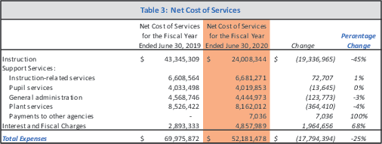

Kenyon (2021a, p. 9).

**Figure 8**

*LASD YE 2020 Capital Assets*

|  |  |  |  |  |
| --- | --- | --- | --- | --- |
| Table 5: Capital Assets | | | | |
| June 30, 2019 | | June 30, 2020 | *Increase (Decrease)* | *Percentage Change* |
| **Land** | $ 1,488,885 | $ 136,262,476 | *$ 134,773,591* | *9052%* |
| Site improvements | 1,225,056 | 1,225,056 | *-* | *0%* |
| Buildings and improvements | 129,573,748 | 130,339,280 | *765,532* | *1%* |
| Equipment | 4,636,939 | 3,871,407 | *(765,532)* | *-17%* |
| *Total* | 136,924,628 | 271,698,219 | *134,773,591* | *98%* |
| *Less: Accumulated Depreciation* | 47,879,087 | 50,621,771 | *2,742,684* | *6%* |
| Net Capital Assets | $ 89,045,541 | $ 221,076,448 | *$ 132,030,907* | *148%* |

Kenyon (2021a, p. 10).

**Figure 9**

*LASD YE 2020 Long-term Liabilities*

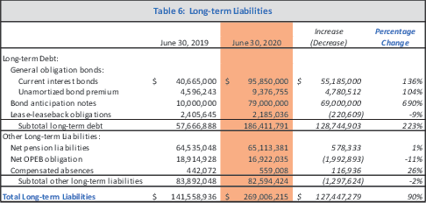

Kenyon (2021a, p. 11).

**Figure 10**

*LASD 2019–20 Multi-Year Projection*

|  |  |  |  |  |  |  |
| --- | --- | --- | --- | --- | --- | --- |
| **2020-21** | | **2021-22** | **2022-23** | **2023-24** | **2024-25** | **2025-26** |
| % Change in Prop Tax Collections | 7.06% | **4.00%** | 4.00% | 4.00% | 4.00% | 4.00% |
| Enrollment | 3,574 | **3,669** | 3,725 | 3,761 | 3,792 | 3,813 |
| In-district students @ charter school | 1043 | **1061** | 1061 | 1061 | 1061 | 1061 |
| *Total* *Enrollment,* *LASD* *+* *BCS* | 4,617 | ***4,730*** | *4,786* | *4,822* | *4,853* | *4,874* |
| Transfer of Prop Tax to BCS | 9,187,469 | **9,926,004** | 10,210,982 | 10,494,976 | 10,785,723 | 10,450,068 |
| Cost-of-Living Adjustment (COLA) | 0.00% | **4.05%** | 2.98% | 3.05% | 3.00% | 3.00% |
| Foundation Funding | 2,400,000 | **2,500,000** | 2,500,000 | 2,500,000 | 2,500,000 | 2,500,000 |
| Parcel Tax | 820 | **820** | 820 | 820 | 820 | 597 |
| Class Size, K-3 | 19 | **22** | 22 | 22 | 22 | 22 |
| Class Size, 4-6 | 25 | **25** | 25 | 25 | 25 | 25 |
| Class Size, 7-8 | 25 | **26** | 26 | 26 | 26 | 26 |
| Teachers, FTE | 226 | **220** | 222 | 223 | 225 | 226 |
| Raises (across-the-board) | 2.00% | **2.00%** | 0.00% | 0.00% | 0.00% | 0.00% |
| Cost of Step/Column Movement | 355,034 | **355,276** | 357,641 | 358,823 | 361,188 | 362,370 |
| Step/Col (converted to % salary inc.) | 1.2% | **1.2%** | 1.2% | 1.2% | 1.2% | 1.2% |
| Health Benefit rate increases | 5.0% | **7.5%** | 7.5% | 7.5% | 7.5% | 7.5% |
| Health Benefits (converted to % salary inc. | 0.9% | **1.4%** | 1.4% | 1.4% | 1.6% | 1.7% |
| STRS rate increases | -1.0% | **0.8%** | 1.1% | 0.0% | 0.0% | 0.0% |
| Total Comp (as % of salary) | 3.2% | **5.4%** | 3.7% | 2.6% | 2.8% | 2.9% |
| LCFF Sources | 47,831,288 | **48,960,469** | 50,930,778 | 52,994,478 | 55,150,308 | 58,023,166 |
| Federal Sources | 2,966,976 | **1,128,389** | 1,162,015 | 1,197,456 | 1,233,380 | 1,270,382 |
| Other State Sources | 7,460,221 | **3,799,074** | 3,848,990 | 3,863,445 | 3,874,123 | 3,881,107 |
| Other Local Sources | 14,942,614 | **15,253,502** | 15,910,684 | 15,977,729 | 16,049,330 | 13,308,736 |
| **Total** **Revenues** | **73,201,099** | **69,141,434** | **71,852,467** | **74,033,108** | **76,307,141** | **76,483,390** |
| Certificated Salaries | 28,473,085 | **26,804,421** | 27,081,223 | 27,286,386 | 27,563,386 | 27,771,946 |
| Classified Salaries | 12,146,432 | **11,964,000** | 12,072,253 | 12,178,439 | 12,284,470 | 12,390,750 |
| Employee Benefits | 16,708,058 | **17,877,672** | 19,185,547 | 19,853,541 | 20,542,397 | 21,163,633 |
| Retiree Benefits | 934,490 | **960,791** | 1,001,625 | 1,044,194 | 1,088,572 | 1,134,836 |
| Books & Supplies | 3,926,089 | **1,508,677** | 1,542,077 | 1,573,747 | 1,607,611 | 1,640,136 |
| Contract Services | 9,782,495 | **8,879,712** | 8,999,752 | 9,143,511 | 9,308,868 | 9,477,329 |
| Capital Outlay | 251,893 | **235,312** | 240,835 | 246,658 | 253,080 | 259,653 |
| Other | 8,262 | **8,262** | 8,262 | 8,262 | 8,262 | 8,262 |
| **Total** **Expenses** | **72,230,804** | **68,238,847** | **70,131,574** | **71,334,737** | **72,656,646** | **73,846,545** |
| **Net** **Change** | **970,295** | **902,587** | **1,720,892** | **2,698,370** | **3,650,495** | **2,636,845** |
| Adjusted Beginning Balance | 4,469,801 | **5,440,096** | 6,342,683 | 8,063,576 | 10,761,946 | 14,412,441 |
| Ending Balance | 5,440,096 | **6,342,683** | 8,063,576 | 10,761,946 | 14,412,441 | 17,049,286 |
| Encumbrances | 5,000 | **5,000** | 5,000 | 5,000 | 5,000 | 5,000 |
| General Fund Reserves | 5,435,096 | **6,337,683** | 8,058,576 | 10,756,946 | 14,407,441 | 17,044,286 |
| Reserves, Special Reserve Funds | 3,590,562 | **3,630,562** | 3,690,466 | 3,760,585 | 3,839,557 | 3,920,188 |
| **Total** **Reserves** | **9,025,657** | **9,968,245** | **11,749,042** **14,517,531** **18,246,998** **20,964,474** | | | |
| **%** **of** **Expense** | **12.50%** | **14.61%** | **16.75%** **20.35%** **25.11%** **28.39%** | | | |

Kenyon (2021b, p. 137).

# Rocketship’s Santa Clara Properties

Each of the 10 existing Rocketship schools in Santa Clara County which were listed in Table 7, *Rocketship Property Information*are described in this appendix.

Except for the photos, all of the information presented in this appendix is available from the web site of the Office of the Assessor, County of Santa Clara, under the heading “Real Property Search” (<https://tinyurl.com/assessors-office-santa-clara>).

# Mateo Sheedy

**Table 14**

*Mateo Sheedy: Property Information*

Property Address 788 Locust St., San José, CA 95110 Assessor’s Parcel No. 264–34–076

Size (acres) 1.55

Date of Last Sale 11 Mar 2016

**Figure 11**

*Mateo Sheedy Plat Map*

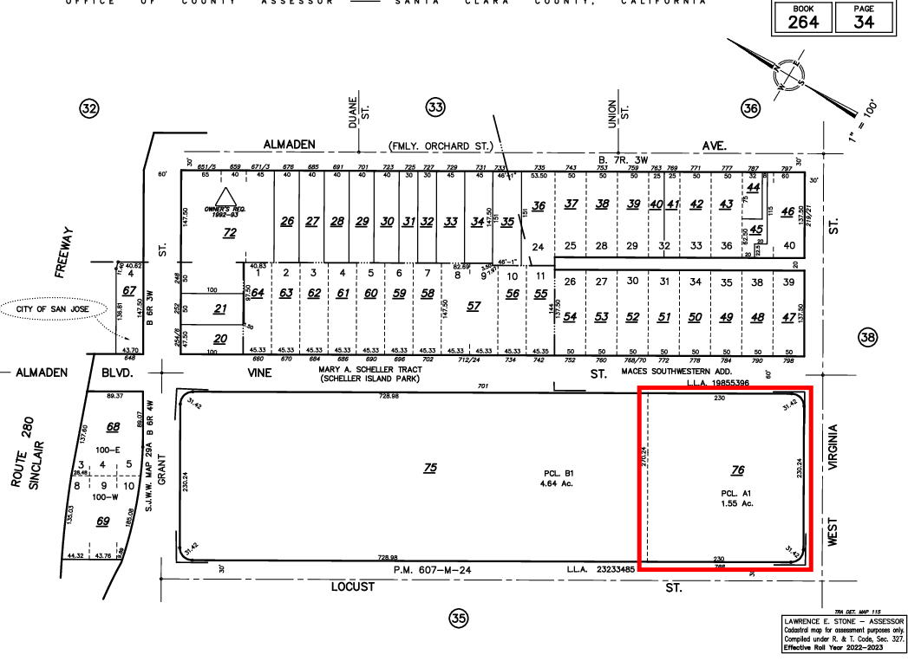

Santa Clara County Assessor’s Office (n.d.). [Plat Map]. Retrieved 22 Dec 2022 from

<https://tinyurl.com/mateo-sheedy-plat-map>.

**Table 15**

*Mateo Sheedy: Taxable Amount of Assessed Property*

|  |  |  |
| --- | --- | --- |
| Year Land | Improvements | Total Assessed Value |
| 2022 $3,011,899 | $780,861 | $3,792,760 |
| 2021 $2,952,843 | $765,550 | $3,718,550 |
| 2020 $2,922,566 | $757,701 | $3,680,267 |

**Figure 12**

*Mateo Sheedy Satellite Photo*

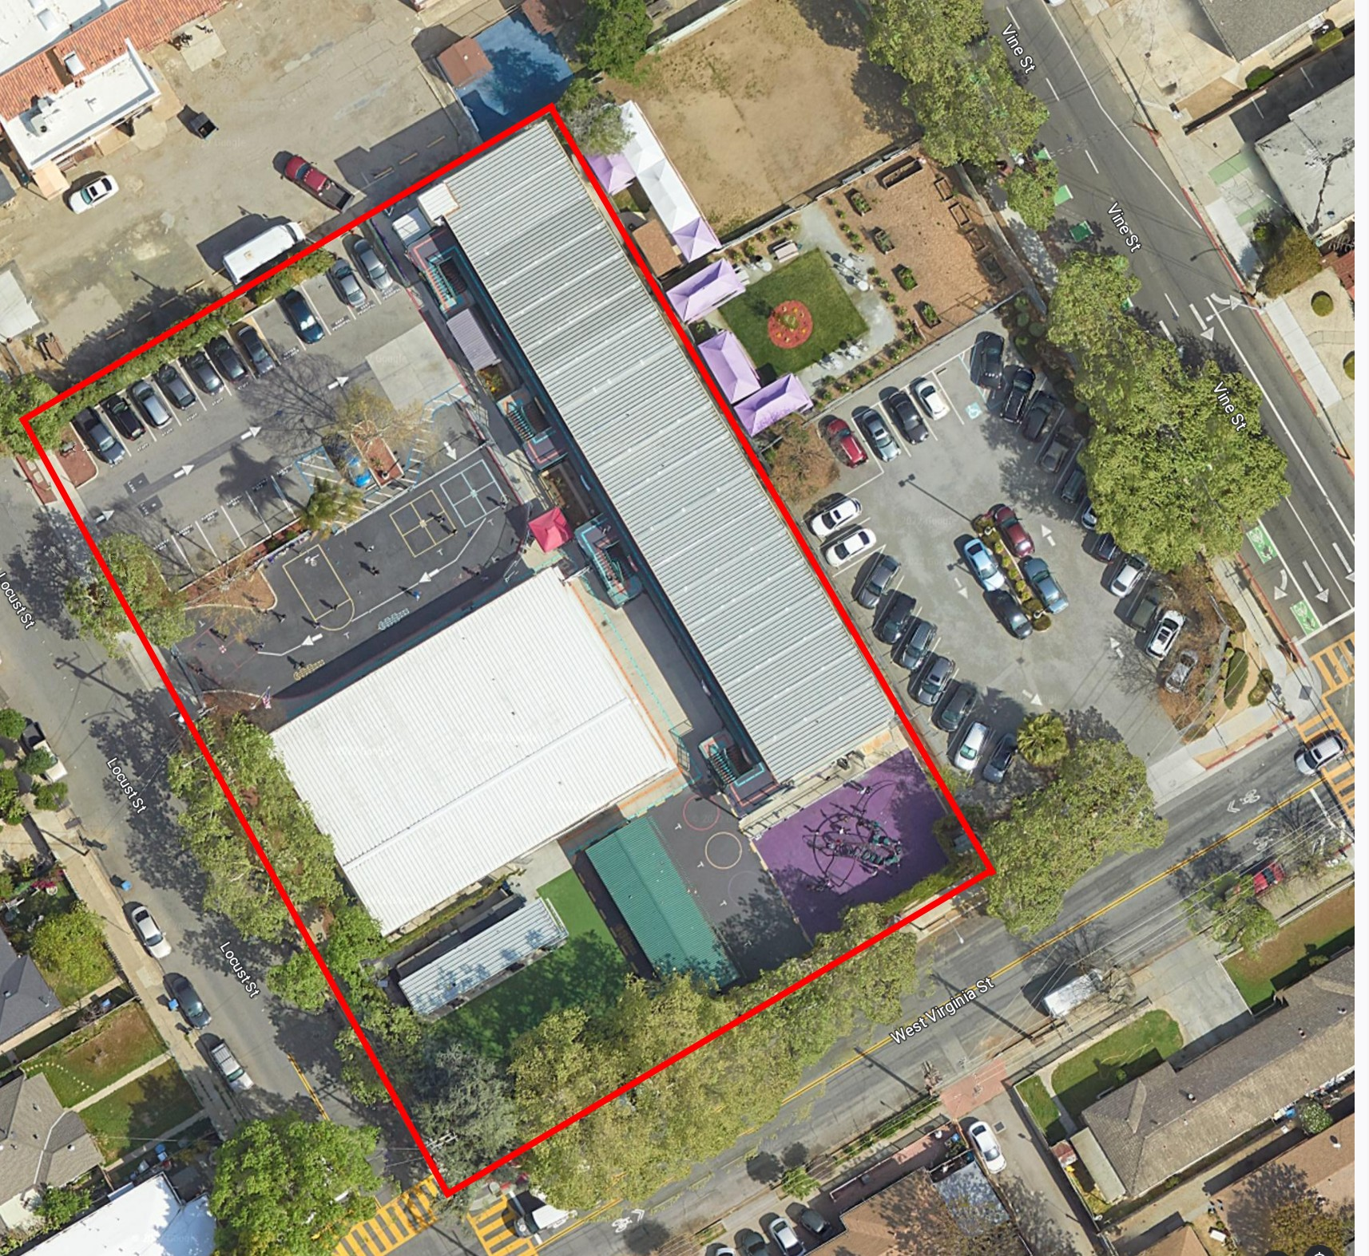

Google. (n.d). [Google Earth image]. Retrieved 19 Dec 2022 from <https://tinyurl.com/mateo-sheedy>.

# Sí Se Puede

**Table 16**

*Sí Se Puede: Property Information*

Property Address 2249 Dobern Ave, San José, CA 95116 Assessor’s Parcel No. 481–32–059

Size (acres) 1.668

Date of Last Sale 20 Mar 2014

**Figure 13**

*Sí Se Puede Plat Map*

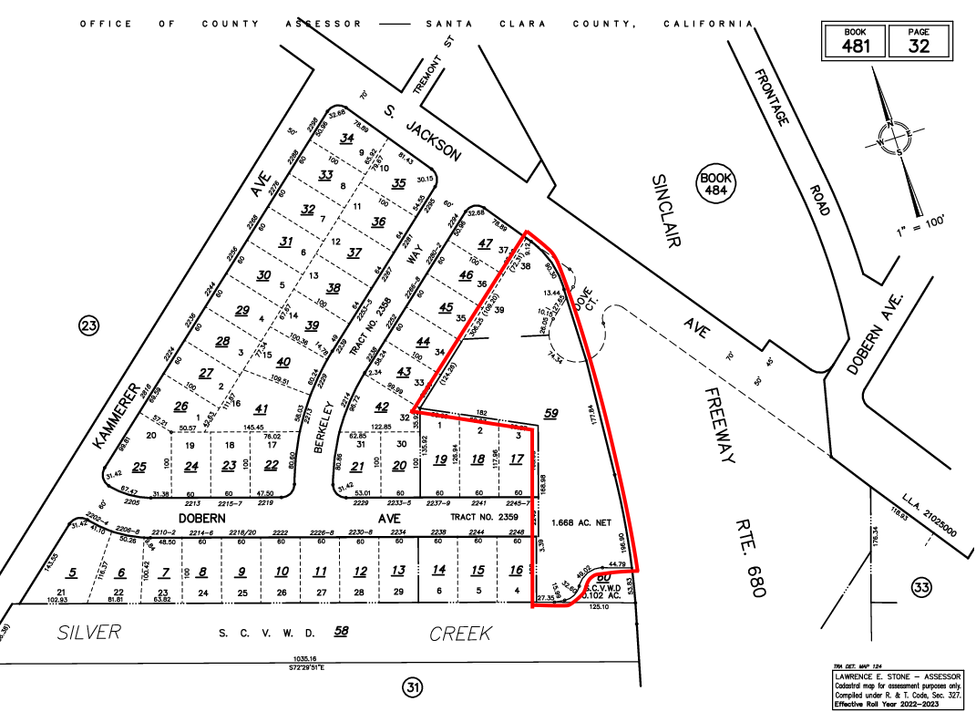

Santa Clara County Assessor’s Office (n.d.). [Plat Map]. retrieved 22 dec 2022 from

<https://tinyurl.com/si-si-puede-plat-map>.

**Table 17**

*Sí Se Puede: Taxable Amount of Assessed Property*

|  |  |  |
| --- | --- | --- |
| Year Land | Improvements | Total Assessed Value |
| 2022 $5,545,914 | $5,411,914 | $10,957,828 |
| 2021 $5,437,171 | $5,305,799 | $10,742,970 |
| 2020 $5,381,420 | $5,251,395 | $10,632,815 |

**Figure 14**

*Sí Se Puede Satellite Photo*

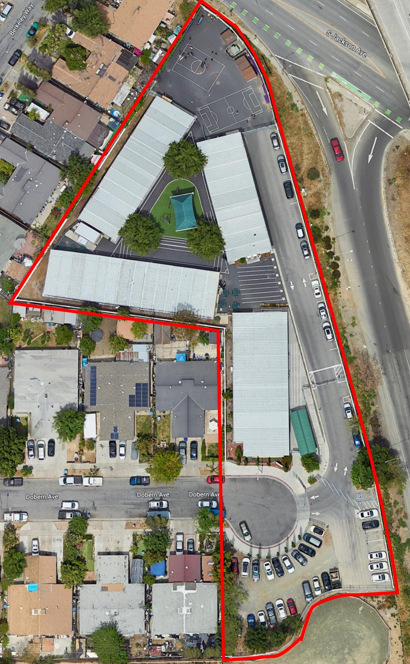

Used with permission from Google. (n.d). [Google Earth image]. Retrieved 19 Dec 2022 from <https://tinyurl.com/si-si-puede-v2>.

# Los Sueños

**Table 18**

*Los Sueños: Property Information*

Property Address 331 S. 34th St, San José, CA 95116 Assessor’s Parcel Nos. 481–45–001

481–45–039

Size (acres) 0.482 + 0.449 = 0.93

Date of Last Sale 19 Apr 2010

**Figure 15**

*Los Sueños Plat Map*

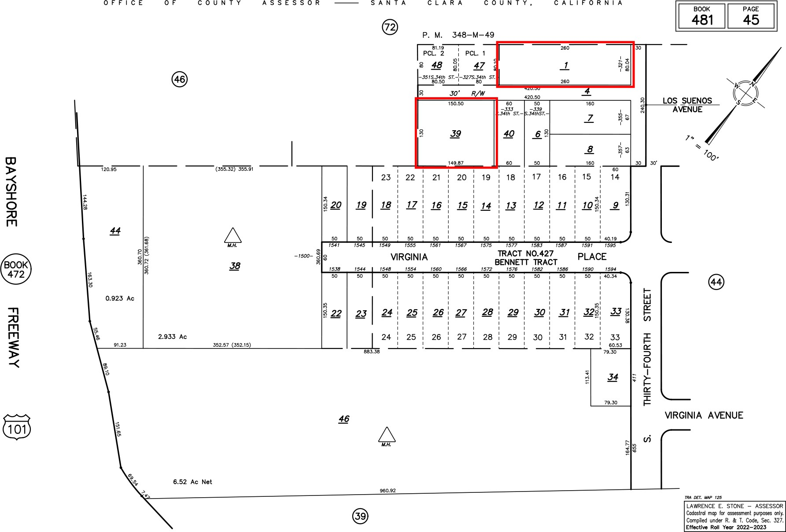

Santa Clara County Assessor’s Office (n.d.). [Plat Map]. Retrieved 23 Dec 2022 from

<https://tinyurl.com/los-suenos-plat-map>.

**Table 19**

*Los Sueños: Taxable Amount of Assessed Property*

|  |  |  |
| --- | --- | --- |
| Year Land | Improvements | Total Assessed Value |
| 2022 $486,545 | $6,510,874 | $6,997,419 |
| 2021 $477,005 | $6,383,210 | $6,860,215 |
| 2020 $472,114 | $6,317,759 | $6,789,873 |

**Figure 16**

*Los Sueños Satellite Photo*

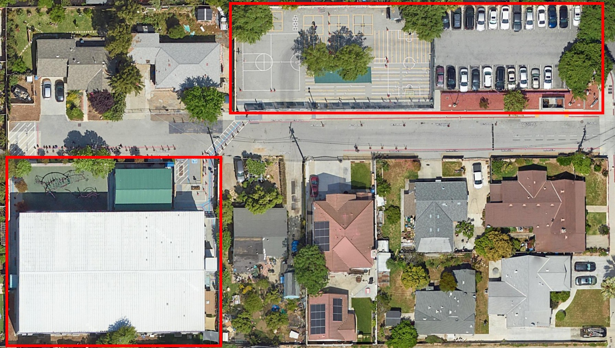

Used with permission from Google. (n.d). [Google Earth image]. Retrieved 23 Dec 2022 from

<https://tinyurl.com/los-suenos-v4>.

# Discovery Prep

**Table 20**

*Discovery Prep: Property Information*

Property Address 370 Wooster Ave, San José, CA 95116 Assessor’s Parcel No. 249–65–079

Size (acres) 1.652

Date of Last Sale 30 Mar 2011

**Figure 17**

*Discovery Prep Plat Map*

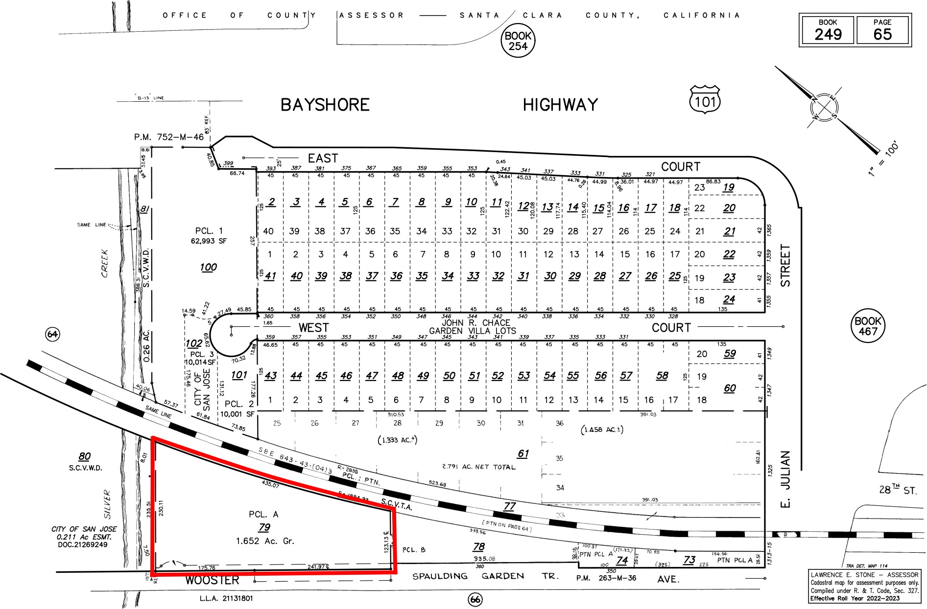

Santa Clara County Assessor’s Office (n.d.). [Plat Map]. Retrieved 23 Dec 2022 from

<https://tinyurl.com/discovery-prep-plat-map>.

**Table 21**

*Discovery Prep: Taxable Amount of Assessed Property*

|  |  |  |
| --- | --- | --- |
| Year Land | Improvements | Total Assessed Value |
| 2022 $2,414,563 | $4,289,318 | $6,703,881 |
| 2021 $2,367,219 | $4,205,214 | $6,572,433 |
| 2020 $2,342,947 | $4,162,095 | $6,505,042 |

**Figure 18**

*Discovery Prep Satellite Photo*

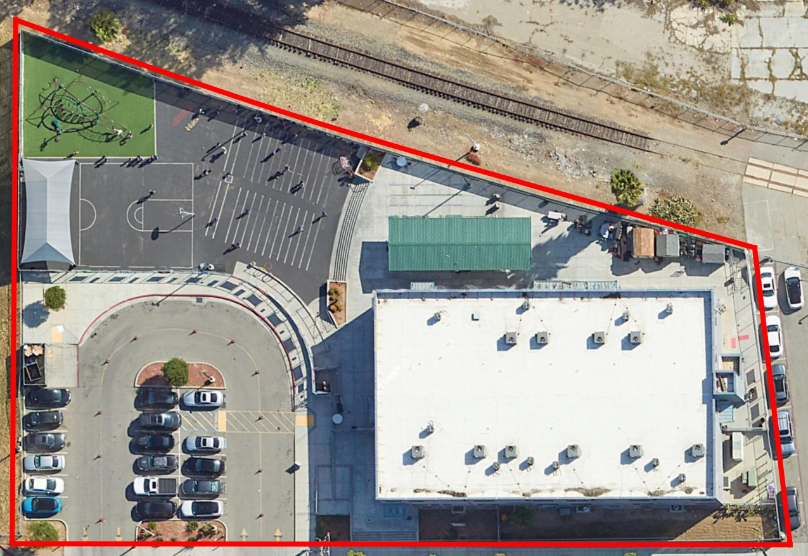

Used with permission from Google. (n.d). [Google Earth image]. Retrieved 23 Dec 2022 from

<https://tinyurl.com/discovery-prep-v2>.

# Mosaic

**Table 22**

*Mosaic: Property Information*

Property Address 950 Owsley Ave, San José, CA 95122 Assessor’s Parcel No. 477–34–088

Size 1.011ac

Date of Last Sale 24 May 2011

**Figure 19**

*Mosaic Plat Map*

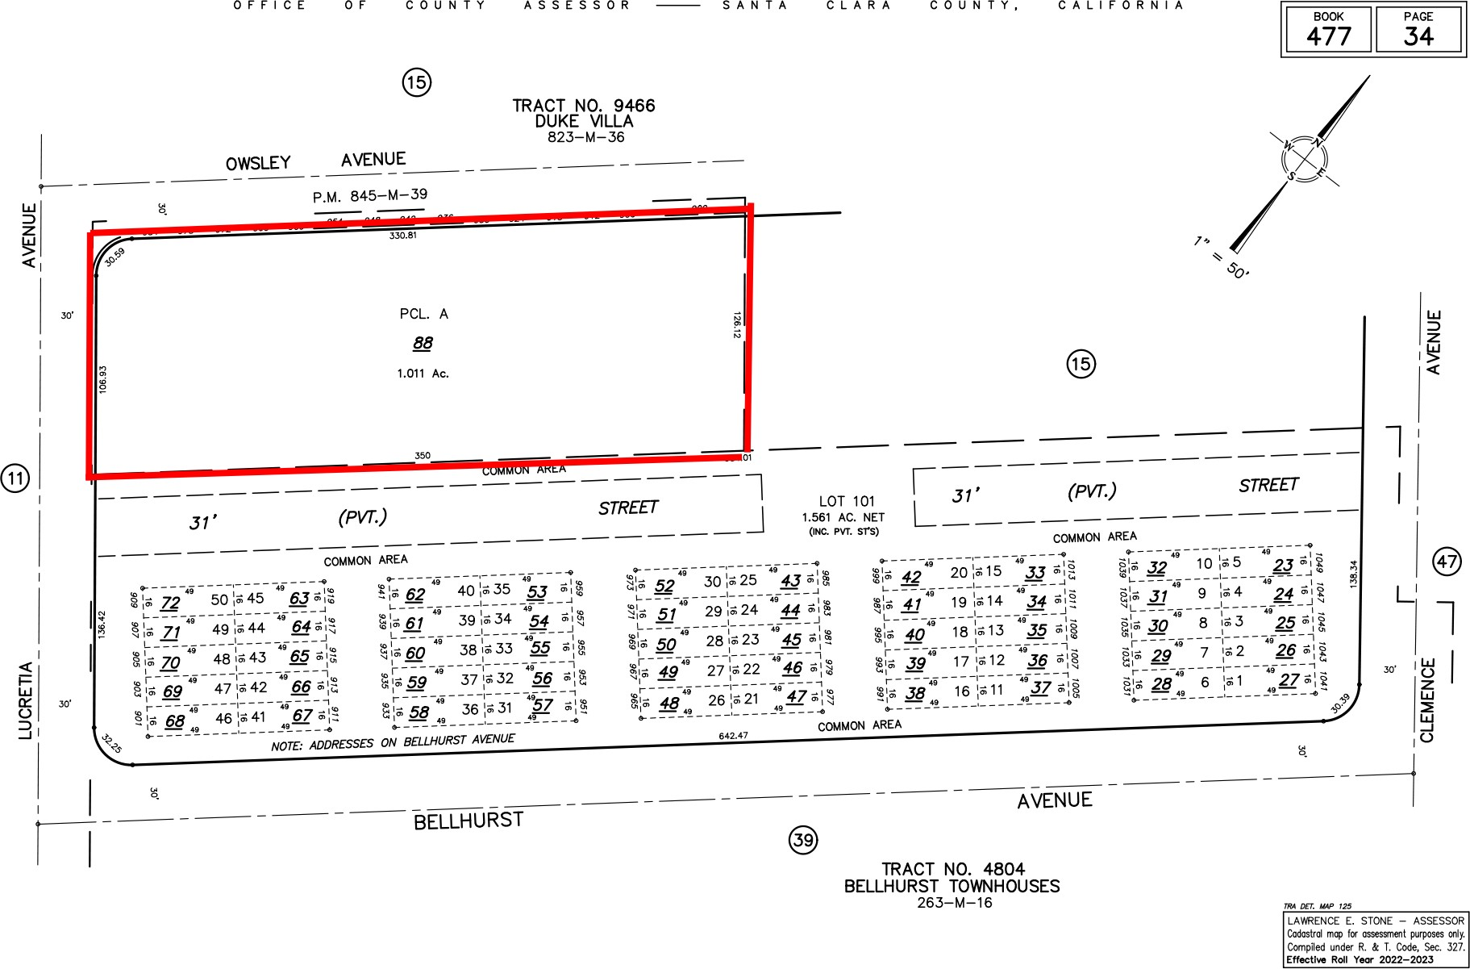

Santa Clara County Assessor’s Office (n.d.). [Plat Map]. Retrieved 23 Dec 2022 from

<https://tinyurl.com/mosaic-plat-map>.

**Table 23**

*Mosaic: Taxable Amount of Assessed Property*

|  |  |  |
| --- | --- | --- |
| Year Land | Improvements | Total Assessed Value |
| 2022 $1,851,242 | $4,971,161 | $6,822,403 |
| 2021 $1,814,944 | $4,873,688 | $6,688,632 |
| 2020 $1,796,334 | $4,823,715 | $6,620,049 |

**Figure 20**

*Mosaic Satellite Photo*

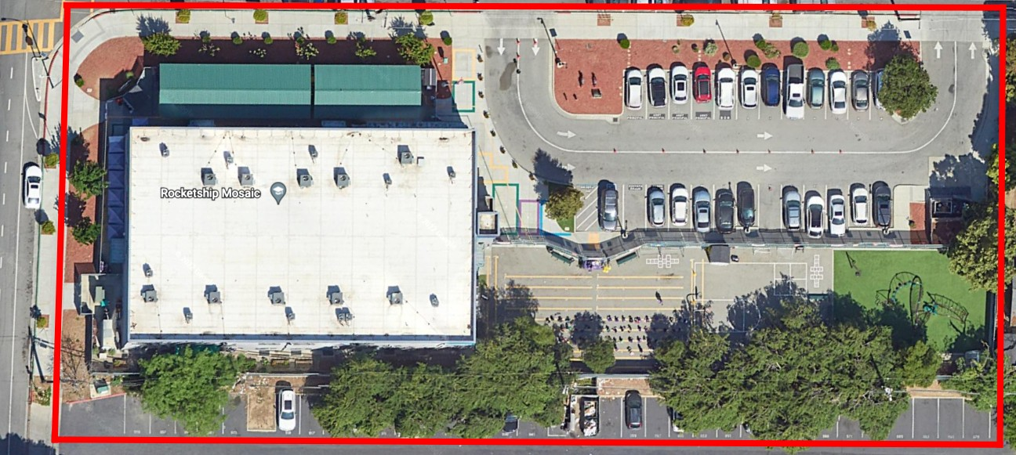

Used with permission from Google. (n.d). [Google Earth image]. Retrieved 23 Dec 2022 from

<https://tinyurl.com/mosaic-v3>.

# Brilliant Minds

**Table 24**

*Brilliant Minds: Property Information*

Property Address 2960 Story Rd, San Jose, CA 95127

2962 Story Rd, San Jose, CA 95127 Assessor’s Parcel No. 488-03-003

Size 1.223ac

Date of Last Sale 11 Feb 2014

Note: Brilliant Minds occupies a single parcel, along with two churches. It appears to have its own buildings, but shares the single parking lot. The size of the parcel is 2.446ac, and arbitrarily, half has been allocated to Rocketship Brilliant Minds.

**Table 25**

*Brilliant Minds: Taxablekk Amount of Assessed Property*

|  |  |
| --- | --- |
| Year Land Improvements | Total Assessed Value |
| 2022 $8,630,187 $4,218,635 | $12,848,822 |
| 2021 $8,460,968 $4,135,917 | $12,596,885 |
| 2020 $8,374,212 $4,093,509 | $12,467,721 |

**Figure 21**

*Brilliant Minds Plat Map*

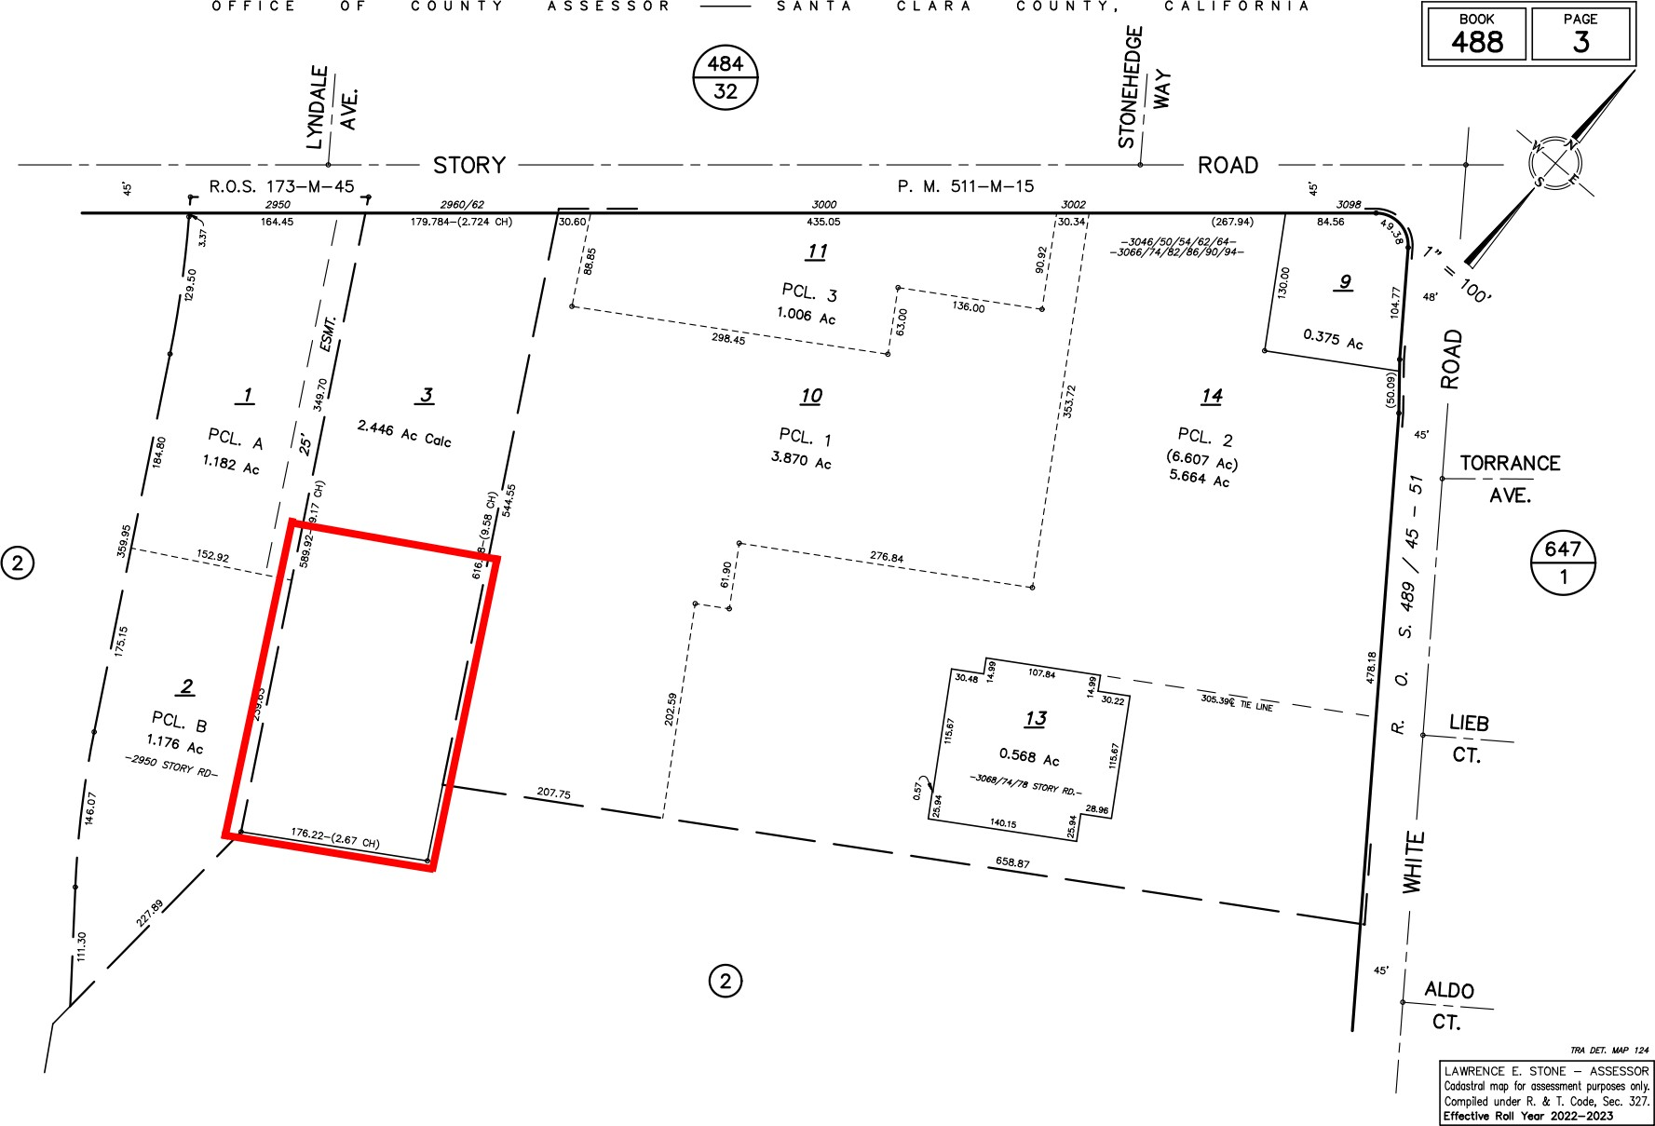

Santa Clara County Assessor’s Office (n.d.). [Plat Map]. Retrieved 23 Dec 2022 from

<https://tinyurl.com/brilliant-minds-plat-map>.

**Figure 22**

*Brilliant Minds Satellite Photo*

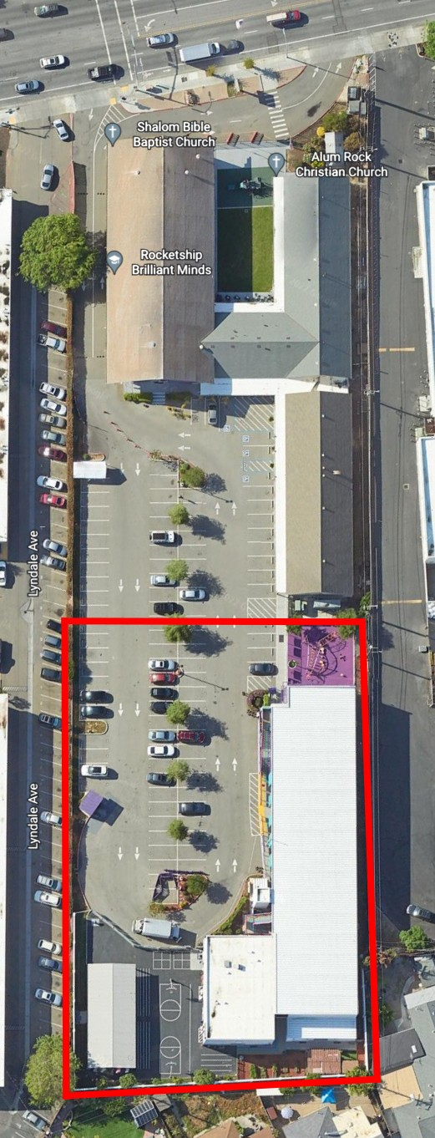

Used with permission from Google. (n.d). [Google Earth image]. Retrieved 23 Dec 2022 from <https://tinyurl.com/brilliant-minds-v2>.

# Alma Academy

**Table 26**

*Alma Academy*: Property Information

Property Address 198 West Alma Ave, San José, CA 95110 Assessor’s Parcel No. 434–22–097,098,099,100,119,132

Size 0.551ac

Date of Last Sale 12 Apr 2012

**Figure 23**

*Alma Academy Plat Map*

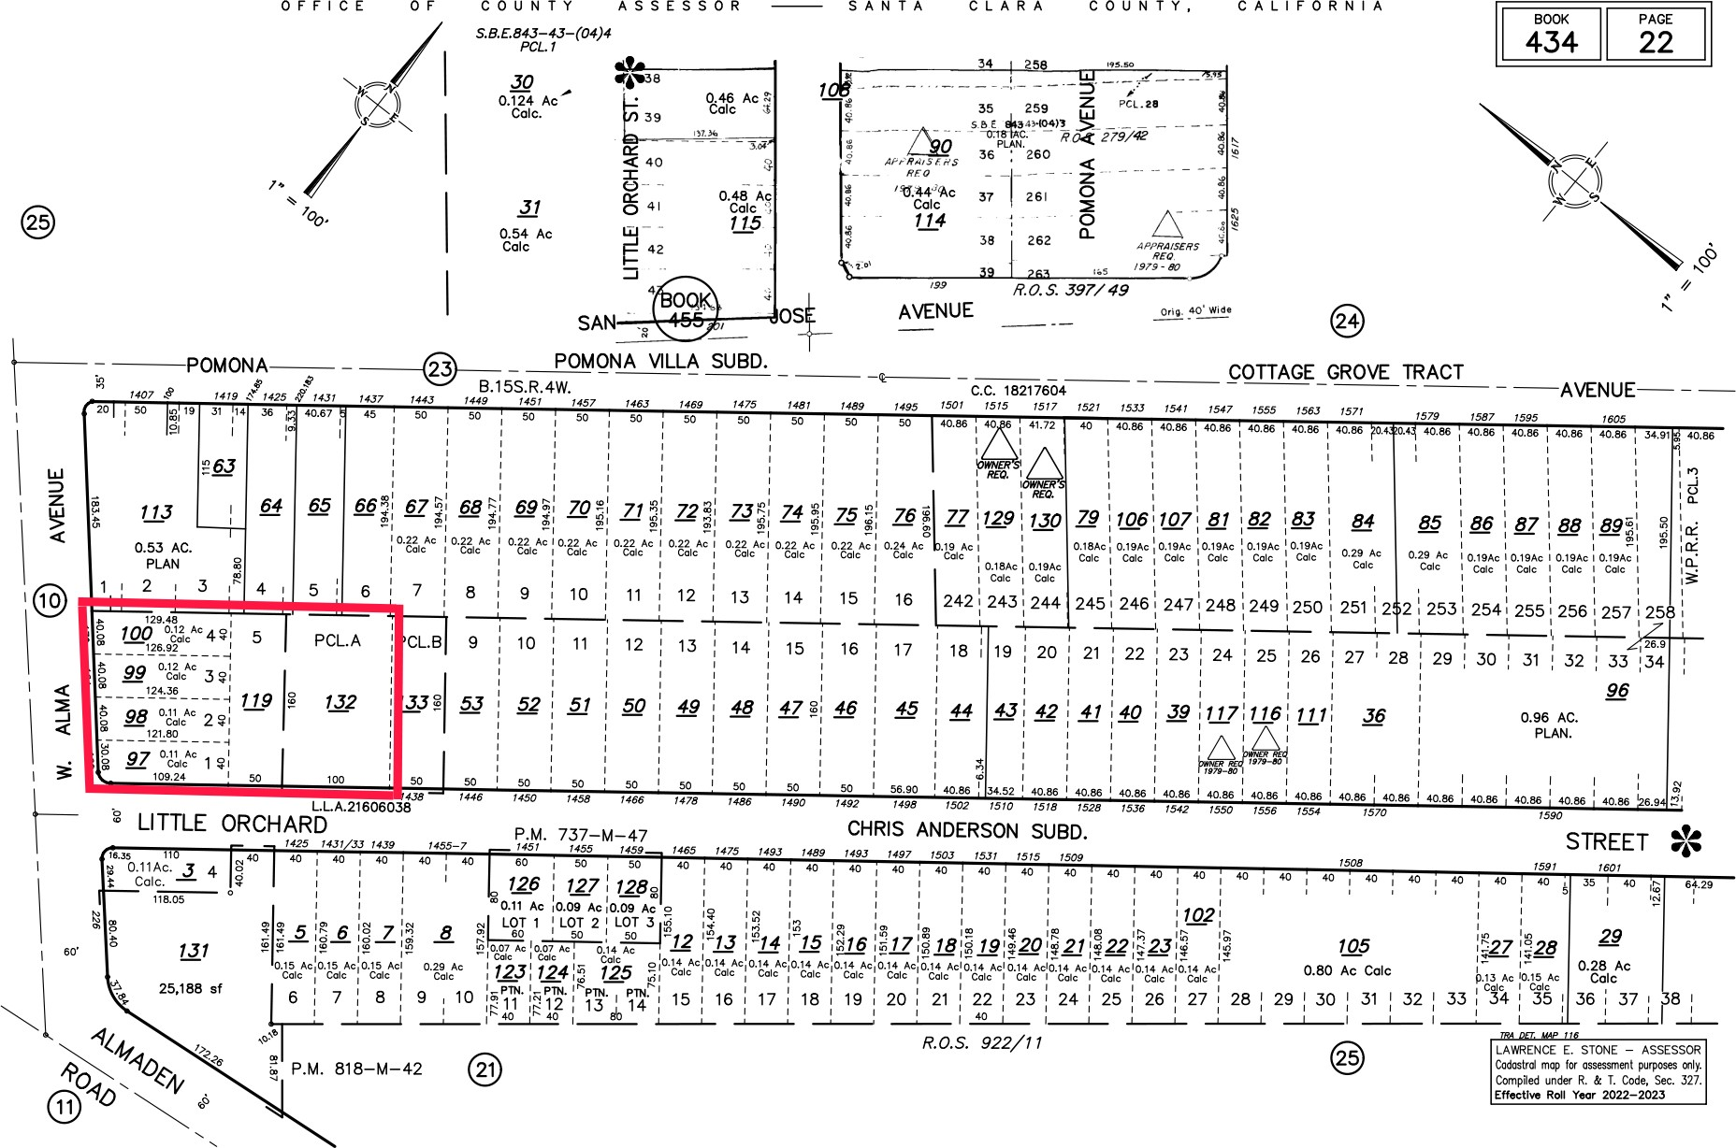

Santa Clara County Assessor’s Office (n.d.). [Plat Map]. Retrieved 03 Jan 2023 from

<https://tinyurl.com/alma-academy-plat-map-v2>.

**Table 27**

*Alma Academy: Taxable Amount of Assessed Property*

|  |  |  |  |
| --- | --- | --- | --- |
| Year | Land | Improvements | Total Assessed Value |
| 2022 | $1,615,598 | $0 | $1,615,598 |
| 2021 | $1,583,932 | $0 | $1,583,932 |
| 2020 | $1,567,686 | $0 | $1,567,686 |

Note: Rocketship Alma Academy comprises six adjacent parcels, so the assessed value indicated in this table is the sum of all six parcels.

**Figure 24**

*Alma Academy Satellite Photo*

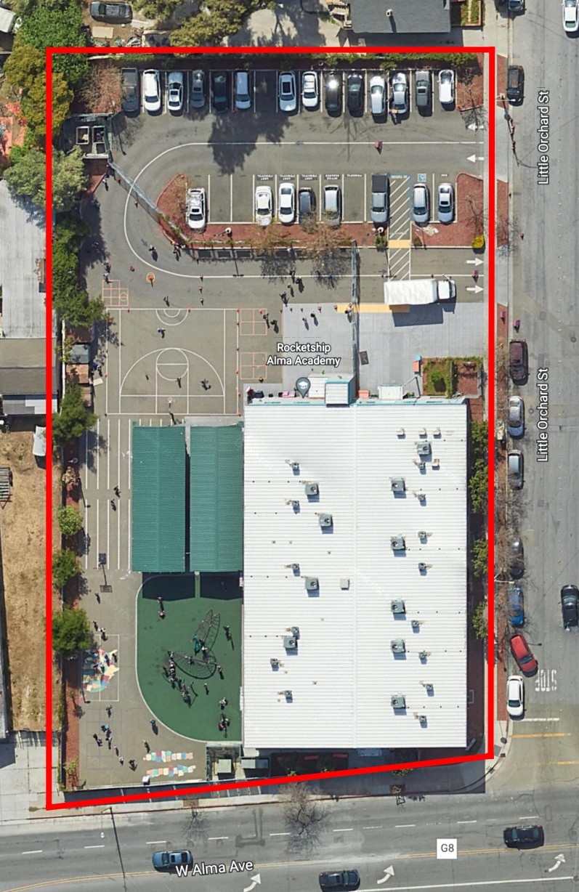

Used with permission from Google. (n.d). [Google Earth image]. Retrieved 03 Jan 2023 from <https://tinyurl.com/alma-academy>.

# Spark Academy

**Table 28**

*Spark Academy: Property Information*

Property Address 683 Sylvandale Ave San José, CA 95111 Assessor’s Parcel No. [494-72-001]

Size approx. 1ac

Date of Last Sale [01 Jun 2012]

Note: Spark Academy has a land lease from the Franklin McKinley School District, so the figures above enclosed in brackets are those of the Franklin McKinley School District.

**Figure 25**

*Spark Academy Plat Map*

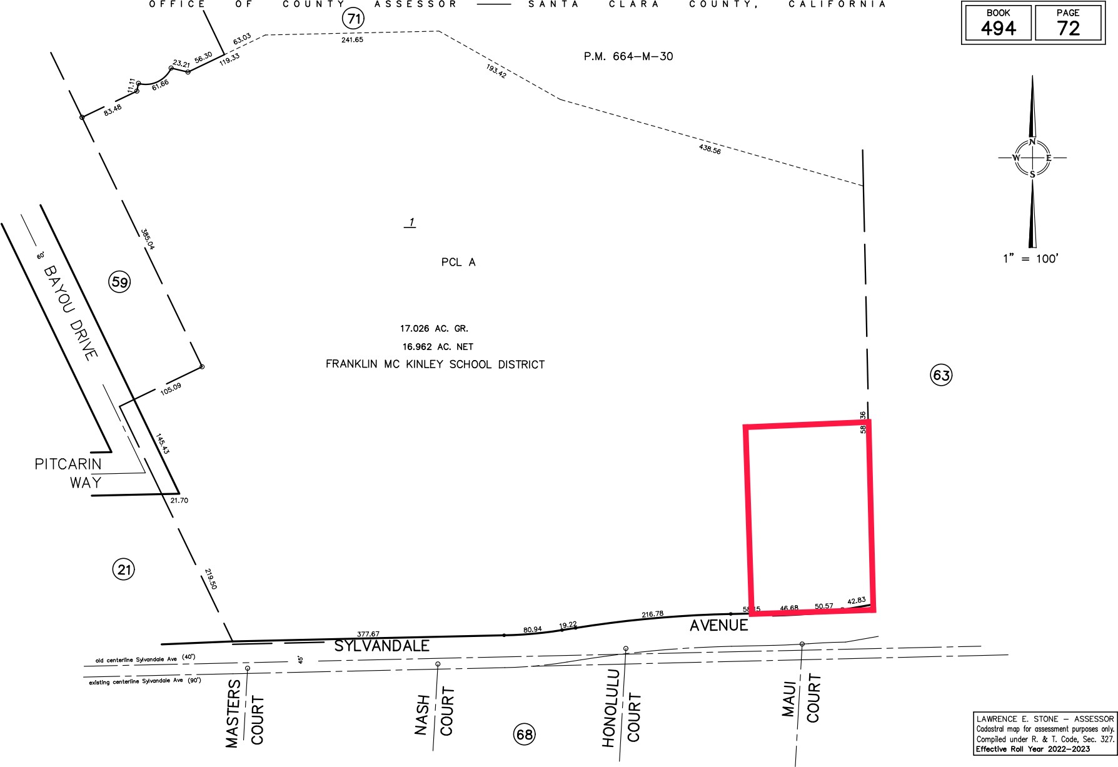

Santa Clara County Assessor’s Office (n.d.). [Plat Map]. Retrieved 07 Jan 2023 from

<https://tinyurl.com/spark-academy-plat-map>.

Note: The outline is approximate.

**Table 29**

*Spark Academy: Taxable Amount of Assessed Property*

Year Land Improvements Total Assessed Value 2022 $0 $0

2021 $0 $0

2020 $0 $0

Note: As noted above, Spark Academy leases its land from the Franklin McKinley School District. Since public school districts are exempt from property taxes, all the taxable amounts in this table are listed as $0.

**Figure 26**

*Spark Academy Satellite Photo*

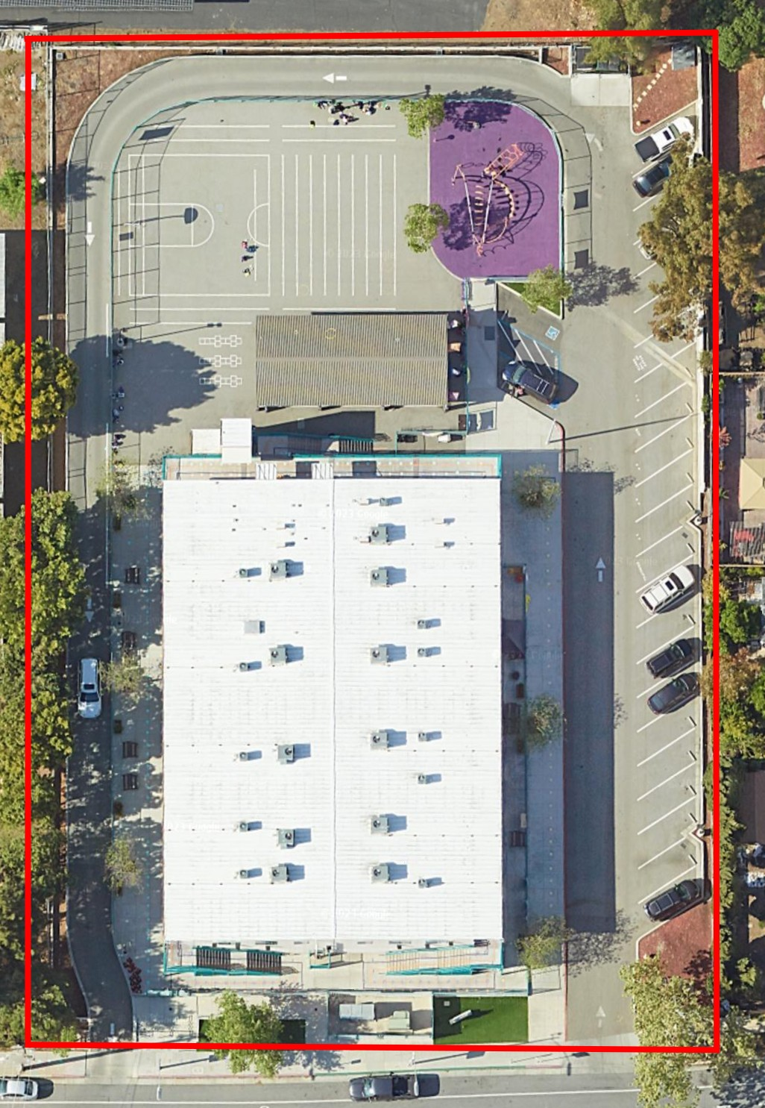

Used with permission from Google. (n.d). [Google Earth image]. Retrieved 07 Jan 2023 from <https://tinyurl.com/spark-academy>.

# Fuerza

**Table 30**

*Fuerza: Property Information*

Property Address 70 S. Jackson Ave, San José, CA 95116 Assessor’s Parcel No. 484–41–162

Size 1.35ac

Date of Last Sale 02 Feb 2018

**Figure 27**

*Fuerza Plat Map*

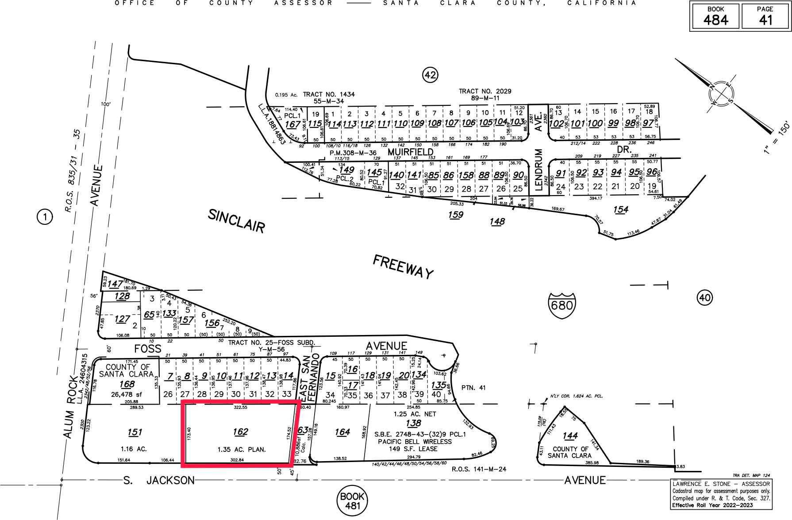

Santa Clara County Assessor’s Office (n.d.). [Plat Map]. Retrieved 07 Jan 2023 from

<https://tinyurl.com/fuerza-plat-map>.

**Table 31**

*Fuerza: Taxable Amount of Assessed Property*

|  |  |  |
| --- | --- | --- |
| Year Land | Improvements | Total Assessed Value |
| 2022 $2,656,862 | $937,117 | $3,593,979 |
| 2021 $2,604,767 | $918,743 | $3,523,510 |
| 2020 $2,578,059 | $909,323 | $3,487,382 |

**Figure 28**

*Fuerza Satellite Photo*

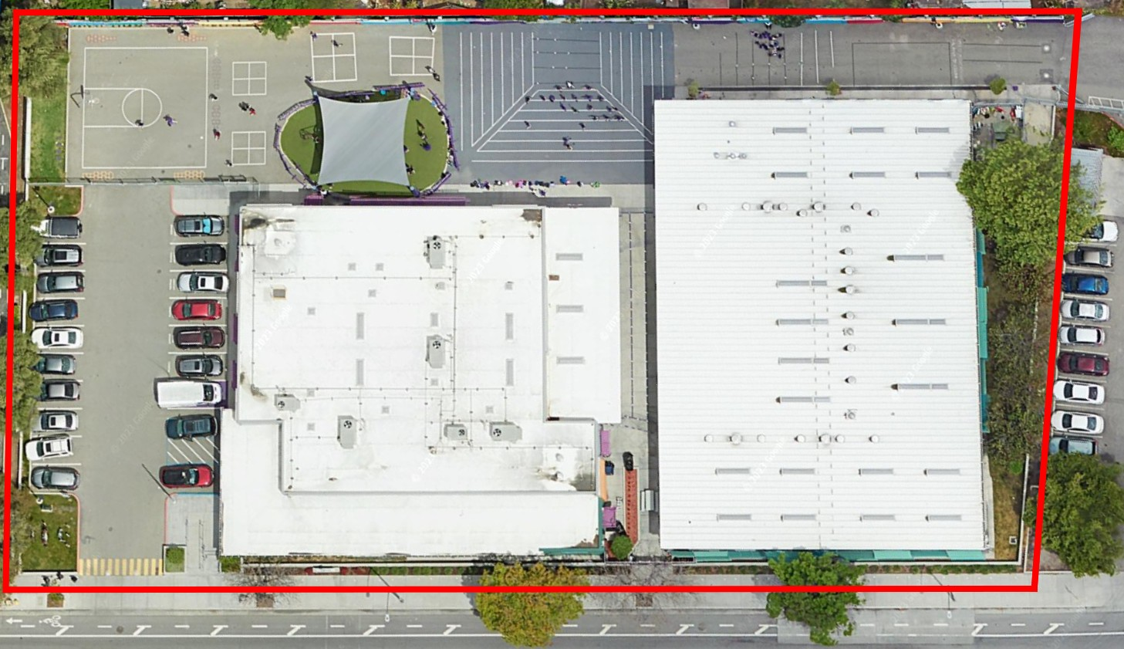

Used with permission from Google. (n.d). [Google Earth image]. Retrieved 07 Jan 2023 from <https://tinyurl.com/fuerza-v2>.

# Rising Stars

**Table 32**

*Rising Stars: Property Information*

Property Address 3173 Senter Road, San José, CA 95111 Assessor’s Parcel No. 494–01–027

Size 1.58ac

Date of Last Sale 01 Dec 2016

**Figure 29**

*Rising Stars Plat Map*

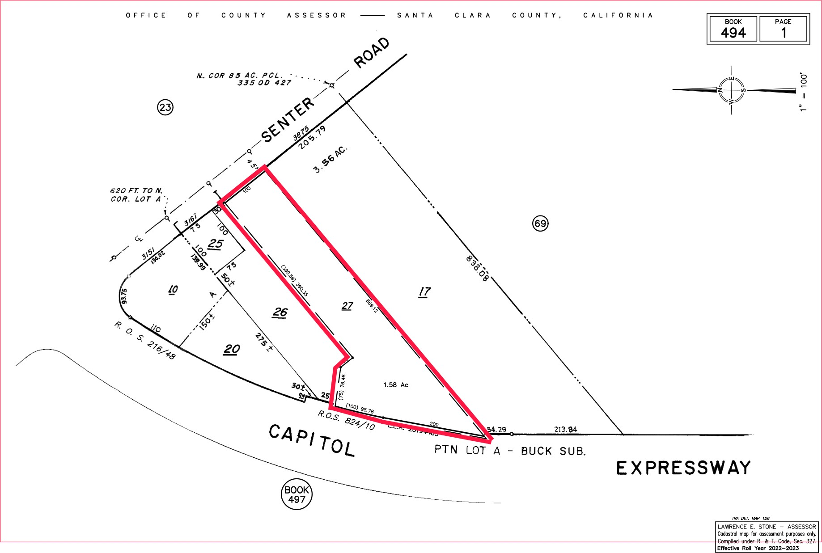

Santa Clara County Assessor’s Office (n.d.). [Plat Map]. Retrieved 07 Jan 2023 from

<https://tinyurl.com/rising-stars-plat-map>.

**Table 33**

*Rising Stars: Taxable Amount of Assessed Property*

|  |  |  |
| --- | --- | --- |
| Year Land | Improvements | Total Assessed Value |
| 2022 $2,997,872 | $12,139,470 | $15,137,342 |
| 2021 $2,939,091 | $11,901,442 | $12,139,470 |
| 2020 $2,908,955 | $11,779,408 | $14,688,363 |

**Figure 30**

*Rising Stars Satellite Photo*

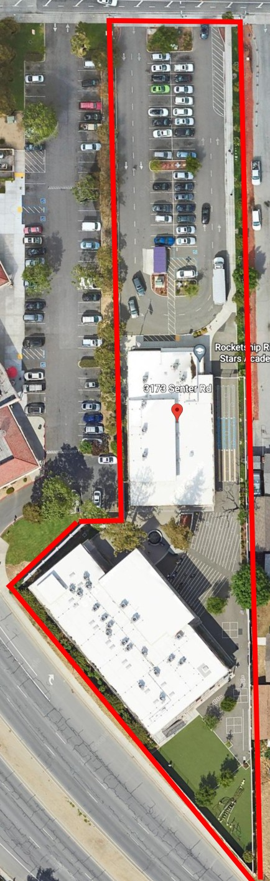

Used with permission from Google. (n.d). [Google Earth image]. Retrieved 07 Jan 2023 from

[https://tinyurl.com/](https://tinyurl.com/rising-stars-v2) [rising-stars-v2](https://tinyurl.com/rising-stars-v2).

# Consolidated Financial Position (2010-2022)

174

**Table 34**

*Consolidated Financial Position, YE 2010-2022*

|  |  |  |  |  |  |  |  |
| --- | --- | --- | --- | --- | --- | --- | --- |
| **Year ending, June 30** | **2010** | **2011** | **2012** | **2013** | **2014** | **2015** | **2016** |
| **Assets** |  |  |  |  |  |  |  |
| **Current Assets** |  |  |  |  |  |  |  |
| Cash and cash equivalents | $7,001,097 | $9,369,115 | $9,172,882 | $14,317,955 | $33,058,905 | $16,072,631 | $24,573,632 |
| Restricted cash | $40,019 | $909,959 | $1,927,649 | $5,014,729 | $5,149,879 | $5,136,357 | $7,624,930 |
| Investments |  |  |  |  |  | $249,350 |  |
| Accounts receivable | $1,732,866 | $4,154,307 | $7,927,381 | $9,880,618 | $9,513,318 | $5,838,881 | $7,889,515 |
| Deferred rent asset |  |  |  |  |  |  |  |
| Grants receivable |  | $1,083,000 | $333,598 | $593,008 | $873,694 | $588,050 | $503,160 |
| Note receivable |  |  |  |  |  |  |  |
| Prepaid expenses and deposits | $218,858 | $145,658 | $407,045 | $1,583,894 | $1,736,015 | $1,265,685 | $2,497,514 |
| Total current assets | $8,992,840 | $15,662,039 | $19,768,555 | $31,390,204 | $50,331,811 | $29,150,954 | $43,088,751 |
| **Long-Term Assets** | | | | | | | |
| Grants receivable |  |  | $582,367 | $703,443 | $420,022 | $163,714 | $235,474 |
| Intracompany receivable |  |  |  |  |  |  |  |
| Security deposits |  |  |  |  |  |  |  |
| Accounts receivable |  |  |  |  |  |  |  |
| Prepaid expenses and deposits |  |  |  | $64,034 |  |  |  |
| Note receivable |  |  |  | $560,000 | $560,000 | $560,000 | $560,000 |
| Deferred rent asset |  |  |  |  |  |  |  |
| Total property, plant and equipment, net | $17,347,756 | $32,470,668 | $42,596,821 | $45,821,468 | $58,986,771 | $63,644,651 | $89,243,223 |
| Total long-term assets | $17,347,756 | $32,470,668 | $43,179,188 | $47,148,945 | $59,966,793 | $64,368,365 | $90,038,697 |
| Total assets | $26,340,596 | $48,132,707 | $62,947,743 | $78,539,149 | $110,298,604 | $93,519,319 | $133,127,448 |

175

*Consolidated Financial Position, YE 2010-2022, cont’d*

|  |  |  |  |  |  |  |
| --- | --- | --- | --- | --- | --- | --- |
| **Year ending, June 30** | **2017** | **2018** | **2019** | **2020** | **2021** | **2022** |
| **Assets** |  |  |  |  |  |  |
| **Current Assets** |  |  |  |  |  |  |
| Cash and cash equivalents | $43,265,177 | $38,794,312 | $34,519,662 | $36,215,753 | $47,620,276 | $48,532,010 |
| Restricted cash | $10,634,074 | $11,363,000 | $12,497,822 | $12,547,596 | $14,098,510 | $9,720,654 |
| Investments |  |  |  |  |  |  |
| Accounts receivable | $8,203,486 | $9,533,421 | $13,242,884 | $18,555,403 | $26,926,079 | $25,916,680 |
| Deferred rent asset |  |  | $175,000 |  | - |  |
| Grants receivable | $476,241 | $1,404,283 |  | $900,000 | $17,000 | $15,000 |
| Note receivable | $560,000 |  |  |  |  |  |
| Prepaid expenses and deposits | $1,368,099 | $3,347,455 | $3,612,640 | $4,024,684 | $6,021,009 | $6,547,464 |
| Total current assets | $64,507,077 | $64,442,471 | $64,048,008 | $72,243,436 | $94,682,874 | $90,731,808 |
| **Long-Term Assets** | | | | | | |
| Grants receivable | $96,325 | $75,000 |  |  |  |  |
| Intracompany receivable |  |  |  |  |  |  |
| Security deposits |  | $35,795 | $26,830 | $28,330 | $49,709 | $53,297 |
| Accounts receivable |  |  |  |  | $19,723 | $8,475 |
| Prepaid expenses and deposits |  |  |  |  |  |  |
| Note receivable |  |  |  |  |  |  |
| Deferred rent asset |  |  |  |  |  |  |
| Total property, plant and equipment, net | $99,989,879 | $103,593,491 | $140,800,699 | $137,529,685 | $161,798,585 | $156,960,429 |
| Total long-term assets | $100,086,204 | $103,704,286 | $140,827,529 | $137,558,015 | $161,868,017 | $157,022,201 |
| Total assets | $164,593,281 | $168,146,757 | $204,875,537 | $209,801,451 | $256,550,891 | $247,754,009 |

*Consolidated Financial Position, YE 2010-2022, cont’d*

|  |  |  |  |  |  |  |  |
| --- | --- | --- | --- | --- | --- | --- | --- |
| **Year ending, June 30** | **2010** | **2011** | **2012** | **2013** | **2014** | **2015** | **2016** |
| **Liabilities and Net Assets** |  |  |  |  |  |  |  |
| **Current Liabilities** |  |  |  |  |  |  |  |
| Accounts payable and accrued liabilities | $1,837,261 | $3,149,027 | $3,149,027 | $3,343,879 | $6,778,855 | $4,971,627 | $7,979,337 |
| Accrued interest | $91,909 | $89,014 | $224,902 | $318,293 | $448,391 | $417,127 | $516,835 |
| Lines of credit |  |  | $1,000,000 |  |  |  |  |
| Deferred rent liability |  |  |  |  |  |  |  |
| Deferred revenues |  | $62,500 |  | $1,635,767 | $622,884 | $370,372 | $1,341,972 |
| Current portion of loans payable | $262,124 | $256,660 | $2,075,432 | $7,453,675 | $17,996,666 | $6,842,252 | $7,617,636 |
| Total current liabilities | $2,191,294 | $4,246,221 | $7,811,754 | $12,751,614 | $25,846,796 | $12,601,378 | $17,455,779 |

**Long-Term Liabilities**

176

Security deposits

|  |  |  |  |  |  |  |  |
| --- | --- | --- | --- | --- | --- | --- | --- |
| Accrued interest | $126,494 | $190,407 | $203,554 | $116,862 | $77,459 | $108,256 | $149,196 |
| Deferred rent liability |  |  |  | $164,972 | $631,405 | $1,185,092 | $1,350,949 |
| Intracompany payable |  |  |  |  |  |  |  |
| Convertible loans | $2,450,000 | $1,800,000 | $1,800,000 | $550,000 | $550,000 |  |  |
| Loans payable | $19,353,844 | $32,683,939 | $41,199,336 | $49,074,491 | $69,836,416 | $69,061,846 | $97,240,060 |
| Total long-term liabilities | $21,930,338 | $34,674,346 | $43,202,890 | $49,906,325 | $71,095,280 | $70,355,194 | $98,740,205 |
| Total liabilities | $24,121,632 | $38,920,567 | $51,014,644 | $62,657,939 | $96,942,076 | $82,956,572 | $116,195,984 |
| **Net Assets** | | | | | | | |
| Unrestricted | $2,218,964 | $7,629,140 | $10,363,266 | $13,486,489 | $12,089,432 | $10,074,280 | $16,442,127 |
| Temporarily restricted |  | $1,583,000 | $1,569,833 | $2,394,721 | $1,267,096 | $488,467 | $489,337 |
| Total net assets | $2,218,964 | $9,212,140 | $11,933,099 | $15,881,210 | $13,356,528 | $10,562,747 | $16,931,464 |
| Total liabilities and net assets | $26,340,596 | $48,132,707 | $62,947,743 | $78,539,149 | $110,298,604 | $93,519,319 | $133,127,448 |
| Net Asset Increase over Prior Year |  | 315.16% | 29.54% | 33.09% | -15.90% | -20.92% | 60.29% |

*Consolidated Financial Position, YE 2010-2022, cont’d*

|  |  |  |  |  |  |  |
| --- | --- | --- | --- | --- | --- | --- |
| **Year ending, June 30** | **2017** | **2018** | **2019** | **2020** | **2021** | **2022** |
| **Liabilities and Net Assets** |  |  |  |  |  |  |
| **Current Liabilities** |  |  |  |  |  |  |
| Accounts payable and accrued liabilities | $6,783,072 | $9,728,362 | $10,652,213 | $8,237,562 | $12,379,687 | $14,580,021 |
| Accrued interest | $761,817 | $592,457 | $745,229 | $730,670 | $807,476 | $615,761 |
| Lines of credit |  |  |  |  |  |  |
| Deferred rent liability |  |  |  | $35,276 |  |  |
| Deferred revenues | $823,348 | $1,324,670 | $921,751 | $1,593,373 | $2,942,053 | $5,680,705 |
| Current portion of loans payable | $9,722,526 | $2,716,668 | $3,690,122 | $4,006,297 | $8,298,873 | $4,546,870 |
| Total current liabilities | $18,090,763 | $14,362,157 | $16,009,315 | $14,603,178 | $24,428,089 | $25,423,357 |

**Long-Term Liabilities**

177

Security deposits

|  |  |  |  |  |  |  |
| --- | --- | --- | --- | --- | --- | --- |
| Accrued interest | $113,478 | $148,825 | $166,076 | $196,643 | $233,082 | $172,481 |
| Deferred rent liability | $1,922,841 | $5,917,604 | $4,706,852 | $5,689,509 | $5,541,230 | $6,711,830 |
| Intracompany payable |  |  |  |  |  |  |
| Convertible loans |  |  |  |  |  |  |
| Loans payable | $126,930,036 | $126,675,229 | $159,908,722 | $164,694,827 | $188,117,172 | $182,003,696 |
| Total long-term liabilities | $128,966,355 | $132,741,658 | $164,781,650 | $170,580,979 | $193,891,484 | $188,888,007 |
| Total liabilities | $147,057,118 | $147,103,815 | $180,790,965 | $185,184,157 | $218,319,573 | $214,311,364 |
| **Net Assets** | | | | | | |
| Unrestricted | $16,490,691 | $20,883,606 | $23,897,122 | $23,717,294 | $38,214,318 | $33,008,787 |
| Temporarily restricted | $1,045,472 | $987,130 | $187,450 | $900,000 | $17,000 | $433,858 |
| Total net assets | $17,536,163 | $21,870,736 | $24,084,572 | $24,617,294 | $38,231,318 | $33,442,645 |
| Total liabilities and net assets | $164,593,281 | $168,974,551 | $204,875,537 | $209,801,451 | $256,550,891 | $247,754,009 |
| Net Asset Increase over Prior Year | 3.57% | 24.72% | 10.12% | 2.21% | 55.30% | -12.53% |

# Consolidated Activities (2010-2022)

This table describes the origin (categories) of the funds Rocketship uses to pay for the various categories of operating costs (expenses) that it incurs. It is remarkable that its net assets have grown every year from 2010 until 2022 except for a likely pandemic-induced drop in 2022. This is a performance that is better than most startups in Silicon Valley.

178

179

**Table 35**

*Consolidated Activities, Years Ending 2010-2022*

Consolidated Activities

|  |  |  |  |  |  |  |
| --- | --- | --- | --- | --- | --- | --- |
| **Year ending June 30** | **2010 Total** | **2011 Total** | **2012 Total** | **2013 Total** | **2014 Total** | **2015 Total** |
| **UNRESTRICTED NET ASSETS**  **REVENUES** | | | | | | |
| LCFF State Aid & Property Tax Revenue | $ 1,307,654 | $ 3,808,147 | $7,750,396 | $13,345,784 | $23,505,887 | $29,395,472 |
| Categorical grant revenue | $802,227 | $1,286,595 | $2,234,521 | $3,324,789 |  |  |
| Property taxes | $2,905,691 | $2,757,142 | $4,178,669 | $5,422,165 | $6,328,495 | $7,536,074 |
| Apportionment revenue | $1,307,654 | $3,808,147 | $7,750,396 | $13,345,784 | $2,005,025 | $7,039,060 |
| Other State revenue | $1,307,189 | $2,158,917 | $3,612,096 | $6,279,357 | $8,107,055 | $9,200,216 |
| Federal revenue | $1,438,772 | $1,846,344 | $2,791,168 | $3,794,964 | $6,257,194 | $8,136,903 |
| Other local revenue | $123,109 | $1,284,251 | $159,258 | $246,867 | $330,206 | $498,053 |
| Contributions | $1,047,856 | $5,833,925 | $3,848,403 | $6,261,881 | $7,140,065 | $5,251,662 |
| Amounts released from restriction |  |  | $1,583,000 | $1,422,347 | $2,780,203 | $851,995 |
| Total unrestricted revenues | $10,240,152 | $22,783,468 | $33,907,907 | $53,443,938 | $56,454,130 | $67,909,435 |
| **EXPENSES**  Program expenses | | | | | | |
| Educational programs | $4,719,700 | $7,620,063 | $13,130,262 | $22,280,859 | $36,985,459 | $46,219,562 |
| Site supports & program development |  |  | $6,821,115 | $10,775,327 | $16,905,996 | $16,955,433 |
| Program development and expansion | $655,990 | $735,481 |  |  |  |  |
| Site supports | $1,419,008 | $2,719,223 |  |  |  |  |
| Supporting services |  |  |  |  |  |  |
| Administration and general | $932,421 | $2,490,378 | $3,472,008 | $3,918,745 | $3,959,732 | $4,933,874 |
| Fundraising |  |  |  |  |  |  |
| Total supporting services | $3,007,419 | $5,945,082 | $10,293,123 | $14,694,072 | $20,865,728 | $21,889,307 |
| Total expenses | $7,727,119 | $13,565,145 | $23,423,385 | $36,974,931 | $57,851,187 | $68,108,869 |
| Change in unrestricted net assets | $1,205,379 | $5,410,176 | $2,734,126 | $3,123,223 | -$1,397,057 | -$199,434 |

180

*Consolidated Activities, Years Ending 2010-2022, cont’d*

Consolidated Activities

**Year ending June 30 2010 Total 2011 Total 2012 Total 2013 Total 2014 Total 2015 Total**

**TEMPORARILY RESTRICTED NET ASSETS**

|  |  |  |  |  |  |  |
| --- | --- | --- | --- | --- | --- | --- |
| Amounts released from restriction |  |  | -$1,422,347 |  | -$2,780,203 | -$851,995 |
| Contributions |  | $1,583,000 | $2,247,235 | $2,247,235 | $1,652,578 | $73,366 |
| Change in temporarily restricted net assets |  | $1,583,000 | -$13,167 | $824,888 | -$1,127,625 | -$778,629 |
| Change in net assets | $1,205,379 | $6,993,176 | $2,720,959 | $3,948,111 | -$2,524,682 | -$978,063 |
| Beginning net assets | $1,013,585 | $2,218,964 | $9,212,140 | $11,933,099 | $15,881,210 | $11,540,810 |
| Ending net assets | $2,218,964 | $9,212,140 | $11,933,099 | $15,881,210 | $13,356,528 | $10,562,747 |

181

*Consolidated Activities, Years Ending 2010-2022, cont’d*

Consolidated Activities

|  |  |  |  |  |  |  |
| --- | --- | --- | --- | --- | --- | --- |
| **Year ending June 30** | **2016 Total** | **2017 Total** | **2018 Total** | **2019 Total** | **2020 Total** | **2021 Total** |
| **UNRESTRICTED NET ASSETS**  **REVENUES** | | | | | | |
| LCFF State Aid & Property Tax Revenue | $36,874,280 | $38,756,121 | $54,505,286 | $63,871,048 | $66,915,020 | $68,946,084 |
| Categorical grant revenue |  |  |  |  |  |  |
| Property taxes | $9,388,704 | $13,886,120 |  |  |  |  |
| Apportionment revenue | $11,304,499 | $20,628,908 | $24,205,579 | $29,960,397 | $35,399,299 | $41,743,700 |
| Other State revenue | $11,818,504 | $12,324,370 | $14,517,185 | $21,341,595 | $20,884,624 | $23,380,609 |
| Federal revenue | $9,850,236 | $11,057,467 | $12,951,747 | $12,974,150 | $11,965,795 | $19,487,194 |
| Other local revenue | $385,359 | $2,766,145 | $7,440,059 | $3,938,359 | $886,809 | $2,640,117 |
| Contributions | $8,141,627 | $8,197,231 | $8,006,858 | $5,461,149 | $6,323,553 | $5,798,443 |
| Amounts released from restriction | $299,290 | $264,170 | $670,638 | $799,680 | $187,450 | $900,000 |
| Total unrestricted revenues | $88,062,499 | $107,880,532 | $122,297,352 | $138,346,378 | $142,562,550 | $162,896,147 |
| **EXPENSES**  Program expenses | | | | | | |
| Educational programs | $55,869,661 | $70,573,394 | $77,408,214 | $92,810,139 | $98,929,764 | $101,402,187 |
| Site supports & program development | $20,076,599 | $27,977,604 |  |  | $26,861,068 | $29,008,887 |
| Program development and expansion |  |  |  |  |  |  |
| Site supports |  |  | $13,798,155 | $19,510,598 |  |  |
| Supporting services |  |  |  |  |  |  |
| Administration and general | $5,748,392 | $9,280,970 | $27,685,198 | $21,743,194 | $16,606,399 | $17,547,189 |
| Fundraising |  |  |  | $281,801 | $345,147 | $440,860 |
| Total supporting services | $25,824,991 | $37,258,574 | $27,685,198 | $22,024,995 | $16,951,546 | $17,988,049 |
| Total expenses | $81,694,652 | $107,831,968 | $118,891,567 | $134,345,732 | $142,742,378 | $148,399,123 |
| Change in unrestricted net assets | $6,367,847 | $48,564 | $3,405,785 | $4,000,646 | $14,497,024 | $14,497,024 |

182

*Consolidated Activities, Years Ending 2010-2022, cont’d*

Consolidated Activities

**Year ending June 30 2016 Total 2017 Total 2018 Total 2019 Total 2020 Total 2021 Total**

**TEMPORARILY RESTRICTED NET ASSETS**

|  |  |  |  |  |  |  |
| --- | --- | --- | --- | --- | --- | --- |
| Amounts released from restriction | -$299,290 | -$264,170 | -$670,638 | -$799,680 | -$187,450 | -$900,000 |
| Contributions | $300,160 | $820,305 |  |  | $900,000 | $17,000 |
| Change in temporarily restricted net assets | $870 | $556,135 | -$58,342 | -$799,680 | $712,550 | -$883,000 |
| Change in net assets | $6,368,717 | $604,699 | $3,347,443 | $3,200,966 | $532,722 | $13,614,024 |
| Beginning net assets | $10,562,747 | $16,931,464 | $17,536,163 | $20,883,606 | $24,084,572 | $24,617,294 |
| Ending net assets | $16,931,464 | $17,536,163 | $20,883,606 | $24,084,572 | $24,617,294 | $38,231,318 |

# Consolidated Cash Flows (2006-2022)

183

184

**Table 36**

*Consolidated Cash Flows, Years Ending 2006-2022*

costs

|  |  |  |  |  |
| --- | --- | --- | --- | --- |
| **Year Ending June 30th,** | **2006-2008** | **2009** | **2010** | **2011** |
| **Cash flows from operating activities** |  |  |  |  |
| Change in net assets | $396,350 | $617,235 | $1,205,379 | $6,993,176 |
| Adjustments to reconcile change in net |  |  |  |  |
| assets to net cash provided (used) by |  |  |  |  |
| operating activities |  |  |  |  |
| Depreciation and amortization expense | $15,898 | $285,270 | $430,901 | $607,170 |
| Transfers and losses on disposal of assets |  |  |  |  |
| Allowance for non-recoverable project  Loss/(gain) on disposal of assets |  | -$122 |  |  |
| Forgiveness of debt |  | -$400,000 | -$650,000 | -$650,000 |
| Donated investments |  |  |  |  |
| (increase) decrease in operating assets |  |  |  |  |
| Accounts receivable | -$132,089 | -$557,343 | -$1,043,434 | -$3,141,035 |
| Grants receivable |  |  |  | -$1,083,000 |
| Prepaid expenses and deposits | -$53,930 | -$74,002 | -$90,926 | $73,200 |
| Deferred rent asset |  |  |  |  |
| Increase (decrease) in operating liabilities |  |  |  |  |
| Accounts payable and accrued liabilities | $168,568 | $125,965 | $339,095 | $1,339,028 |
| Deferred revenues |  |  |  | $62,500 |
| Deferred rent liability |  |  |  |  |
| Net cash provided (used) by operating | $394,797 | -$2,997 | $191,015 | $4,201,039 |
| activities |  |  |  |  |

*Consolidated Cash Flows, Years Ending 2006-2022, cont’d*

185

equipment

|  |  |  |  |  |
| --- | --- | --- | --- | --- |
| **Year Ending June 30th,** | **2006-2008** | **2009** | **2010** | **2011** |
| **Cash flows from investing activities** |  |  |  |  |
| Proceeds from sale of property, plant, and |  |  |  |  |
| equipment |  |  |  |  |
| Proceeds from sale of stock |  |  |  |  |
| Proceeds from note receivable |  |  |  |  |
| Purchases of property, plant, and | -$4,243,089 | -$5,729,479 | -$6,685,221 | -$14,287,712 |
| Purchases of investment |  | -$1,000,001 |  |  |
| Net sales of investments |  |  | $1,000,123 |  |
| Net cash used by investing activities | -$4,243,089 | -$6,729,480 | -$5,685,098 | -$14,287,712 |
| **Cash flows from financing activities** |  |  |  |  |
| Intracompany loans |  |  |  |  |
| Change in restricted cash |  |  | -$40,019 | -$869,940 |
| Borrowings on notes payable | $3,849,612 | $14,254,483 | $8,286,077 | $13,561,059 |
| Borrowings on line of credit | $752,042 | $435,000 |  |  |
| Change in line of credit |  |  |  |  |
| Payments on lines of credit | -$752,042 | -$435,000 |  |  |
| Principal payments on notes payable |  | -$2,907,537 | -$366,667 | -$236,428 |
| Net cash provided (used) by financing | $3,849,612 | $11,346,946 | $7,879,391 | $12,454,691 |
| Net increase in cash, cash equivalents and | $1,320 | $4,614,469 | $2,385,308 | $2,368,018 |
| restricted cash |  |  |  |  |

activities

*Consolidated Cash Flows, Years Ending 2006-2022, cont’d*

# year

|  |  |  |  |
| --- | --- | --- | --- |
| **Year Ending June 30th,** **2006-2008** | **2009** | **2010** | **2011** |
| **Cash and cash equivalents , beginning of** $0 | $1,320 | $4,615,789 | $7,001,097 |

Cash, and cash equivalents Restricted cash

**Cash and cash equivalents, end of year** $1,320 $4,615,789 $7,001,097 $9,369,115

# Non-cash investing activities

Property and equipment financed through accounts payable

# Supplemental Disclosures of Cash Flow Information

Forgiveness of debt

$1,422,036

186

amount)

|  |  |  |  |
| --- | --- | --- | --- |
| Cash paid for interest (net of capitalized $21,384 | $290,260 | $595,603 | $1,145,472 |
| Capitalized Interest |  | $24,426 | $152,186 |

# Notes

Totals may not add up exactly because small entries may have been omitted.

Some related entries have been combined.

*Consolidated Cash Flows, Years Ending 2006-2022, cont’d*

187

to net cash provided (used) by operating

|  |  |  |  |  |
| --- | --- | --- | --- | --- |
| **Year Ending June 30th,** | **2012** | **2013** | **2014** | **2015** |
| **Cash flows from operating activities** |  |  |  |  |
| Change in net assets | $2,720,959 | $3,948,111 | -$2,524,682 | -$978,063 |
| Adjustments to reconcile change in net assets  activities |  |  |  |  |
| Depreciation and amortization expense | $1,065,143 | $1,473,483 | $1,453,818 | $2,080,534 |
| Transfers and losses on disposal of assets |  |  |  |  |
| Allowance for non-recoverable project costs |  |  | $670,656 | $6,365 |
| Loss/(gain) on disposal of assets |  | $321,492 |  |  |
| Forgiveness of debt | -$539,232 | -$1,376,033 | -$566,782 | -$550,000 |
| Donated investments | -$6,687 |  |  | -$249,350 |
| (increase) decrease in operating assets |  |  |  |  |
| Accounts receivable | -$4,903,258 | -$2,196,302 | $1,467,891 | $7,077,426 |
| Grants receivable | $167,035 | -$380,486 | $2,735 | $541,952 |
| Prepaid expenses and deposits | -$261,387 | -$1,240,883 | -$88,087 | $470,333 |
| Deferred rent asset |  |  |  |  |
| Increase (decrease) in operating liabilities |  |  |  |  |
| Accounts payable and accrued liabilities | $1,943,090 | $1,096,710 | -$384,880 | $697,873 |
| Deferred revenues | -$62,500 | $1,635,767 | -$1,012,883 | -$252,513 |
| Deferred rent liability |  | $164,972 | $492,459 | $515,839 |
| Net cash provided (used) by operating | $123,163 | $3,446,831 | -$489,755 | $9,360,396 |

activities

*Consolidated Cash Flows, Years Ending 2006-2022, cont’d*

188

activities restricted cash

|  |  |  |  |
| --- | --- | --- | --- |
| **Year Ending June 30th,** **2012** | **2013** | **2014** | **2015** |
| **Cash flows from investing activities**  Proceeds from sale of property, plant, and  equipment | $1,650,071 | $770,000 |  |
| Proceeds from sale of stock Proceeds from note receivable |  |  |  |
| Purchases of property, plant, and equipment -$11,133,681 | -$9,115,145 | -$13,206,306 | -$11,025,976 |
| Purchases of investment |  |  |  |
| Net sales of investments |  |  |  |
| Net cash used by investing activities -$11,133,681 | -$7,465,074 | -$12,436,306 | -$11,025,976 |
| **Cash flows from financing activities**  Intracompany loans  Change in restricted cash -$1,017,690 | -$3,087,080 | -$135,150 | $13,522 |
| Borrowings on notes payable $16,326,366 | $19,025,730 | $47,916,624 | $400,000 |
| Borrowings on line of credit |  |  |  |
| Change in line of credit $1,000,000 | -$1,000,000 |  |  |
| Payments on lines of credit |  |  |  |
| Principal payments on notes payable -$5,494,391 | -$5,775,334 | -$16,114,463 | -$15,734,216 |
| Net cash provided (used) by financing $10,814,285 | $9,163,316 | $31,667,011 | -$15,320,694 |
| Net increase in cash, cash equivalents and -$196,233 | $5,145,073 | $18,740,950 | -$16,986,274 |

*Consolidated Cash Flows, Years Ending 2006-2022, cont’d*

189

# year

|  |  |  |  |
| --- | --- | --- | --- |
| **Year Ending June 30th,** **2012** | **2013** | **2014** | **2015** |
| **Cash and cash equivalents , beginning of** $9,369,115  Cash, and cash equivalents Restricted cash | $9,172,882 | $14,317,955 | $33,058,905 |
| **Cash and cash equivalents, end of year** $9,172,882 | $14,317,955 | $33,058,905 | $16,072,631 |
| **Non-cash investing activities**  Property and equipment financed through |  |  |  |
| **Supplemental Disclosures of Cash Flow**  Forgiveness of debt  Cash paid for interest (net of capitalized $2,300,580 | $3,066,545 | $3,715,640 | $4,975,669 |
| Capitalized Interest $120,316 | $18,764 | $162,839 | $130,319 |

accounts payable

# Information

amount)

# Notes

Totals may not add up exactly because small entries may have been omitted.

Some related entries have been combined.

*Consolidated Cash Flows, Years Ending 2006-2022, cont’d*

190

to net cash provided (used) by operating

|  |  |  |  |  |
| --- | --- | --- | --- | --- |
| **Year Ending June 30th,** | **2016** | **2017** | **2018** | **2019** |
| **Cash flows from operating activities** |  |  |  |  |
| Change in net assets | $6,368,717 | $604,699 | $3,347,443 | $3,200,966 |
| Adjustments to reconcile change in net assets  activities |  |  |  |  |
| Depreciation and amortization expense | $2,265,143 | $2,957,153 | $3,303,505 | $3,730,769 |
| Transfers and losses on disposal of assets |  |  |  |  |
| Allowance for non-recoverable project costs | -$105,540 | $1,721,312 |  |  |
| Loss/(gain) on disposal of assets |  |  |  |  |
| Forgiveness of debt |  |  |  |  |
| Donated investments |  |  |  |  |
| (increase) decrease in operating assets |  |  |  |  |
| Accounts receivable | $175,572 | -$276,902 | -$1,329,935 | -$3,709,467 |
| Grants receivable | $13,130 | $166,068 | -$906,717 | $1,304,283 |
| Prepaid expenses and deposits | -$1,558,793 | $677,420 | -$1,236,192 | -$254,876 |
| Deferred rent asset |  |  |  |  |
| Increase (decrease) in operating liabilities |  |  |  |  |
| Accounts payable and accrued liabilities | $1,456,653 | $1,183,357 | $3,546,032 | $1,067,570 |
| Deferred revenues | $1,298,564 | -$66,629 | -$268,181 | -$412,375 |
| Deferred rent liability | $165,857 | $608,637 | $4,144,643 | -$1,171,631 |
| Net cash provided (used) by operating | $10,079,303 | $7,575,115 | $10,600,598 | $3,755,239 |

activities

*Consolidated Cash Flows, Years Ending 2006-2022, cont’d*

191

equipment

|  |  |  |  |  |
| --- | --- | --- | --- | --- |
| **Year Ending June 30th,** | **2016** | **2017** | **2018** | **2019** |
| **Cash flows from investing activities** |  |  |  |  |
| Proceeds from sale of property, plant, and | $3,611 |  |  |  |
| Proceeds from sale of stock | $249,350 |  |  |  |
| Proceeds from note receivable |  |  | $560,000 |  |
| Purchases of property, plant, and equipment | -$26,165,647 | -$18,766,316 | -$6,891,872 | -$39,946,341 |
| Purchases of investment |  |  |  |  |
| Net sales of investments |  |  |  |  |
| Net cash used by investing activities | -$25,912,686 | -$18,766,316 | -$6,331,872 | -$39,946,341 |
| **Cash flows from financing activities** |  |  |  |  |
| Intracompany loans | -$2,244,791 | -$2,244,791 | -$750,000 |  |
| Change in restricted cash | -$2,488,573 | -$3,009,144 | -$699,262 |  |
| Borrowings on notes payable | $41,539,443 | $44,837,264 | $17,060,412 | $36,081,955 |
| Borrowings on line of credit |  |  |  |  |
| Change in line of credit |  |  |  |  |
| Payments on lines of credit |  | -$9,700,583 |  |  |
| Principal payments on notes payable | -$12,471,695 |  | -$24,321,077 | -$2,841,680 |
| Net cash provided (used) by financing | $24,334,384 | $29,882,746 | -$8,709,927 | $33,240,275 |
| Net increase in cash, cash equivalents and | $8,501,001 | $18,691,545 | -$4,441,201 | -$2,950,827 |

activities restricted cash

*Consolidated Cash Flows, Years Ending 2006-2022, cont’d*

192

# year

|  |  |  |  |  |
| --- | --- | --- | --- | --- |
| **Year Ending June 30th,** | **2016** | **2017** | **2018** | **2019** |
| **Cash and cash equivalents , beginning of** | $16,072,631 | $24,573,632 | $43,265,177 | $38,823,976 |
| Cash, and cash equivalents |  |  |  | $34,519,662 |
| Restricted cash |  |  |  | $12,497,822 |
| **Cash and cash equivalents, end of year** | $24,573,632 | $43,265,177 | $38,823,976 | $47,017,484 |
| **Non-cash investing activities** |  |  |  |  |
| Property and equipment financed through |  |  |  |  |
| accounts payable |  |  |  |  |
| **Supplemental Disclosures of Cash Flow** |  |  |  |  |
| **Information** |  |  |  |  |
| Forgiveness of debt |  |  |  |  |
| Cash paid for interest (net of capitalized | $5,376,401 | $6,734,613 | $7,761,957 | $7,761,957 |
| Capitalized Interest | $130,858 | $111,379 | $28,050 | $28,050 |
| **Notes** |  |  |  |  |
| Totals may not add up exactly because small |  |  |  |  |
| entries may have been omitted. |  |  |  |  |
| Some related entries have been combined. |  |  |  |  |

amount)

*Consolidated Cash Flows, Years Ending 2006-2022, cont’d*

193

to net cash provided (used) by operating

|  |  |  |  |
| --- | --- | --- | --- |
| **Year Ending June 30th,** | **2020** | **2021** | **2022** |
| **Cash flows from operating activities** |  |  |  |
| Change in net assets | $532,722 | $13,614,024 | -$4,788,673 |
| Adjustments to reconcile change in net assets  activities |  |  |  |
| Depreciation and amortization expense | $4,569,248 | $4,798,935 | $7,051,934 |
| Transfers and losses on disposal of assets | $41,744 | $62,490 |  |
| Allowance for non-recoverable project costs |  |  |  |

Loss/(gain) on disposal of assets -$77,251

Forgiveness of debt -$1,687,635 - -

|  |  |  |  |
| --- | --- | --- | --- |
| Donated investments  (increase) decrease in operating assets |  | | |
| Accounts receivable | -$5,313,437 | -$8,390,399 | $1,020,647 |
| Grants receivable | -$725,000 | $883,000 | $2,000 |
| Prepaid expenses and deposits | -$413,544 | -$2,017,706 | -$530,043 |
| Deferred rent asset |  |  |  |
| Increase (decrease) in operating liabilities |  |  |  |
| Accounts payable and accrued liabilities | -$2,395,184 | $4,274,373 | $1,952,538 |
| Deferred revenues | $671,623 | $1,348,680 | $2,738,652 |
| Deferred rent liability | $1,017,932 | -$183,558 | $1,166,080 |
| Net cash provided (used) by operating | -$2,013,896 | $12,702,204 | $8,535,884 |

activities

194

equipment

|  |  |  |  |
| --- | --- | --- | --- |
| *Consolidated Cash Flows, Years Ending 2006-2022, cont’d* |  | | |
| **Year Ending June 30th,** | **2020** | **2021** | **2022** |
| **Cash flows from investing activities** |  |  |  |
| Proceeds from sale of property, plant, and |  |  | $1,079,193 |
| Proceeds from sale of stock |  |  |  |
| Proceeds from note receivable |  |  |  |
| Purchases of property, plant, and equipment | -$980,966 | -$28,891,372 | -$1,036,008 |
| Purchases of investment |  |  |  |
| Net sales of investments |  |  |  |
| Net cash used by investing activities | -$980,966 | -$28,891,372 | $43,185 |
| **Cash flows from financing activities** |  |  |  |
| Intracompany loans |  | -$19,355 |  |
| Change in restricted cash |  |  |  |
| Borrowings on notes payable | $8,387,635 | $32,711,734 | $43,704,197 |
| Borrowings on line of credit |  |  |  |
| Change in line of credit |  |  |  |
| Payments on lines of credit |  |  |  |
| Principal payments on notes payable | -$3,646,908 | -$3,547,774 | -$55,749,388 |
| Net cash provided (used) by financing | $4,740,727 | $29,144,605 | -$12,045,191 |
| Net increase in cash, cash equivalents and | $1,745,865 | $12,955,437 | -$3,466,122 |

activities restricted cash

*Consolidated Cash Flows, Years Ending 2006-2022, cont’d*

# Year Ending June 30th, 2020 2021 2022

**year**

|  |  |  |  |
| --- | --- | --- | --- |
| **Cash and cash equivalents , beginning of** | $47,017,484 | $48,763,349 | $61,720,807 |
| Cash, and cash equivalents | $36,215,753 | $47,620,276 | $48,532,010 |
| Restricted cash | $12,547,596 | $14,098,510 | $9,720,654 |
| **Cash and cash equivalents, end of year** | $48,763,349 | $61,720,807 | $58,256,707 |
| **Non-cash investing activities** |  |  |  |
| Property and equipment financed through |  |  |  |
| **Supplemental Disclosures of Cash Flow** |  |  |  |
| Forgiveness of debt |  | $1,687,635 |  |

accounts payable

# Information

Cash paid for interest (net of capitalized amount)

Capitalized Interest

# Notes

Totals may not add up exactly because small entries may have been omitted.

Some related entries have been combined.

$9,501,979 $9,636,799 $11,041,165

195

# Consolidated Functional Expenses (2019-2022)

196

197

**Table 37**

*Consolidated Functional Expenses, (2019-2022)*

|  |  |  |  |  |  |  |
| --- | --- | --- | --- | --- | --- | --- |
| **Year Ending, 30 June** |  | **2019** |  | **2020** | **2021** | **2022** |
| Salaries |  | $54,294,263 |  | $62,373,909 | $66,828,182 | $81,042,560 |
| Employee Benefits |  | $6,428,104 |  | $7,562,911 | $9,730,733 | $9,464,728 |
| Pension |  | $3,879,706 |  | $4,545,283 | $5,511,783 | $6,416,455 |
| Payroll Taxes |  | $3,030,272 |  | $3,488,943 | $3,521,365 | $4,223,462 |
| Management Fees | - |  | - |  |  |  |
| District Fee |  | $1,275,290 |  | $955,533 | $1,183,610 | $1,642,503 |
| Accounting Expenses |  | $166,059 |  | $423,683 | $264,784 | $848,221 |
| Legal Expenses |  | $457,817 |  | $637,787 | $894,912 | $809,606 |
| Instructional Materials |  | $3,593,898 |  | $3,316,399 | $2,948,451 | $4,795,970 |
| Other Fees For Services |  | $14,590,025 |  | $17,967,479 | $17,164,978 | $24,909,490 |
| Advertising |  | $251,310 |  | $118,555 | $81,334 | $210,761 |
| Office Expenses |  | $2,481,166 |  | $2,906,902 | $2,229,970 | $3,705,681 |
| Information Technology |  | $3,806,135 |  | $3,413,075 | $7,263,178 | $5,960,090 |
| Printing and Postage |  | $328,479 |  | $395,094 | $250,472 | $407,136 |
| Occupancy |  | $10,075,489 |  | $7,597,805 | $8,941,605 | $11,165,624 |
| Travel |  | $2,125,714 |  | $1,954,354 | $785,025 | $2,635,011 |
| Conferences and Meetings |  | $49,276 |  | $16,520 | $21,273 | $25,654 |
| Insurance |  | $410,924 |  | $528,233 | $614,141 | $970,539 |
| Bad Debt |  | $606,798 |  | $47,124 |  |  |
| Depreciation and |  |  |  |  |  |  |
| Amortization | $3,730,769 | | $4,569,248 | | $4,919,017 | $6,801,509 |
| Interest Expense | $7,957,256 | | $9,568,359 | | $10,161,272 | $10,943,932 |
| Capital Expenses | $1,598,061 | | $218,054 | | $38,413 | $151,922 |
| Grants to School |  | |  | |  |  |
| Other Expenses | $13,208,921 | | $10,137,128 | | $5,044,625 | $12,181,105 |
|  | $134,345,732 | | $142,742,378 | | $148,399,123 | $189,311,959 |
| Eliminations | $36,290,573 | | $36,976,313 | |  | $42,697,311 |

**Index**

Alum Rock, 42

astroturf, 3

basic aid, 56

Billionaires Boys Club, 23 billionaires, wealth, 23 bonds

conduit, 82–83

types of, 81–83

Broad, Eli, 23

Brown v. Board of Education, 18–20 Budde, Ray, 28

budgets

annual, 56

interim reports, 56

budgets, audited, 56 budgets, budget cycle, 50–51 budgets, types of, 50

California

FPPC Form 700, Statement of Economic Interests, 68–69

parcel taxes, 81

property taxes, 80–81

California Environmental Quality Act (CEQA), 73

California Public Records Act (CPRA), 61 charter management organization, 5 charter school

original concept, 29

Charter School Act of 1992, intent of, 29 charter school chain, 5

charter schools accountability, 110–111

annual filing requirement, 62 authorization process, 24

authorizer checklist, 24

authorizers, 25

budget, 60

CAFR, 60, 62–63

classification of, 24 compared to public schools, 4 conflict-of-interest laws, 26 disposal of assets, 106–108

enrollment of in Santa Clara County, 3 facilities

co-location, 64–65

financing of, 66–68, 78

leasing, 65–66

options for, 64

owning, 66

finances, 6

study of, 8 financial controls

effectiveness of, 112

financing of, 58–59

fiscal monitoring, 113

initial petition, 60

required elements, 61

interim reports, 60, 62

LCAP, 60, 63

net benefit of, 113–114 number of U.S., 3

out performed by public schools, 4 pedagogy

similarity to public schools, 27 petition contents, 24

petitions

publicly available, 61

staff reports, 62

portfolio of, 40

profit-makeing, 25–26 real estate documents, 64 renewal petition, 60

surveys of research on, 30–34

virtual, 27

CMO, *see* charter management organization Common Core State Standards, 24 Comprehensive Annual Financial Report

(CAFR), 56, 58

Comprehensive Annual Financial Report. (CAFR), 62

Comprehensive Annual Financial Reports (CAFR), 58

comunity funded, 56 conversion, types of, 101

dissertation

design of, 48

finance, 48

framework of, 9–12

goal of, 5

process used by, 49–50

educational management organization, 5 EMO, *see* educational management

organization

financial liability auditors, 58

framework

conceptual, 11–12

theoretical, 9–11

Freedom of Information Act (FOIA), 61 Friedman, Milton, 28

gaps and anomalies, 69 Gates, Bill, 23

Internal Revenue Service Form 990, 69, 76–77

Jobs, Laurene, 23 K-12 funding

comprehensive description of (fn), 56 key findings, 97

Koch brothers, 23

Launchpad LLCs (fn), 6 LCAP, 57–58

LCFF, 51–55, 78–80

Local Control Accountability Plan (LCAP), 57

New Markets Tax Credit Program, 86–88 example, 87–88

non-profit

private gain, 101–103

philanthrocapitalism, 2, 47 politics

definition of, 1 privatization

in education, 3

Proposition 98, 51–53, 55–56 public education

American

alleged failure of, 13 public policy

changes to, 109–112 public policy issues, 103–112

fraud, 104

real estate conversion, 105–109

research question, 8 Rocketship

501(c)(3) non profit, 61–62 annual academic growth, 96

annual financial statement, 61–62 anomalies, 89–91

administrative expenses, 90

check review, 89

differing functional expenses, 90 large swings in accounting expenses,

91

level of materiality, 89 per pupil expenditure, 91 travel expenses, 91

as a model, 6–7

adopted by Caliber Public Schools (fn), 6

adopted by Navigator Schools (fn), 6 board meetings, 63

bonds issued, 83

claims of academic performance, 94–95 corporate structure, 71

Launchpad Development, 73

ownership details, 71–73

rationale, 73–74

debt, 85–86

discrepancies, 92–93

audited contributions vs object code sums, 93

Form 990 vs audited salaries, 92

Form 990 vs financial statements, 92 object code sums vs financial

statements, 93

unclear reporting, 93 facilities

requirements for, 74–75 financial model

school parameters, 77 financial model and forecast, 77 financial statements, 76

activities, 75

cash flows, 75

financial position, 75

functional expenses, 75 financing charter schools, 76–77 net worth, 88

per-pupil spending, 94

private grants, 83–85

properties, 75

rent subsidies, 85, 108–109 schools in Santa Clara County

Alma Academy, 75

Brilliant Minds, 75

Discovery Prep, 75

Fuerza, 75

Los Sueños, 75

Mateo Sheedy, 75

Mosaic, 75

Rising Stars, 75

Spark Academy, 75 Sí Se Puede, 75

spreadsheet used for forecasting, 114 teacher, 95

experience, 95

salaries, 95

turnover, 95

teachers, 96

travel expenses, 113 vision and goals, 93–94

Rocketship Public Schools (fn), 6

school choice, 1

forms of financing, 2 school funding

example of, 49

school vouchers, 2 schools

attributes, 26

forms of, 2

Shanker, Albert, 28 social impact bonds, 2

social media, 69

sweeps, 110

triangulation, 69–70 unaffiliated board member, 111

virtual charter schools expansion of, 3

Zuckerbergs, 23

# Colophon

This dissertation was created entirely with free, open source software (FOSS), except for a single proprietary program used to convert PDFs into spreadsheets. The typefaces, editor, markup language, reference manager, operating system, and all utilities are FOSS.

F F 8 f f

The body and headings were set in 12pt Alegreya. The Alegreya family of serif & sans serif typefaces was designed by Juan Pablo del Peral of Huerta Tipográfica in 2011 and immediately won praise and awards. It is a classic Renaissance typeface, a kind that was first developed in the fourteenth and fifteenth centuries in northern Italy. It comes in Regular, Medium, Bold and Black weights, all of which are available in Roman and Italic styles. There is a full set of Greek and Cyrillic letters as well as Latin small caps. All have a full set of ligatures, and Old Style and Lining numerals. Notably, all the numerals share the same width so they line up regardless of which style is being used. (Multiplication using Roman numerals, anyone?) If any criticism can be leveled against the Alegreya superfamily, it is that the family does not include display sizes and does not contain swash characters. Otherwise, it is nearly perfect.

F F 8 f f

The programs TEX & LATEX and the document class memoir were used to format this dissertation. LATEX was created by Leslie Lamport as a user-friendly version of one of the first digital typesetting systems, TEX . TEX is one of the masterpieces of computer programming whose author, Donald Knuth, won the Turing Award in 1974. It is a testament to Knuth’s brilliance as both a mathematician and as a programmer that TEX is still in use more than four decades later, and arguably has no peers when it comes to typesetting complex mathematics and scientific material. It is, however, awkward to use and hard to learn. Fortunately, Leslie Lamport wrapped TEX in a macro system, LATEX , which was orders of magnitude easier to use than TEX itself.

LaTeX is extraordinarily flexible as shown by the housands of packages which implement

specialized tasks. Currently, CTAN (the Comprehensive TeX Archive Network) has just shy of 6000 packages which can be downloaded. One of those packages implements the class memoir that was used here. It was written by Peter Wilson, and released in 2001. (I’m listed as a contributor to memoir, but in truth I really only just corrected some minor typos.)

F F 8 f f

Wilson’s muse is Robert Bringhurst, author of *The Elements of Typographic Style*, which some consider to be the definitive book on typography and book design. It is certainy the most elegant. The package memoir would undoubtedly meet with Bringhurst’s approval. The class memoir provides in one package nearly everything a person needs to produce what Knuth calls “beautiful books”.

F F 8 f f

One particularly important FOSS program in academia is Zotero. It manages and maintains a bibliographic database and provides citations on demand. It, along with the text editor GNU Emacs (“an operating system disguised as an editor”) and the package reftex, cooperate with the class memoir to provide a complete system for writing scholarly papers, theses, reports, and dissertations.

F F 8 f f

All of these program run on Arch Linux, a particular distribution of GNU Linux, itself a version of Unix. It is notable that GNU Linux, GNU Emacs, TEX and LATEX are all programs that originated decades ago, are still actively used, have never been truly replaced or superseded, and are constantly being improved. They share a common set of characteristics: their fundamental architecture is sound, extensibility is a core feature, and they and thousands of specialized packages are freely available. I predict that iPhones (which run a version of Unix) will be the faintest of memories when GNU Unix, GNU Emacs, and TEX and LATEX start to fade from view.